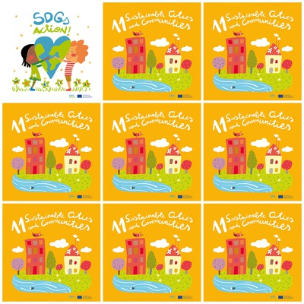

More than 50% of mankind live in cities and by 2050 they will be 75%

Sustainable development can be realized transforming the way we build our urban spaces

The rising populations and the increasing migration has led to a boom in megacities, above all in the developing countries

Slums- densily populated urban areas, characterized by poverty and degradation, are a significant part of urban life

**11. Sustainable cities and Communities**

1. Where will most people live by 2050?

2. How can we realize sustainable development?

3. Why is there a rapid growth of cities and megacities?

4. What is there on the building of the Goal 11 logo?

5. What are significant parts, of megacities?

6. What are slums?