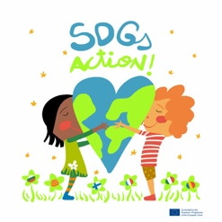
SDGs Action! Online meeting 23rd April 2021

Items to talk about:

- Dates VM France “ Life on land” : 10th, 17th , 18th May
- Let’s Clean up Europe “ 18th May” . Each school can adapt this action to the most suitable date. A Padlet will be Shared . It will have different columns for different types of garbage. Each school will make different groups, each one responsible to pick up a type of rubbish. Upload a post with an image7s and the kilos collected and the name of the country. We will sum up all the products in the end.
- VM Catalonia: 19th, 20th, 21st May “ Launching the project!. The draft program is shared. Each country will have to present 1 Scratch game done during the 2 years of project. Each country will prepare a 5’ warm up game and a 10’ cultural event ( dance, game, song, recipe...) for the last day.
- Jennifer Williams Meeting : 19th May at 15:30-16:30 CET. We will ask he 1 question per country, maybe we will also tell her about our project. We are still preparing the Meeting.
- Gifts: T-shirts sizes of 2-3 teachers per country. A document will be sent. A box will also be sent to each country. We will open it during the closing ceremony.
- SDGs Peace: evaluation: teachers and students still pending. QL to be filled.
- SDGs box game: 5 templates per SDG. Better i fat the end April are finished because we need to send them to the copy printer.
- Next coordinators Meeting: Friday 28th May

