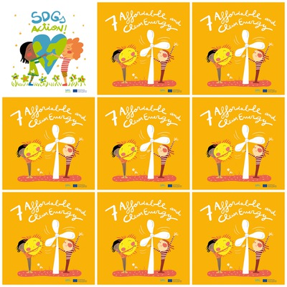

**A wind turbine provides renewable energy.**

**Renewable energies represent 17,5% of the total energy consumption.**

**UN has decided that hospitals and health houses should be a priority for energy supply.**

**Germany the first wind energy producing country in Europe.**

**7. Affordable and Clean Energy**

**1. Does a wind turbine provide renewable energy ?**

**2. What is the percentage of renewable energies in the total energy consumption?**

**3. What type of establishment is one of the UN priorities for energy supply?**

**4. Which is the first wind energy producing country in Europe?**

**5. How many characters are there on the picture ?**

**6. What source of energy is drawn ?**