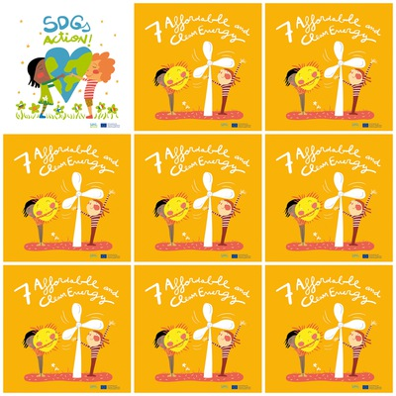

**13% people in the world do not have electricity.**

**A tidal turbine is an underwater turbine that works with ocean currents.**

**Petroleum is a source of fossil energy.**

**Nuclear energy is not green energy because there is a lot of radioactive waste.**

**7. Affordable and Clean Energy**

**1. What percentage of people in the world have no electricity?**

**2. What is a tidal turbine?**

**3. Is petroleum a renewable energy source?**

**4. Is nuclear energy a green energy ?**

**5. How is solar energy represented ?**

**6. What are the skin colours of the characters ?**