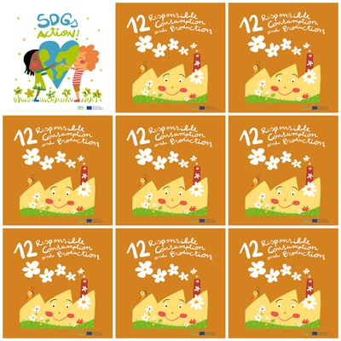

Every year a third part of the food is wasted and with that food we can feed 1.800 million of people.

Nature is important for plants, animals and humans.

Only one-fifth of the world’s final energy consumption in 2013 was from renewable sources.

Only 3 percent of the world’s water is drinkable.

**12. Responsible Consumption and Production**

**1.** How many people do you feed with the food we throw away?

**2.** What is important for the nature?

**3.** Each habitant of a lower country spends 300wph

**4.** What percentage of water is drinkable?

**5.** Is the factory of the logo happy or sad?

**6.** Is the boy wearing a striped or spotted T-shirt?