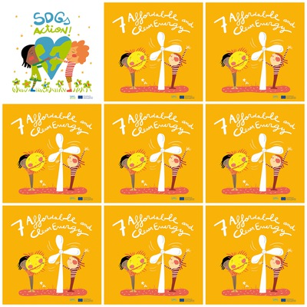

**A coal plant does not produce renewable energy.**

**3 billions people depend on wood or charcoal for cooking and heating.**

**Biomass is a source of energy resulting from the transformation of plants and animals.**

**Russia is the European country that produces the most gas.**

**7. Affordable and Clean Energy**

**1. Is a coal plant a renewable energy source?**

**2. How many people depend on wood or charcoal for cooking and heating?**

**3. What is biomass ?**

**4. Which country in Europe produces the most gas ?**

**5. What is the hair color of the characters?**

**6. What is the color of the striped top?**