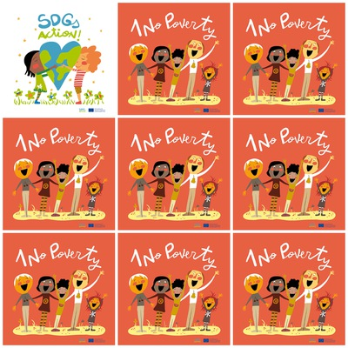

Natural disasters increase poverty.

The majority of people living on less than $1.90 a day live in sub-Saharan Africa

**The contribution of science to end poverty has been significant.**

**Gender equality is one way to reduce poverty.**

1. **No Poverty**

**1. What increases poverty?**

**2. Where the majority of the poorest people live?**

**3. What can contribute to end the poverty?**

**4. Is Gender equality one of the ways to reduce poverty?**

**5**. **What is the color of the dress of the second person in the line in the logo?**

**6. What is the color of the socks of the second person in the line in the logo?**