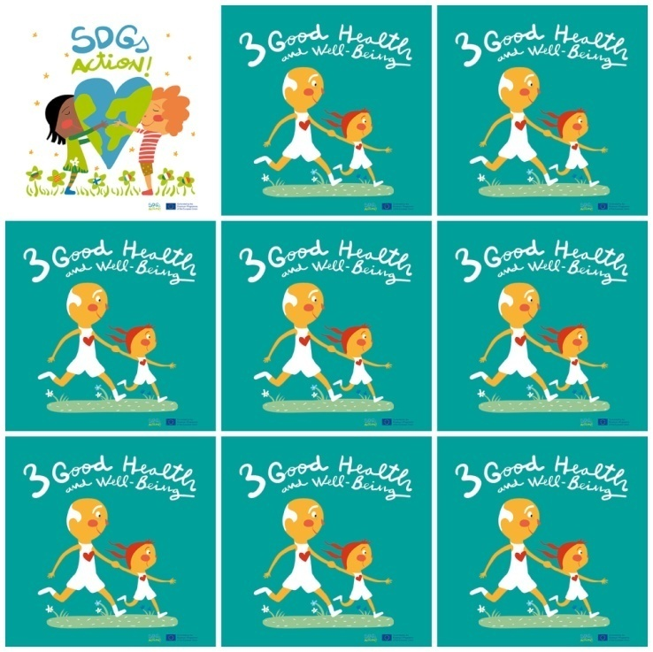

Half of the world’s population are still without access to essential health services.

11% of people die from diseases on the street.

1/5 children do not have access to primary education.

Half of the world has no food.

**3. Good Health and well-Being**

**1.** How many people are living without essential health services?

**2.** How many people die from diseases on the street?

**3.** How many children do not have access to primary education?

**4.** How many people don't have food in the world?

**5.** Which color are the flowers?

**6.** What healthy activity are the people doing in the logo?