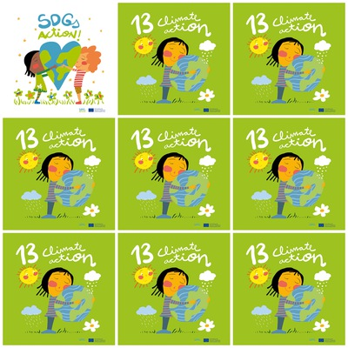

Plastics, chemicals, fuel, farming, deforestation are some causes of climate change.

Animals are dying because of  pollution and climate change.

Temperatures are rising because of the pollution.

In the seas and oceans there are tons of plastics, cans and plastic bags because of human actions.

**13. Climate Action**

**1.** Say 3 causes of climate change.

**2.** Why animals are dying?

**3.** What happens with temperatures with the pollution?

**4.** What do humans throw in the seas?

**5.** Is the girl of the logo happy?

**6.** Is the sun of the logo happy or sad?