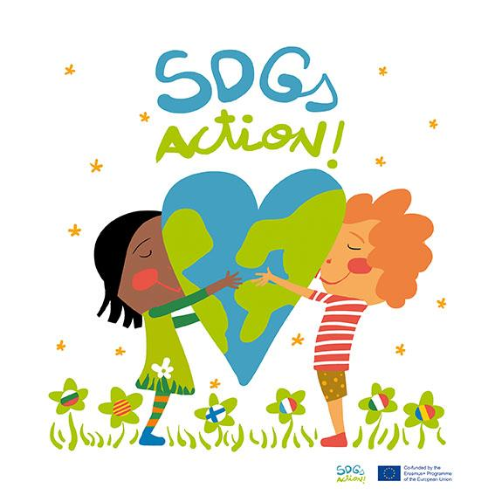
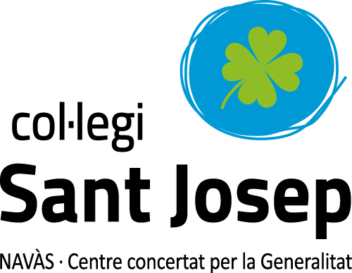

VIRTUAL MOBILITY 19-21 MAY 2021

SDGs Action! sculpture WORKSHOP

Wednesday 19th May:

11:30 - 11: 50:

Pair countries meet and share ideas of what kind of sculpture they imagine to represent our project SDGs Action!
What kind of material can be used

(They can previously have talked about that before the meeting)

Team 1: Romania -Italy
Team 2: Bulgaria - Finland
Team 3: Catalonia - France

Thursday 20th May:

10:15 - 11:50:

Pair countries can meet online and share how they are working, what they are doing, how the sculptures are being made.
Suggestion: each classroom can be divided into small teams making their own sculpture.

Friday 21st May:

10:15 - 10:30:

Present SDGs Action! sculptures : team 1, team 2, team 3

Each team will show their final sculpture, describing what it is , how it was made and which material they used.

All teams will upload images of the shared ideas, working process , and final product on this PADLET

