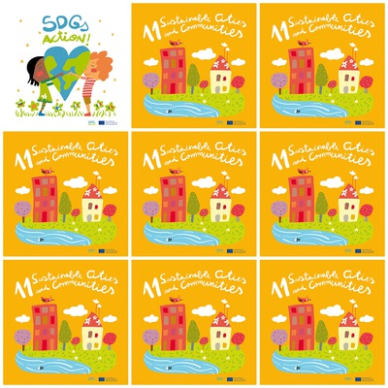

People and governments should protect the world’s natural and cultural heritage

it is important to provide universal access to safe, inclusive and accessible, green and public spaces, in particular for women and children, older persons and persons with disabilities

natural disasters, including water-related disasters, have a direct negative impact on the economic losses of countries, above of in the developing ones and often cause a high number of deaths

Everyone can do small actions to support Goal 11, even with small donations to charities

**11. Sustainable cities and Communities**

1. what kind of heritage are people and government supposed to protect?

2. What can natural disaster cause?

3. How many fish are there in the Goal 11 logo?

4. Who must have access to safe green public spaces?

5. Who can contribute to goal 11?

6. what can have a direct negative impact on the economy?