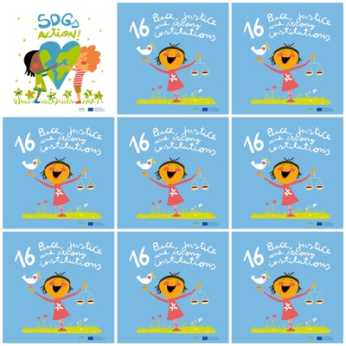

**1. Every day 100 civilians**

**2.** **1 in 4 children has not legal identy**

**3.** **Emotional, verbal, physical**

**4.** **UNICEF**

**16. Peace, justice and strong institutions**

**1. How many children and women die from armed conflict?**

**2. How many children have not legal identity?**

**3. What forms does violence take?**

**4. Which institution promotes peace and protects children's rights?**

**5. What have the girl in hand?**

**6. What is the colour of background of SDG16?**