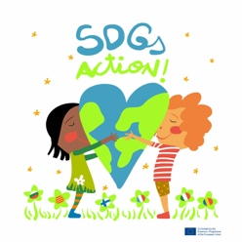
Dissemination plan
1 |  | Communication analysis | Coordination among six partner countries to collaborate in a good and efficient dissemination of the project to achieve the objectives.
2 |  | Objectives | - To achieve a great impact of the project  - To increase awareness towards UN SDGs  - To share good practices and final results
3 |  | Target groups and stakeholders | - Students, families, teachers, school community  - External agents : Mayor, Educational government, experts, local, regional, international organizations/institutions
4 |  | Dissemination level (local, regional, national, international) | - Local, Regional, National: Radio, TV, newspaper, educational digital magazines, reports  - School websites  - Project website: https://sites.google.com/view/sustainabledevelopmentgoalsact  - Project Twin space: https://twinspace.etwinning.net/92917/home
5 |  | Messages | Reports, Presentations, video interviews, survey results, Posters, videos, infographics, web tools: Canva, Genially etc
6 |  | Strategy: language channels and tools. | School website, project website, Twin space, social media: sdgsaction Instagram, Face, Twitter
7 |  | Communication and dissemination activities | - Before: dissemination plan  - During: Media, social nets, periodic activities, website, twins pace, E+PRP, evaluate dissemination  - Final report period: upload final results to E+PRP  - Follow-up: disseminate, ideas for future cooperation, evaluate the impact, contact media
8 |  | Responsible agents | Project coordinator and project partners
9 |  | Chronogram | Weekly -monthly dissemination activities from one partner at least
10 |  | Control indicators / Evaluation | Success indicators:  Media interactions, social nets visibility, project website visits, conferences, seminars and events, external feedbacks.

OTHERS: |  | Budget | Each partner controls the budget for dissemination among other aspects
 |  | Creative commons
 |  | Transferability | Integrating SDGs into our schools curriculum

