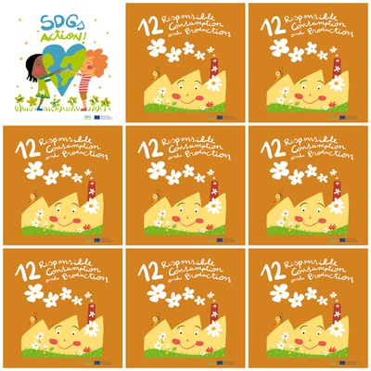

The food waste damages the climate, the water, the sun and biodiversity.

There are 9 million tons of plastics dumped into the seas every year.

Each household throws 76 kilos of food in the trash in a single year.

Low-energy bulbs last between 12,000 and 15,000 hours, while the average life of an incandescent bulb is just over 1,000 hours.

**12. Responsible Consumption and Production**

**1.** Say 3 things that the food waste damages.

**2.** How many tons of plastic are dumped into the seas every year?

**3.** How many kilos of food are thrown in the trash in a household in one year?

**4.** How many hours of life have a low-energy bulb?

**5.** What does come out from the factory chimney?

**6.** What number is this SGD?