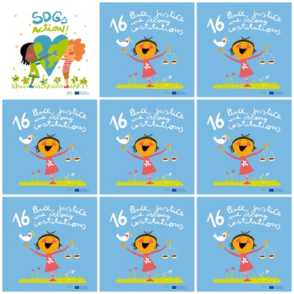

**1 Stronger child protection systems**

**2. To ensure efficiency, transparency, accountability**

**3. Promoting inclusion and respect among people**

**4. Legal identity for all, birth registration**

**16. Peace, justice and strong institutions**

**1. What UNICEF is building**

**2.** **Why do we need strong institutions?**

**3. How we can improve living conditions**

**4. What is wanted by 2030?**

**5. In what hand hold the girl the bird?**

**6. Is the girl white or black?**