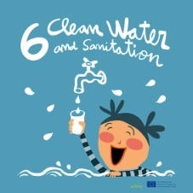
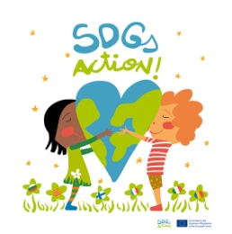
WATER EXPERIMENT

Sant Josep School Navàs

Catalonia

Water experiment will be lead by one Catalan group class. Simultaneously, the other groups will follow the steps and instructions to do the experiment. We recommend doing one experiment per group/class and having all the materials needed ready before to start.

EXPERIMENT: Let’s make a water filter
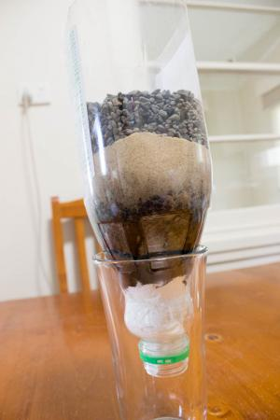
Driving question: How can we clean up dirty water?
Materials:
- Scissors
- Cotton
- Charcoal
- Sand
- Little stones
- Gravel
- Plastic bottle, empty and clean
- Glass
- Dirty water (Add dirt to a glass of water to create muddy water).

Instructions
- First of all, cut off the bottom of an old plastic bottle using scissors.
- Then, place the bottle upside down into the vase of the bottle.
- After that, put cotton balls inside the bottle as the first layer. The first layer should be about one to two inches thick.
- Next, add an inch of charcoal as the second layer on top of the cotton layer.
- Then, add about two inches of gravel or small stones over the charcoal. This will be the third layer.
- After that, add about three to four inches of clean sand on top of the gravel.
- Then, add one inch of gravel into the bottle.
- Next, add some stones as a final layer. Leave about a half inch of space from the top of the upside down bottle.
- Finally, pour dirty water on top of the homemade water filter and what happens?

