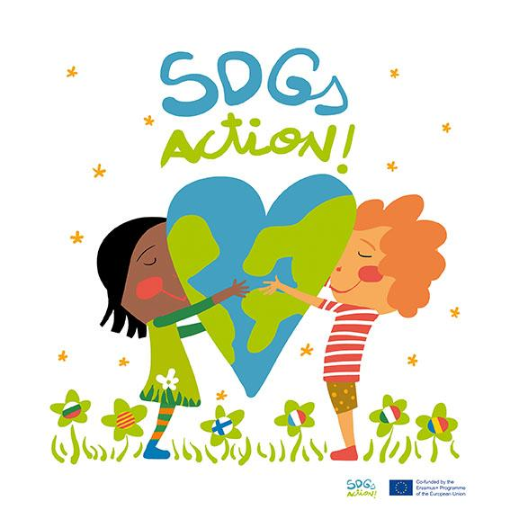

VIRTUAL MOBILITY 19-21 MAY 2021

MAKEY MAKEY WORKSHOP : SDGs in a pizza box!

MATERIAL:

- 9 makey makey boards ( every 2 groups will use 1 makey makey board.Group 1 will use the arrows, and group 2 will use letters: ASW, space)

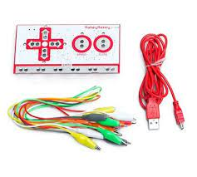
- 18 pizza boxes

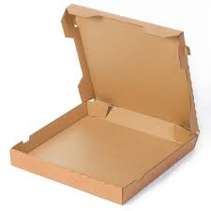

- 17 SDGlogos + SDG general logo printed in the same size as the pizza box surface. Plastify each picture

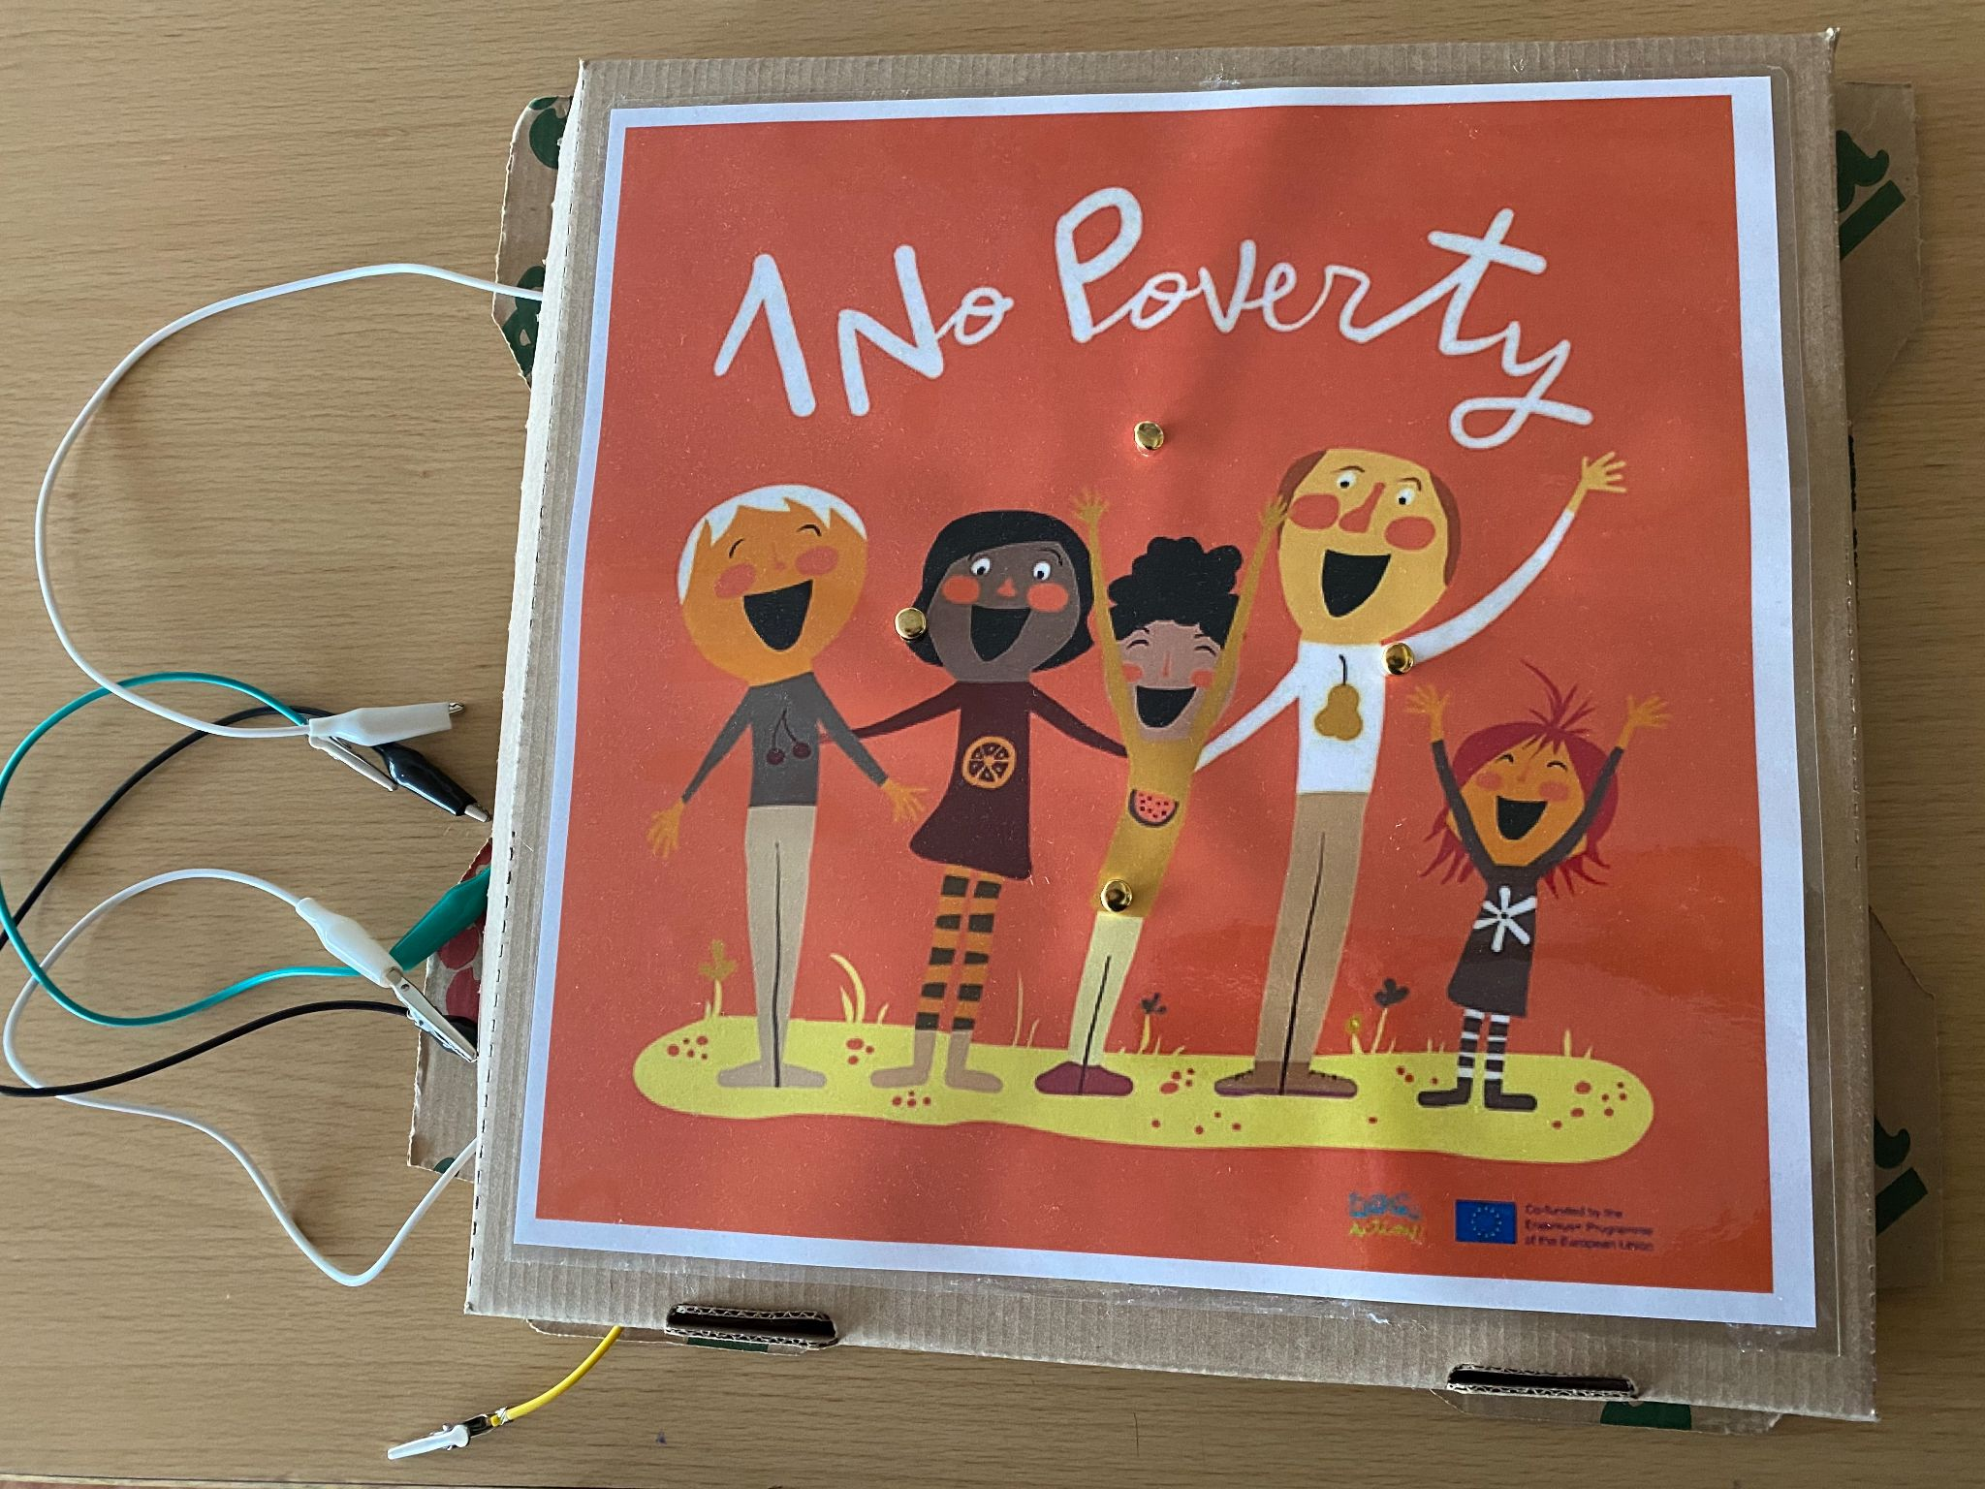

- A box of pins ( 4 pins per pizza box/group)

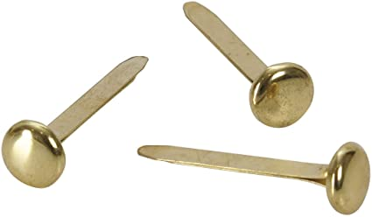

- 1punch per group
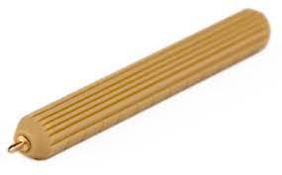

- 1 laptop per group

INSTRUCTIONS:

This workshop will be divided into 4 parts:
- This is the final result that you will get after the makey makey workshop.
- ( Students show a pizza box with the makey makey )

PART 1
- First, choose your favourite SDG
- Then, write 4 instructions like:
1. One question about the SDG logo you have chosen.
2. Say some actions to do related to this SDG.
3. Ask a pair of questions concerning the topic of your SDG

- Look at our example
- Now you have 10 minutes to prepare the 4 instructions.

PART 2
- Now we will share our screen in order to show you how to create the makey makey scratch game
- Follow our steps:
- First of all Log in your scratch account
- Then,click on the makey makey option
- Drag “ when up arrow key pressed”
- Then click the “ sounds” label
- Now it is time to record your instruction on the “ voice” purple icon
- Give each recording a name :
group 1: “ up arrow” or “ down arrow” , “ right arrow”, “ left arrow”.
group 2: ASW, space.

- Then go back to code again and drag the purple sound statement “ start sound…” below “ when up arrow key pressed” statement.
- Select the proper sound for this instruction.
- Repeat the procedure for the rest of the instructions.

PART 3

Now it is time to prepare the pizza box
- First build the box
- Then, stick the logo onto the top of the box, like this.

- After that, use the punch to make 4 holes in the box,one at the top,another one at the bottom, one on the right and one on the left side.
- Put a pin into each hole, like this.
- Connect one coloured cable to each terminal and connect the other side to the makey makey board. Be careful ,you need to connect each sound with the proper makey makey board hole. Example: up arrow makey makey board hole to the up arrow sound.

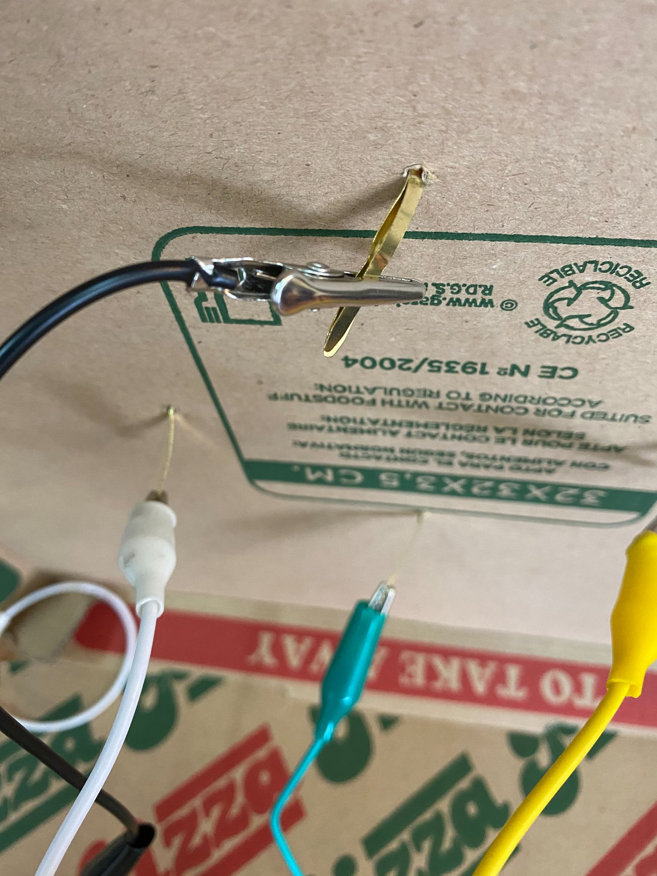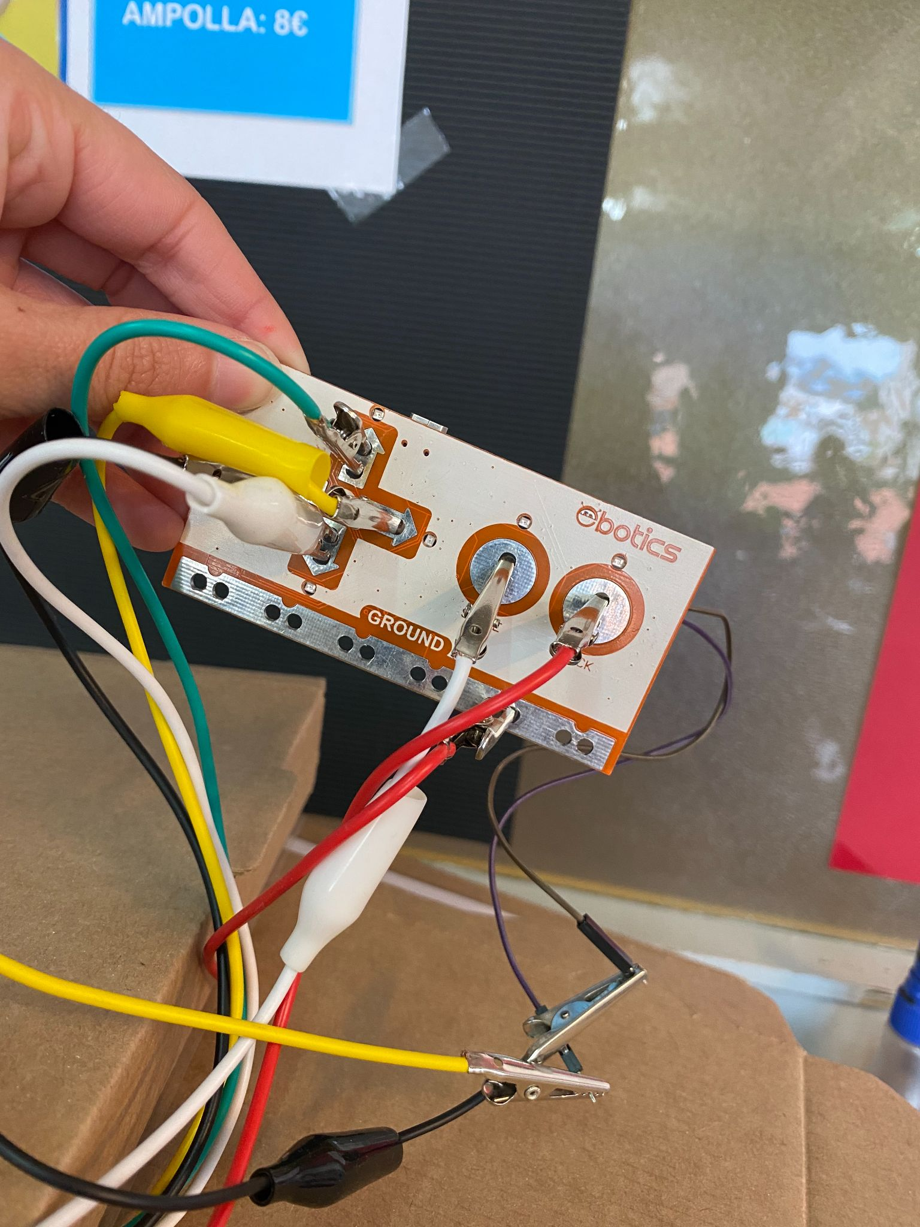

- And finally, connect the earth cable to the makey makey board and hold it with your hand.
- Then, it is time to touch one pin.
- WHAT HAPPENS?

SUGGESTIONS:

You can prepare one pizza box for each SDG, and join them all to play in the yard of the school with other students from other classrooms

