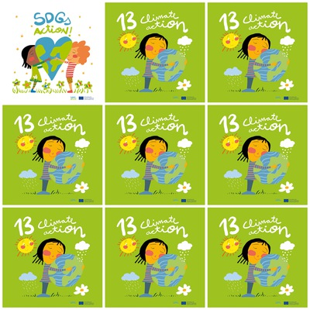

Polar bears, Panda bears, Rhinos, Linxs, Tigers are in danger because of climate change.

.Climate action is the consequence of our bad actions.Climate action is the consequence of our bad actions.

Climate action is about polluting seas, rivers and lakes.

Renewable energy, electric cars, sustainable cities, nearby products will help to stop Climate change

**13. Climate Action**

**1.** Say 3 animals that are in danger of extinction because of climate change.

**2.** What are the consequences of our bad actions?

**3.** Does climate change affect the water?

**4.** Say 3 actions to stop the climate change

**5.** Which color is the T-shirt of the girl?

**6.** What is there in the logo, a sun or a moon?