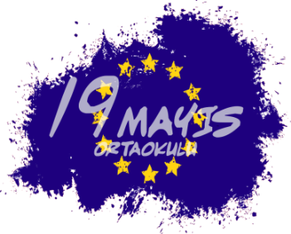
Scan-Think-crEate-drAw-perforM (2019-2021)
2019-1-HU01-KA229-061210_6
WEB 2.0 TOOL
SECTION 1: PRESENTATIONS
*PREZI, POWTOON, KIZOA, EMAZE, POWER POINT, GOOGLE SLAYTLAR, VOKİ

SECTION 2: EVELUATION
*TRICIDER, DOTSTORMING, SURVEY MONKEY, GOOGLE DOCS, KAHOOT, QUIZZIZ

SECTION 3: LOGO WORKS
*LOGOMAKR, CANVA, POSTERMYWALL

SECTION 4: DIGITAL WALLS
LINOIT, PADLET

SECTION 5: CARTOON STRIPS/E-BOOK
*PIXTON, STORYBIRD,STORYJUMPER,BOOK CREATOR

DISSEMINATION
* EMAZE

