Definitions:
https://www.educima.com/wordsearch/showWord/wordsearch.php
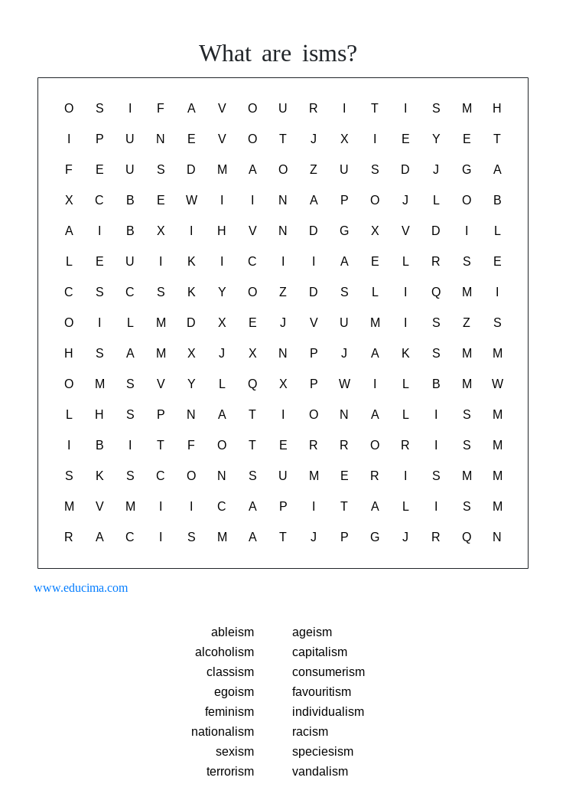

- discrimination against people because of their skin colour.

- discrimination to the conditions or attitudes that promote stereotypes established in sexual differences.

- When a person doesn’t want to work in groups.

- Accumulation of goods and services considered non-essential.

- Discrimination against disabled people.

- The action in which a person acts thinking on himself.

- Show more attention or love to a person without a reason, that deserves less or the same that others.

- The action of destroying and breaking a private property.

- A serious psychological illness that a person has, when he can’t stop drinking alcohol.

- An economic system in which private individuals or businesses own capital goods. The production of goods and services is based on supply and demand in the general market.

- Devotion and loyalty to one's own nation, patriotism.

- Succession of violence actions with the objective of causing terror.

- Discrimination against groups because of their age.

- The advocacy of women’s rights on the ground of the equality of the sexes.

- The discrimination of human superiority to the exploitation of animals.

- Discriminatios against people that belong to a particular social class.

