Erasmus Trip to Finland
30th November – 6th December 2019
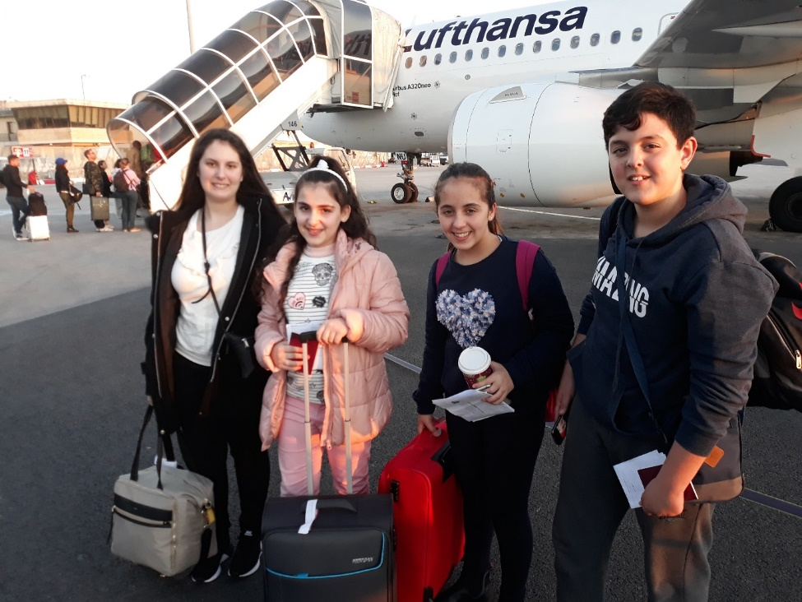
At the beginning of November, our teachers Mr. Robert Vella and Ms. Joanne Azzopardi told us about the ERASMUS midday break club and invited us to attend. Those who attended were given exciting news – four of us were going to be given the wonderful opportunity of going abroad to Finland to participate in an Erasmus Project. It was thanks to that meeting that on the 30th of November 2019, Tiffany Galea, Sebastian Portelli, Maria Scerri and I, Haley Xuereb boarded a plane to Finland. We caught 2 planes, one from Malta to Frankfurt and then from Frankfurt to Helsinki, the capital of Finland. We were going to stay with host families, a student per family.
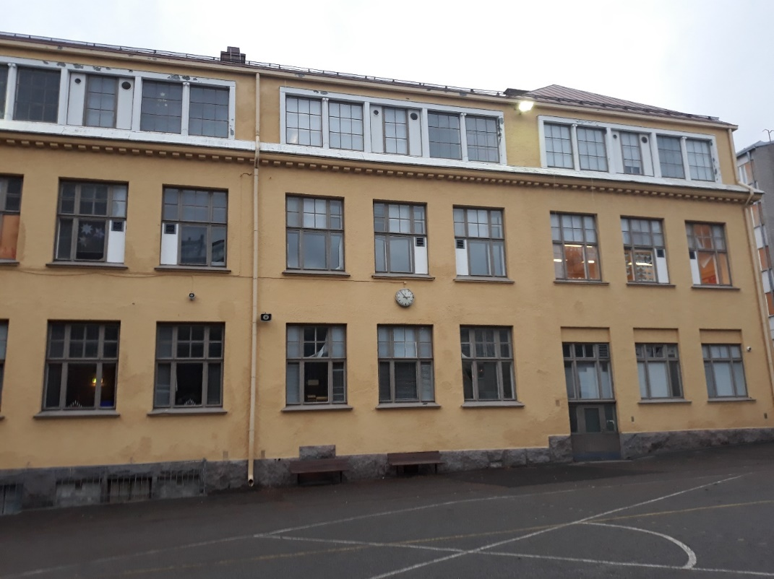
We had different activities every day. On Sunday we went to a forest and to a nature museum together with the other exchange students. There were students from Turkey, Iceland, England, Denmark and Finland. On schooldays, we went to the Tehtaankadun primary school. There we had the opportunity to attend lessons with the Finnish students. The Finnish education system is different from the Maltese one. In Finland, children start school at the age of 6 and are given little or no homework. They have 15-minute breaks between every two lessons and have a very different curriculum. On Monday the students gave a presentation about their countries in front of all the pupils. We found the presentations very interesting. We attended various outings, but the outing that I enjoyed most was when we went to the Korkeasaari Zoo, which is located on one of the many small islands that there are in Helsinki. There we saw bears, leopards, yaks, chimpanzees, camels and many more animals. On Thursday we attended the Independence Day Celebration which was held at the school. We enjoyed the traditional music, singing and dancing which was performed live by the Finnish pupils in front of us. We also had a session of ‘Brian Breaks’ which are short fun games intended to give the mind a well-deserved rest.
Our host families were very hospitable, and we felt at home with them. We went to a Christmas Market, a shopping complex and to an island to name a few.
All good things unfortunately come to an end. However, this trip left us with precious memories to cherish for years to come. We also broadened our life experiences and learned much about diversity and other cultures. It was truly a trip to remember!

