A Trip To Finland
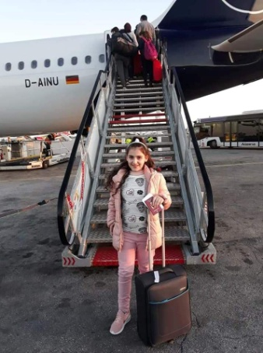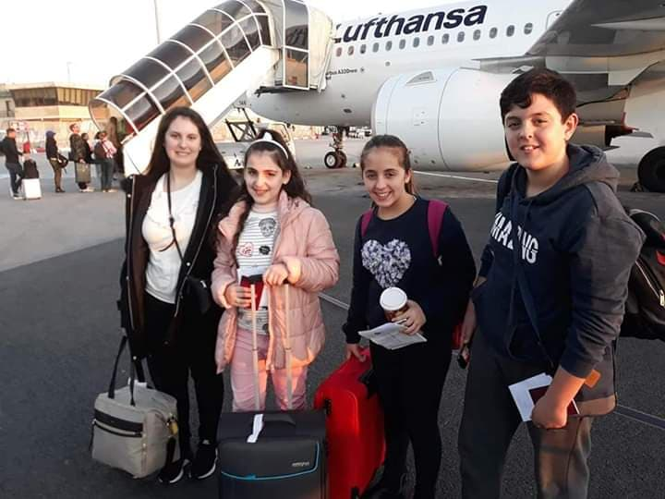
On my way to Finland
We took the ferry in the afternoon and went straight to the airport. First we went to Frankfurt, Germany. Then we went to Helsinki, Finland. A van was waiting for us in front of the airport. It took us near the host families’ houses.

Sunday
We arrived there at around 2 am in the morning while everyone was sleeping. My host family was waiting for me. We all went to sleep because it was a very long trip to arrive there. I woke up we went to scool because there was a bake sale. I won a selfie stick from the spin the wheel. At around 9am we went hiking in the woods with Jenny’s class.

Monday
I woke up and went to school. We had a welcoming party where they gave us traditional stuff. When we went back home, we went to the store. Later we went out with Haley and Maria. We went to one of the largest libraries in Helsinki, and then we went to eat at Burger King.

Tuesday
I went to school and when I was done, I went home to start preparing to gome to Haley’s house. We arrived at Haley’s house and we watched a film called Christmas Chronicles. Then we played a game called African Star and I really liked it. We ate some gingerbreads while we were playing. Haley and I went to her room to talk about what we had done while we weren’t talking to eachother

Wednesday
We went to school and presented our powerpoints. I talked about San Lawrenz and Nadur. After school Jenny and I went out with Haley and her host family. We ate at Hesburger and then we went to the Chritmas Market and the Chrismas Window. Then we went on the tram to go back home.
Thursday
After school, Haley and I went to one of the largest shopping malls in Finland. I bought a lot of clothes. After that, we went in a train to get to Mc Donalds. When we went back home, I started packing up my things since it was my last day.
Friday
I left at around 3 am to get to the airport. First we went to Munich, Germany. Then we went to Frankfurt, Germany. And finally we arrived back in Malta. We went on the ferry and in a few minutes we were back at our home sweet home.

I really had fun and I will definitely cherish it my whole life.

