My Trip To Finland
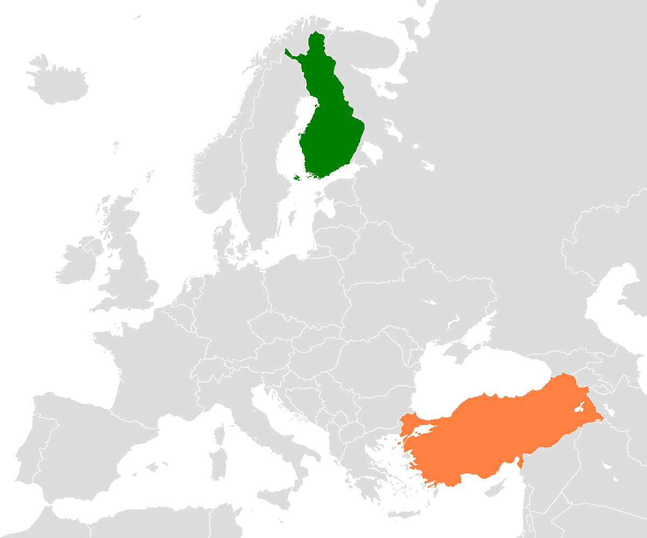
First, I prepared for my flight one day before and I met with my teachers to go to the airport.
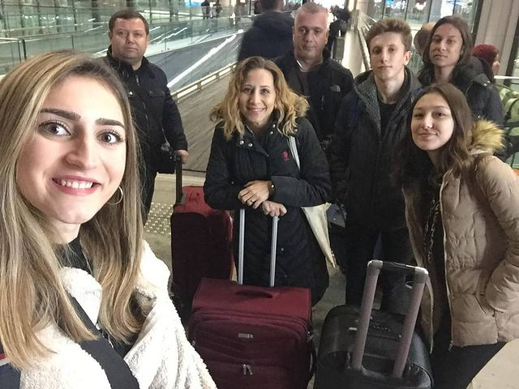
I boarded the plane in İstanbul and arrived at the Helsinki airport.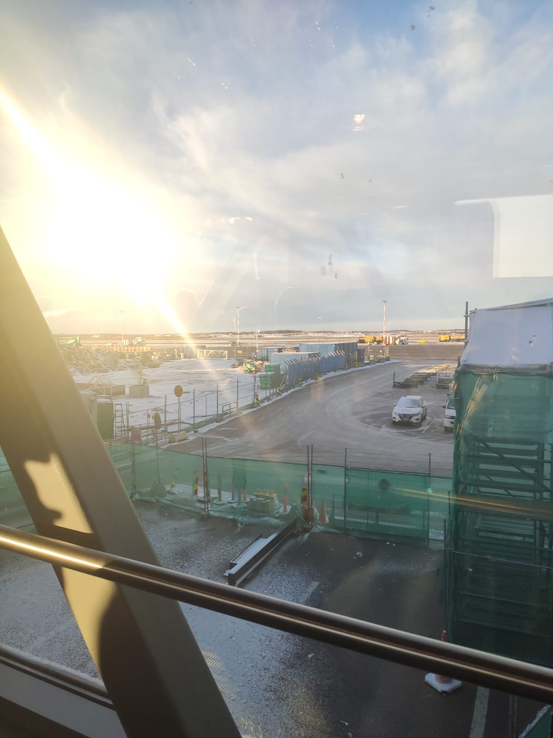

At airport, I met with our host family.
First day our host family showed us around and we went to watch Robin’s football match.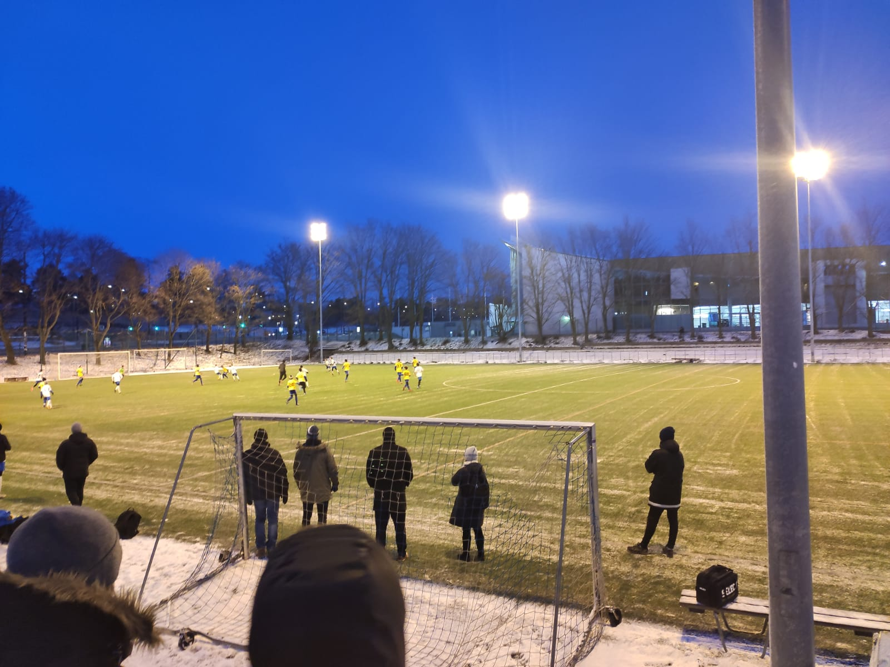

Second day, we went to school and attended classes. Then we went to forest trip. 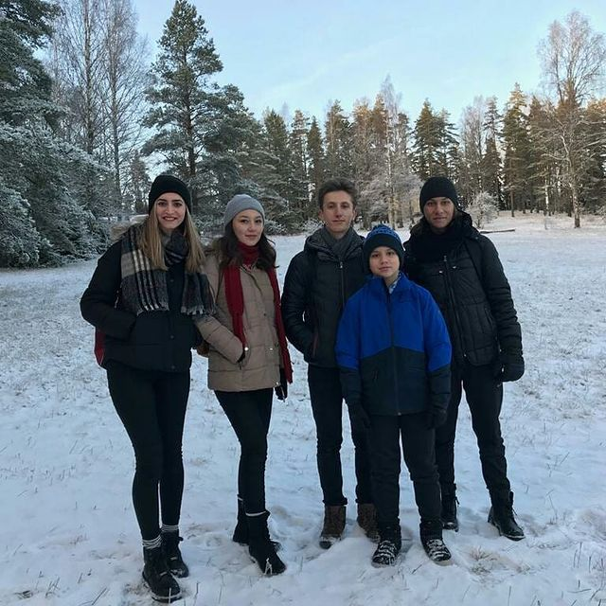
We also had lunch and visited Finnish Nature Centre.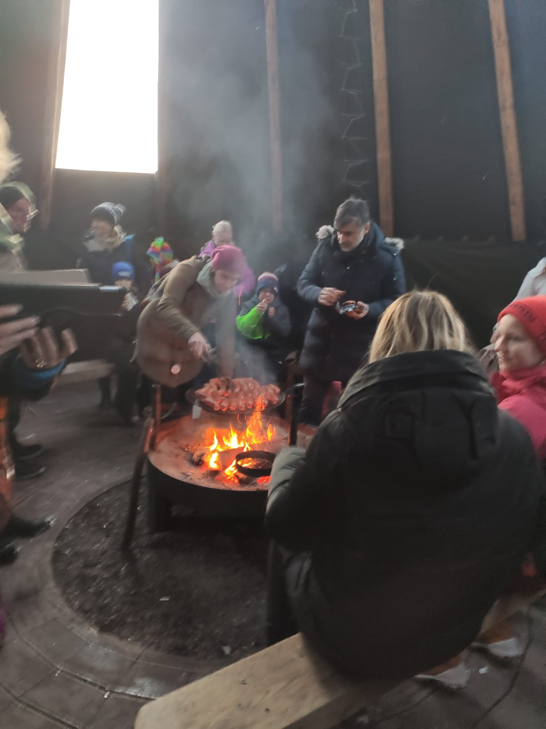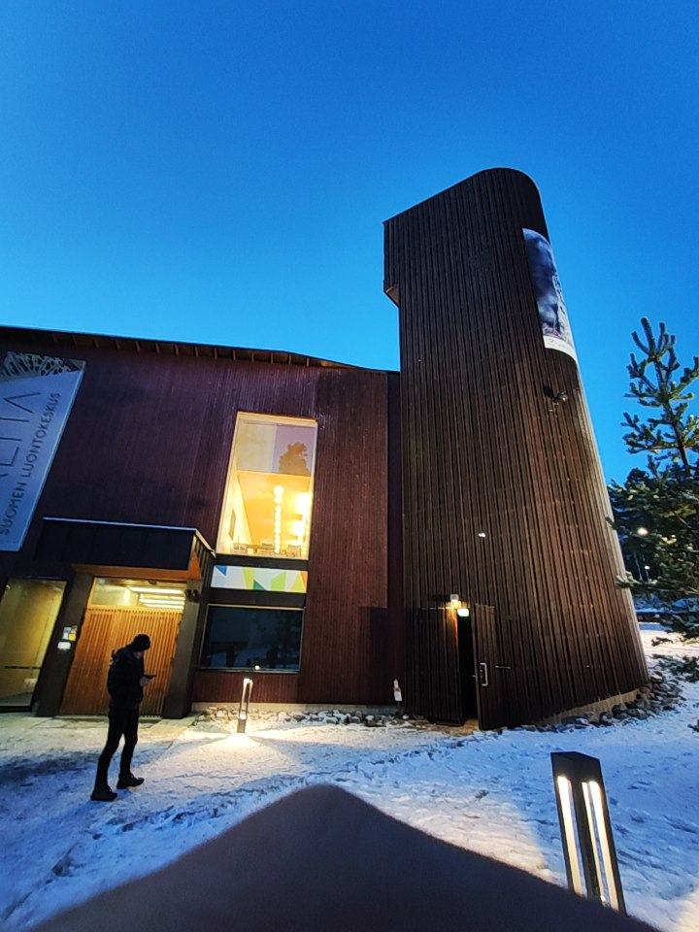

Third day we showed our presentation at school and after that our host family’s father Mr. Irfan showed us around.
We wandered in Helsinki, visited library and churches.
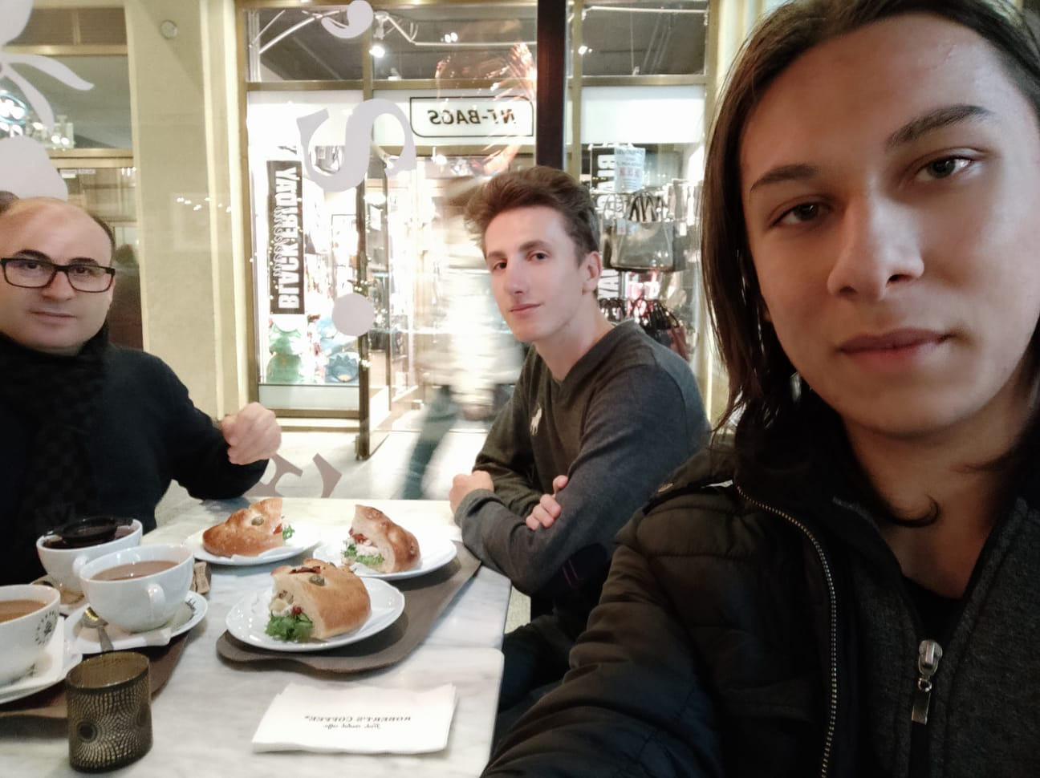
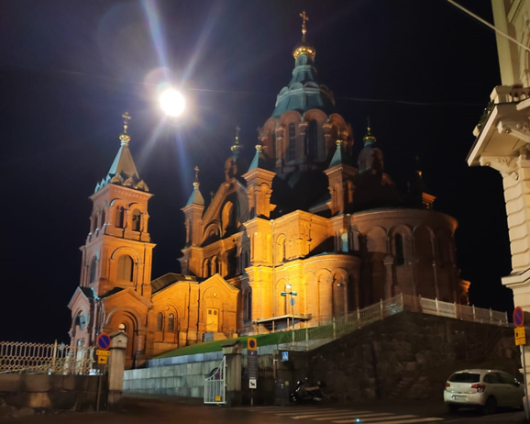
Fourth day I attended classes at school. 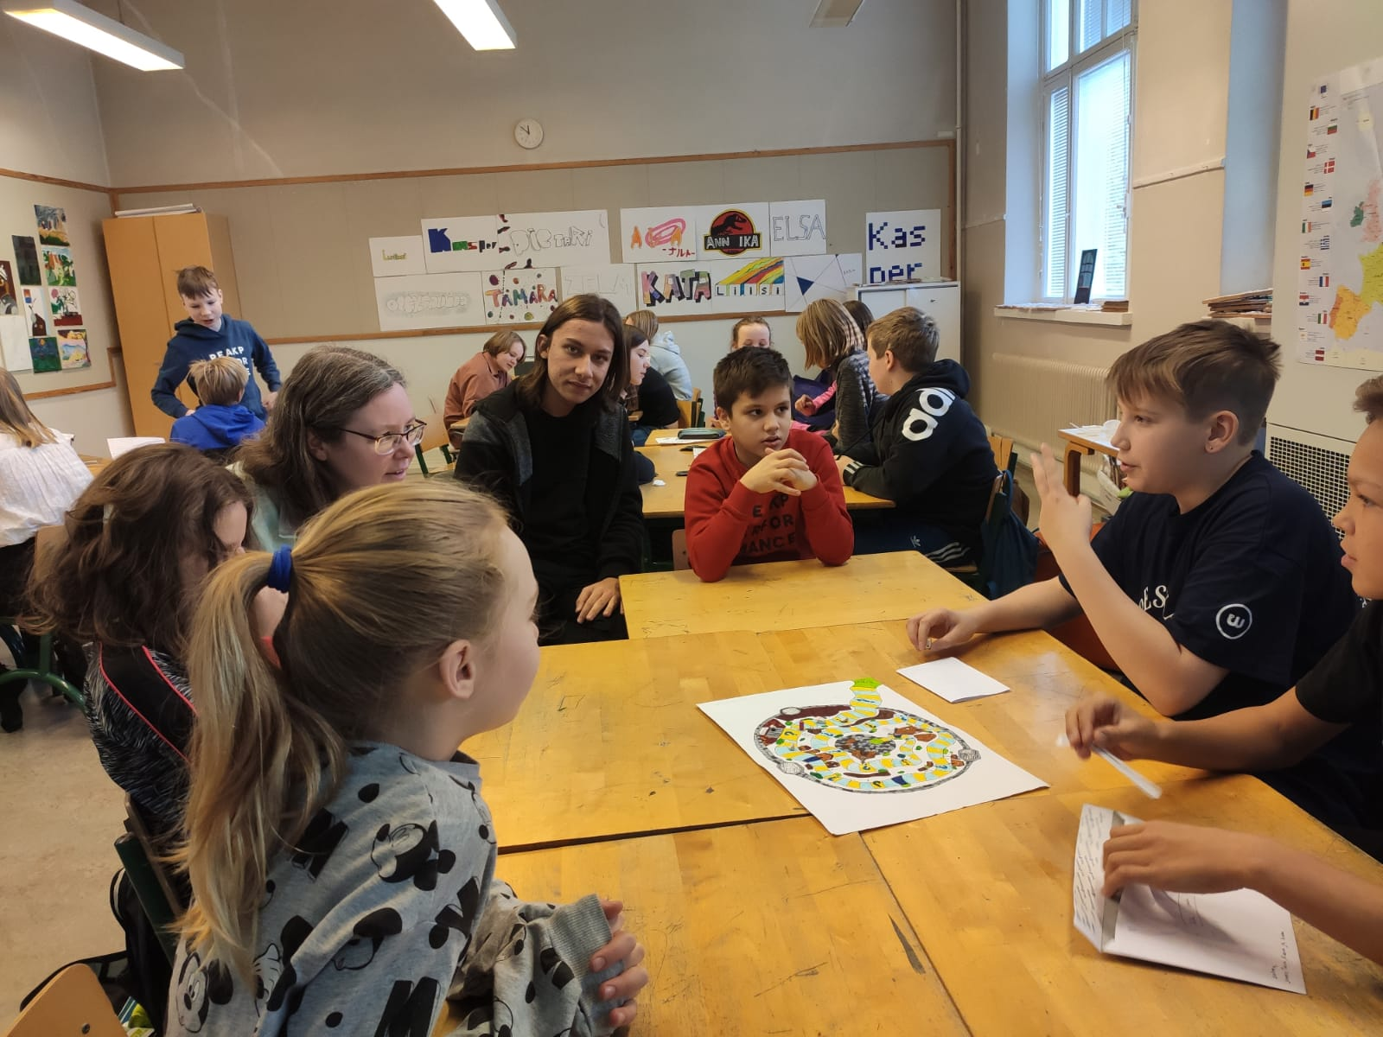
After school, we went to watch ice hockey at stadium with our host family.
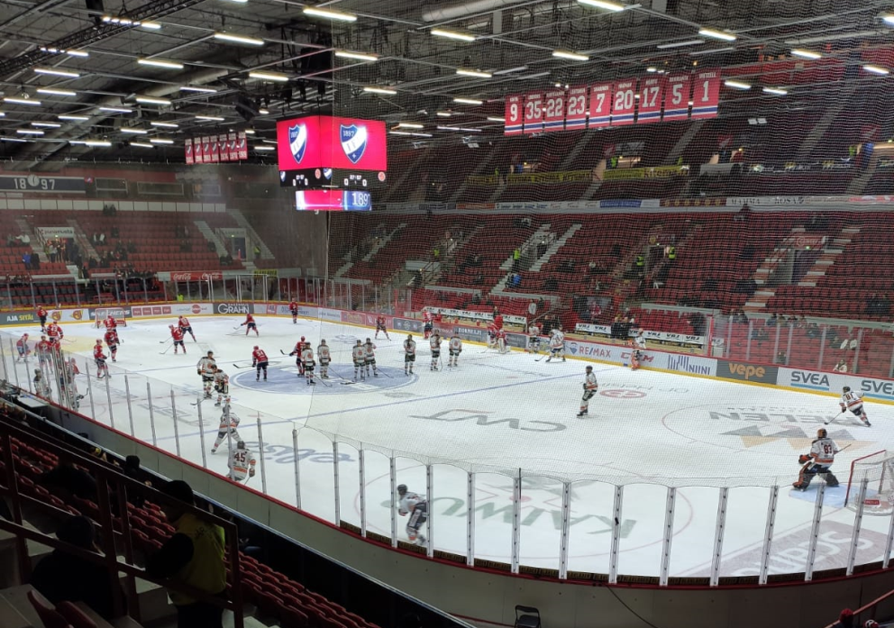
Fifth day I went to zoo with our class and had lunch there. after that we came back to school and attended classes.
At night we visited shops at Helsinki.

Sixth day I attended my final class in Finland
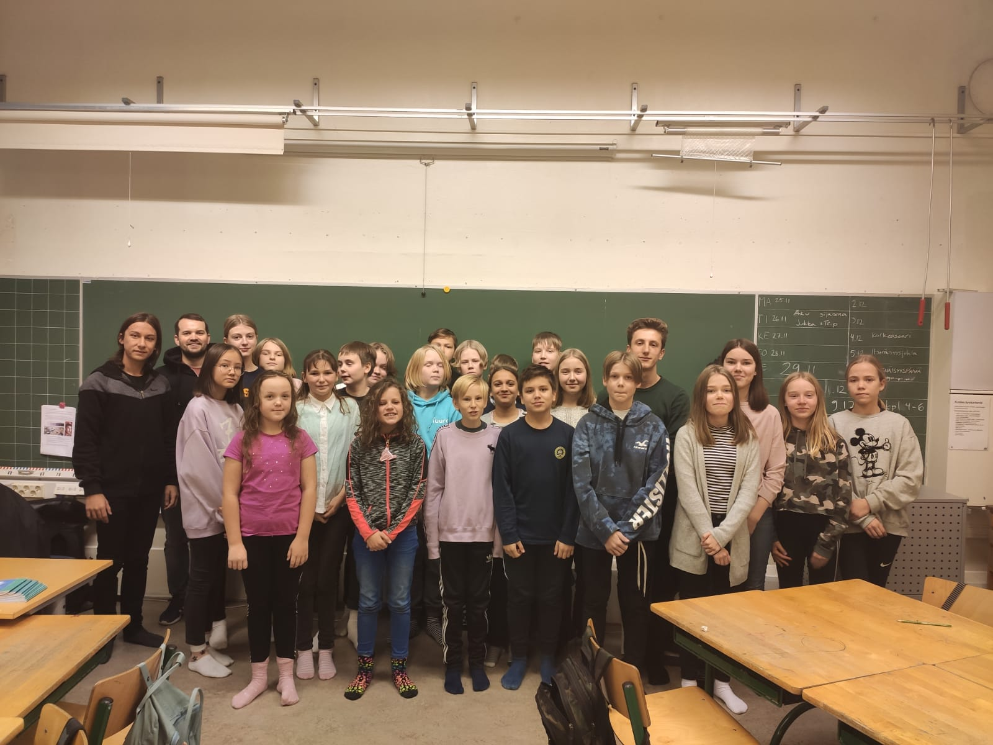

and after school we visited churches and shops.
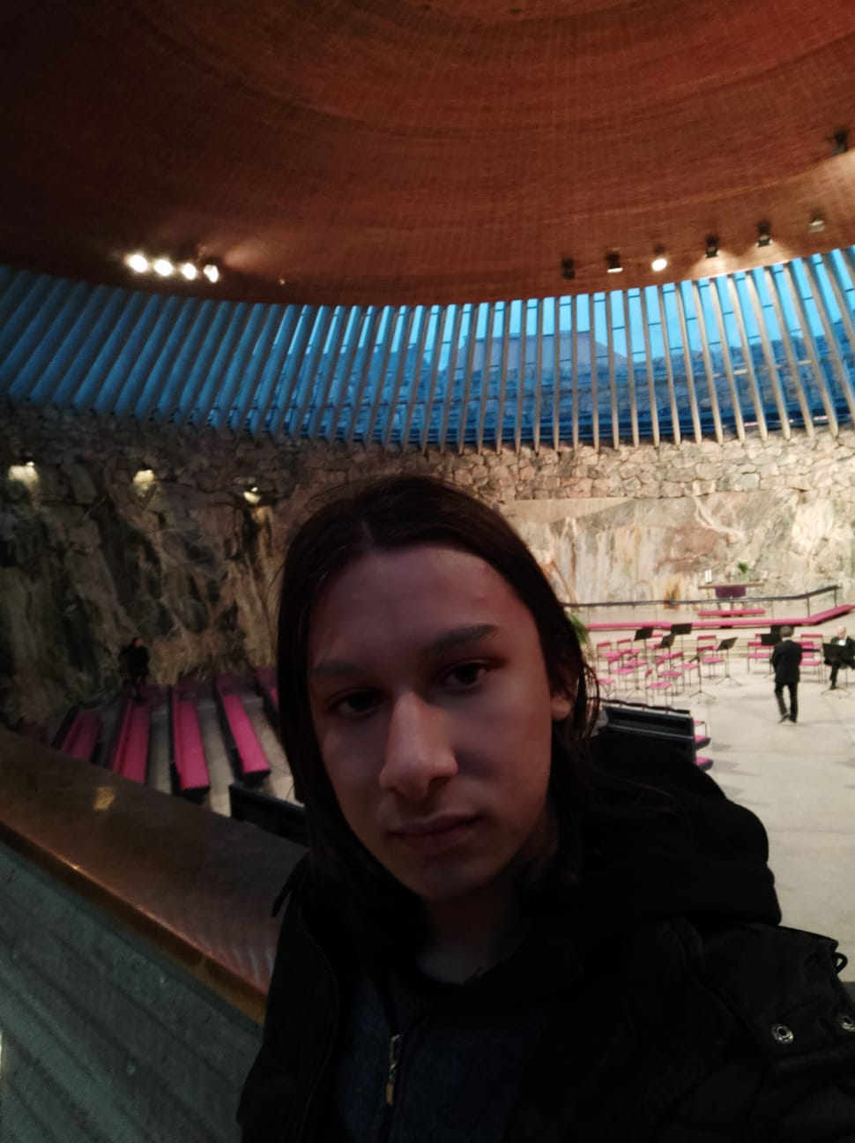

At night we went to ice skating with our host family
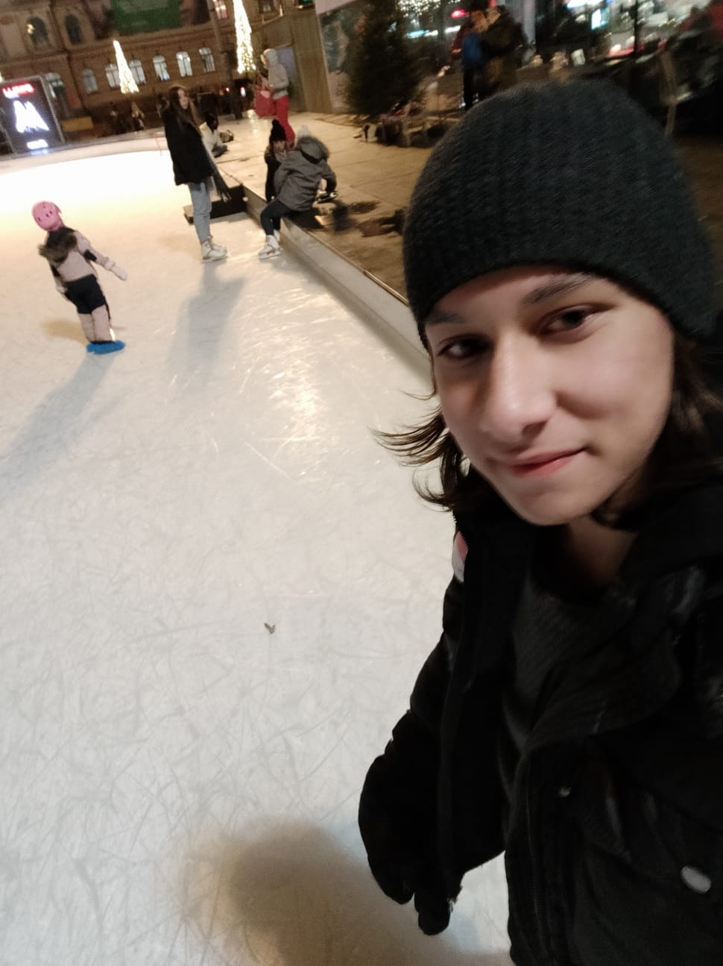
And we had our last dinner with our host family.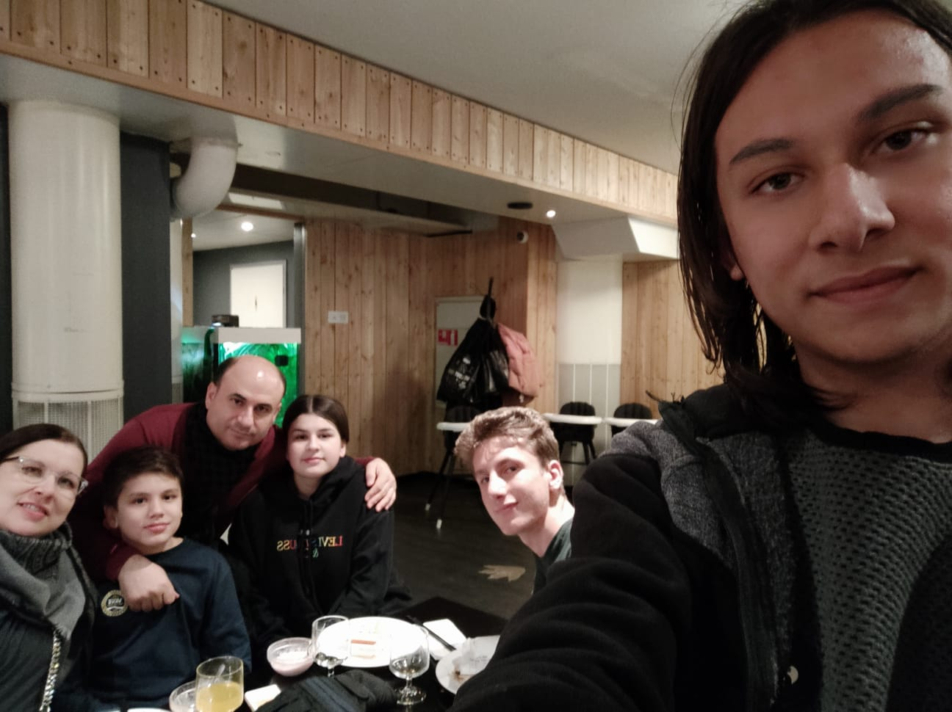
Seventh day in the morning, I came back to Turkey.

Thanks a lot to my teacher and my host family,
I had a great time in finland.

Alper Özel

