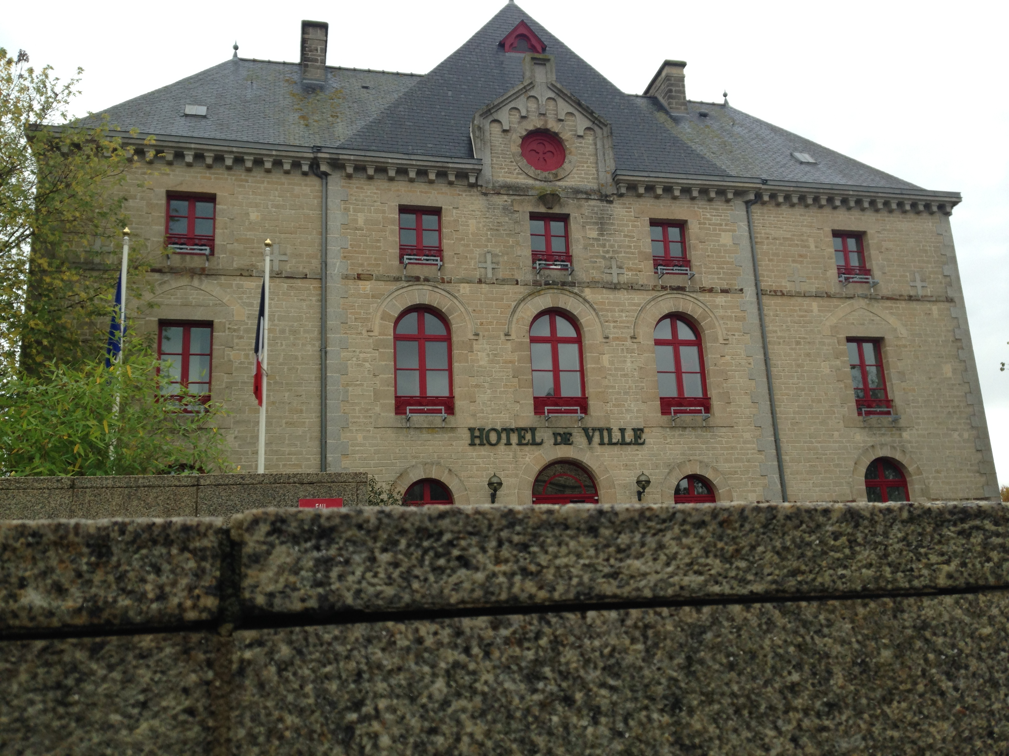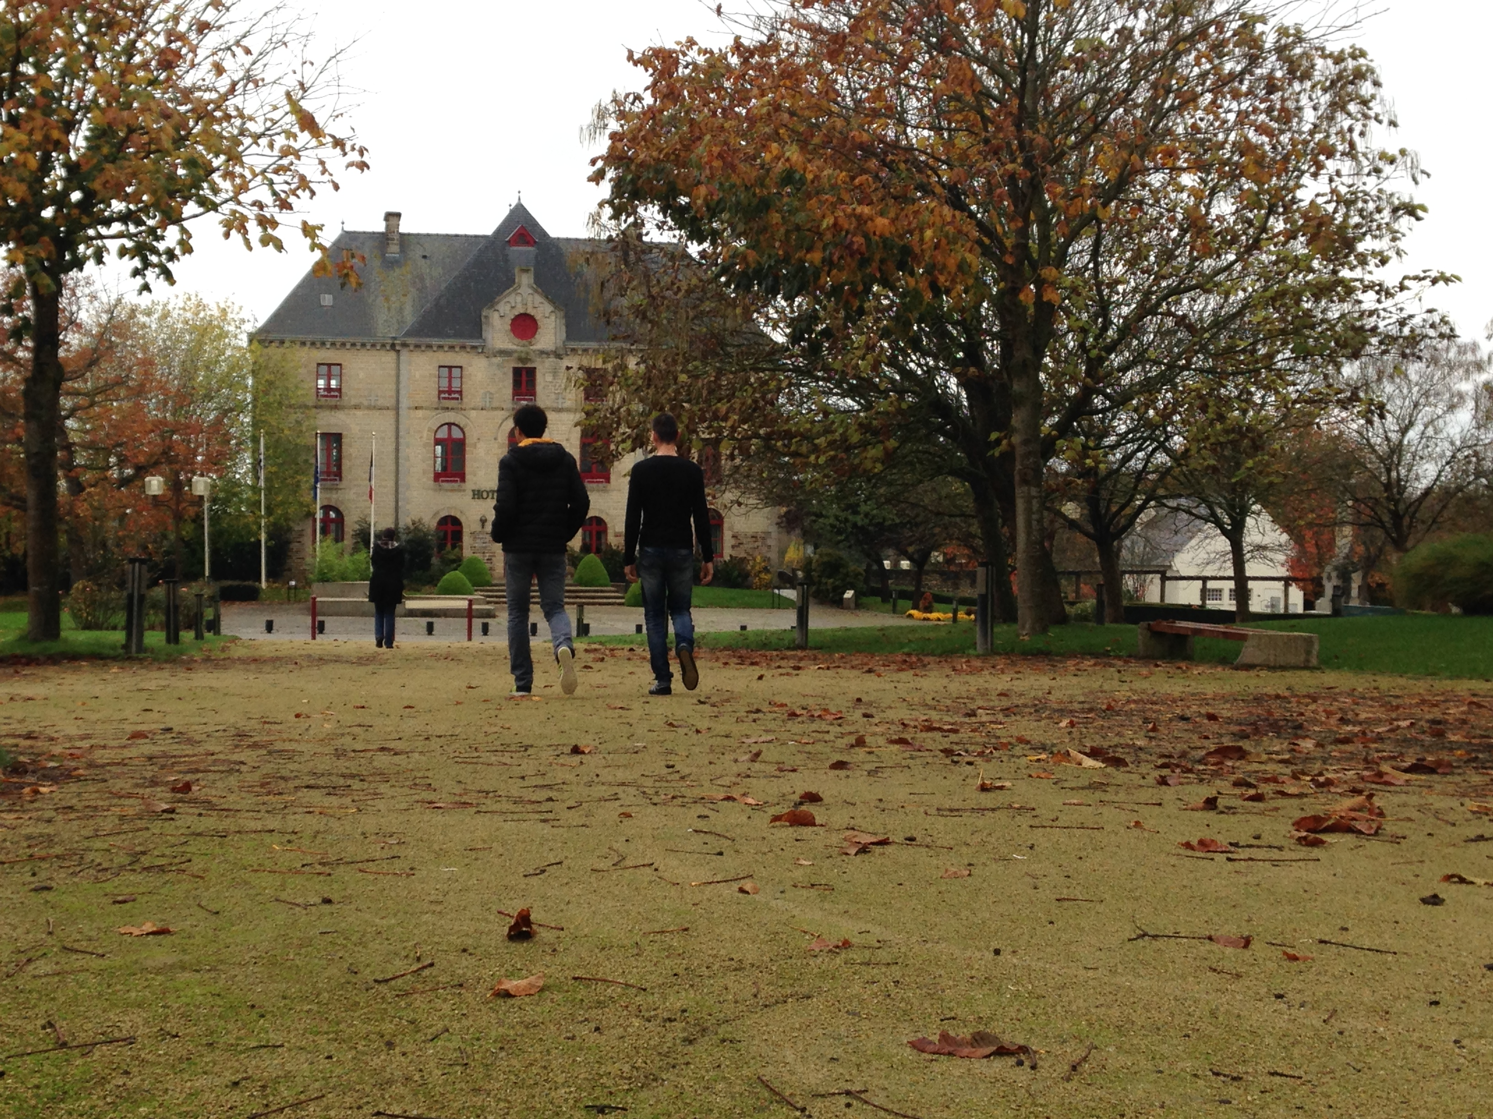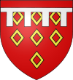
Montauban de Bretagne

Montauban de Bretagne is a town in the West of France, in Britany. There is 4500 in habitants in the town, its a little town. There are 6 schools, One Supermarcket, one cinema, one church.
There are a shops (clothes shop, supermarket, shoes shop…)
Montauban de Bretagne was built in the VIII century and its name was
Saint Eloi
We are 30km west of Rennes. And we are 50km of St Malo on the Northern Coast.
In Montauban de Bretagne there are farms (wheat), we have a Cheese Factory.

