My work placement.

I did my work placement from 19 january to 6 february.

I was in Armor Inox in industrial area in Mauron.

I began at 8:00 and i finished at 17:00.

I had to do wiring or cable laying, i checked and repaired electric systems and i changed breakers.
We used screwdrivers, ring wrenches, electrics drills, hammers.
For our safety we had to wear safety shoes.
There was a good atmosphere in the compagny and they were nice with me.
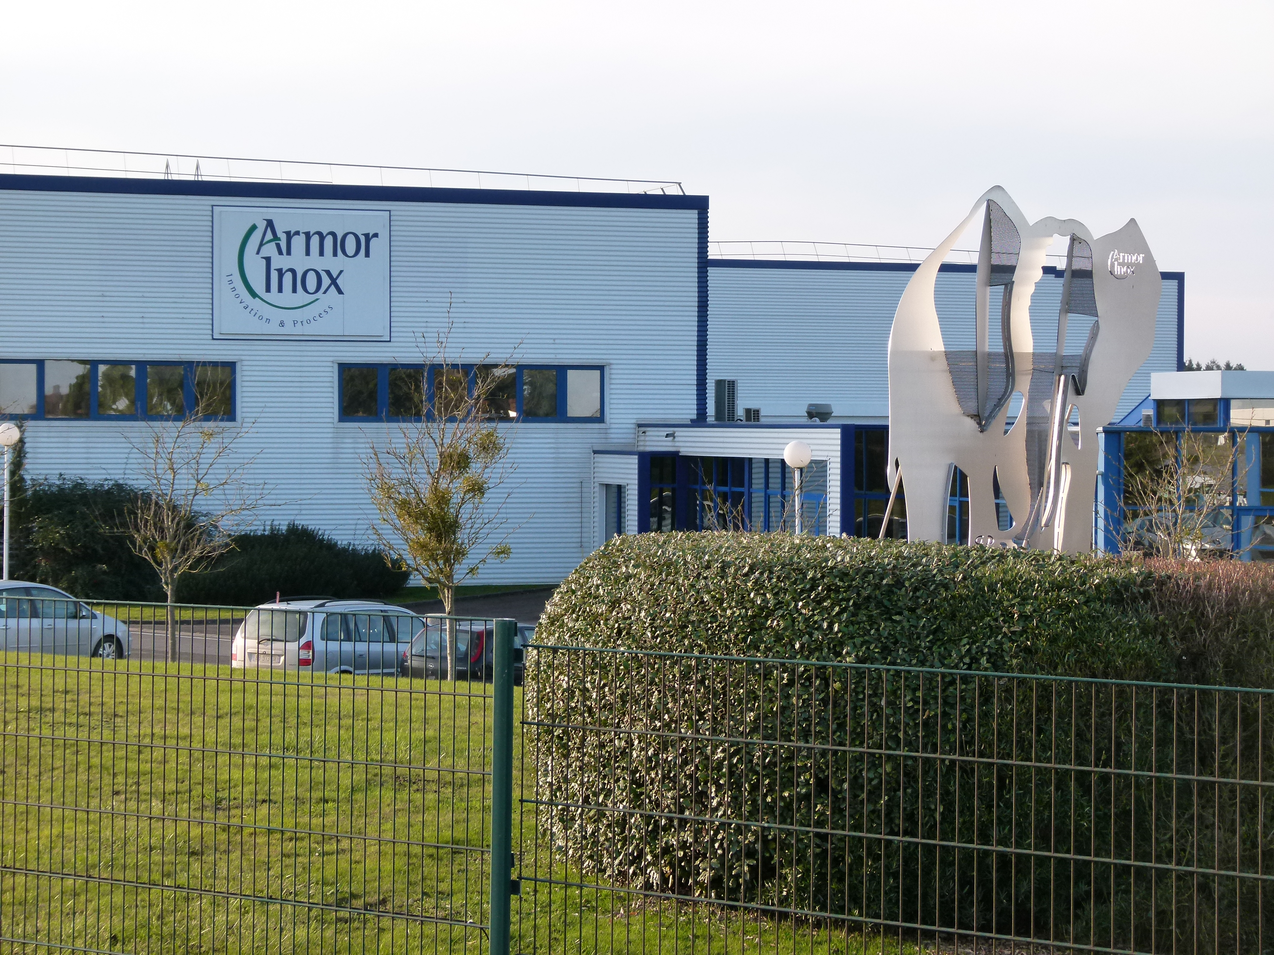
I liked my work placement very mutch because i was a good practice.

