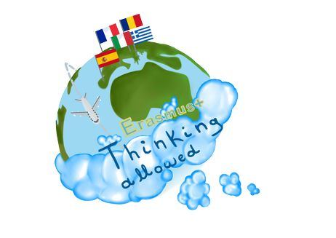



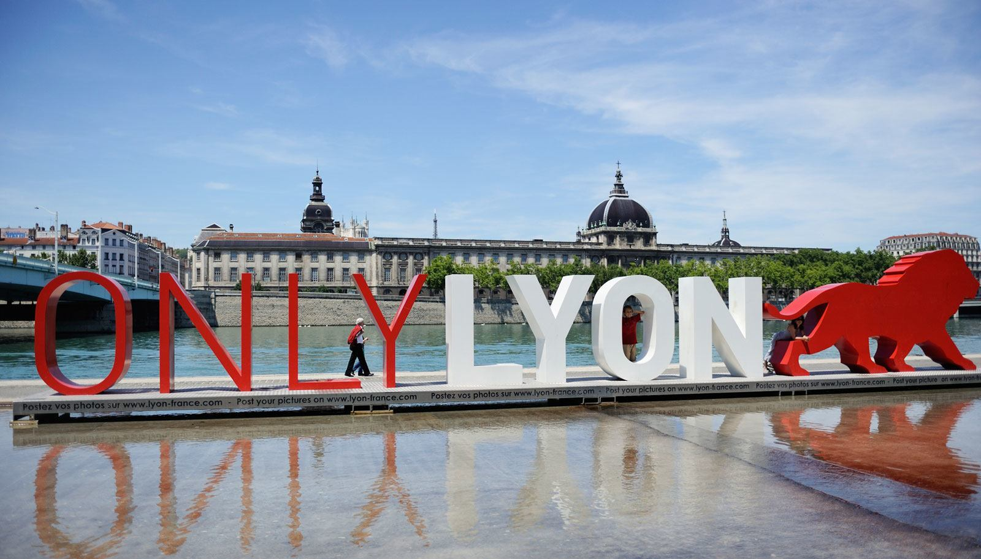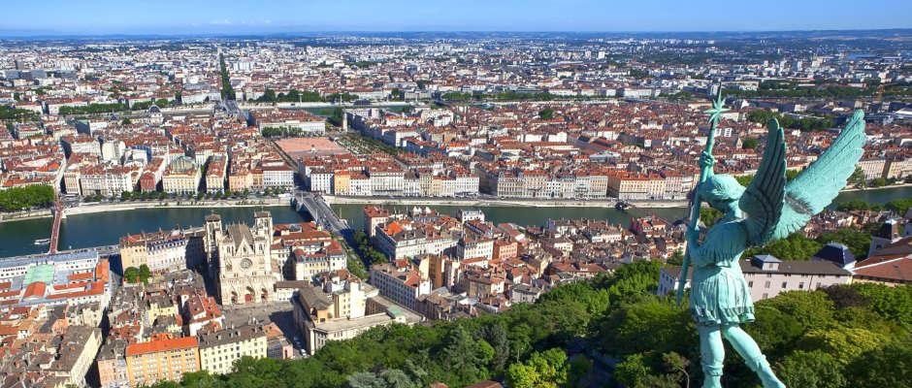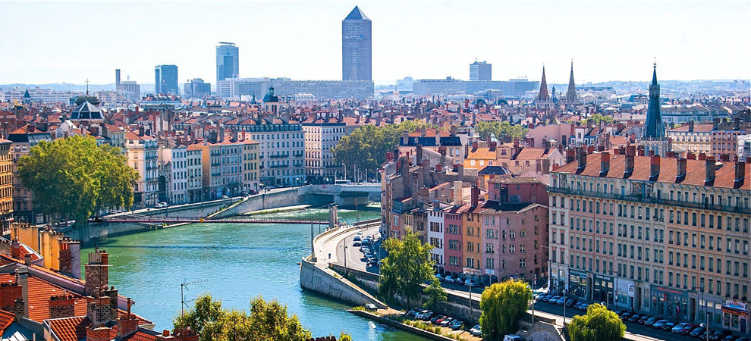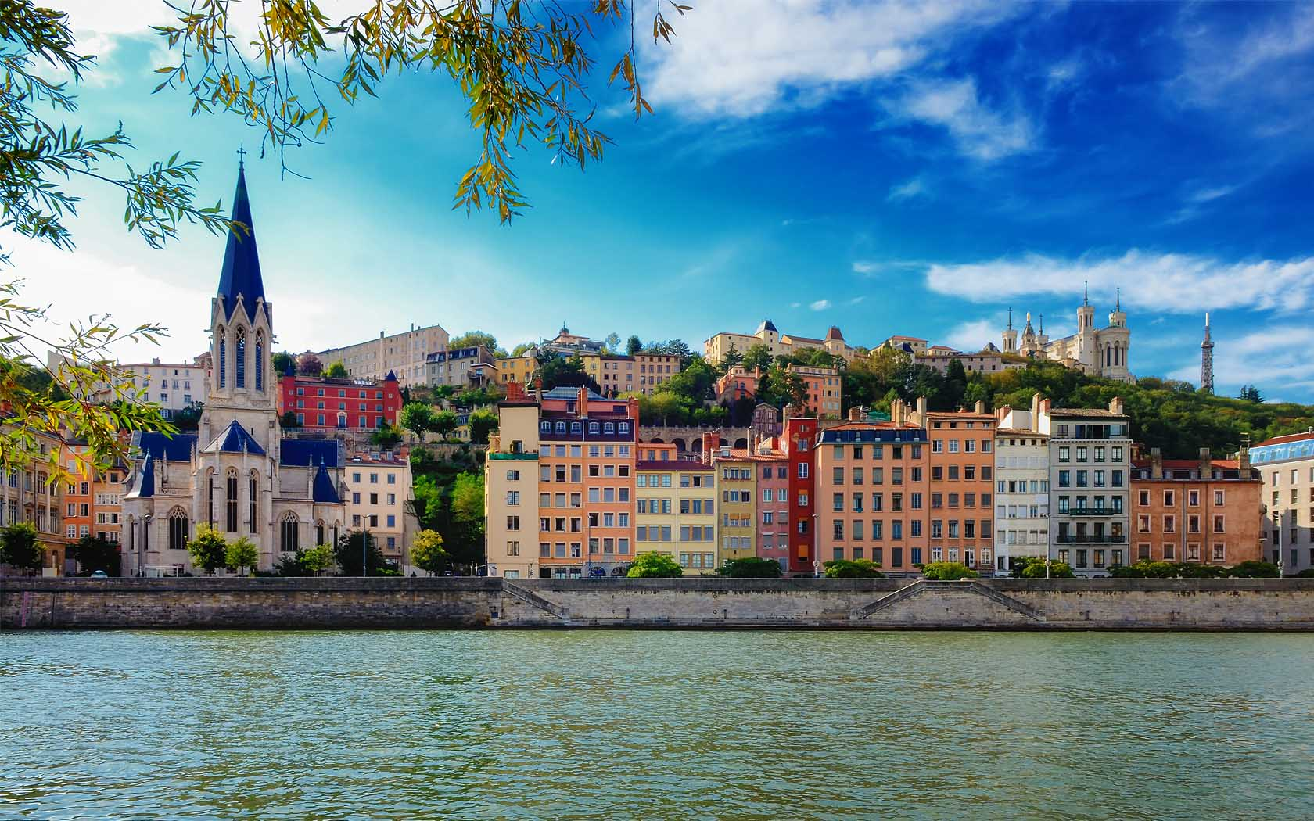

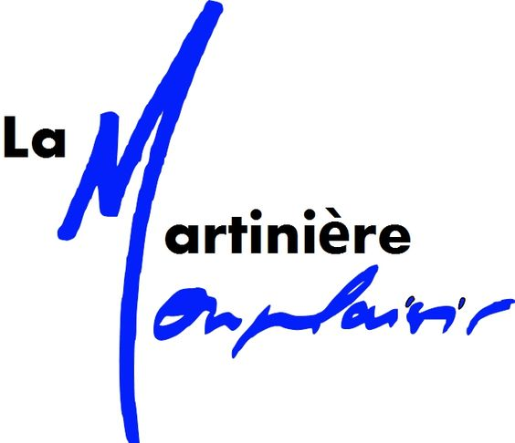
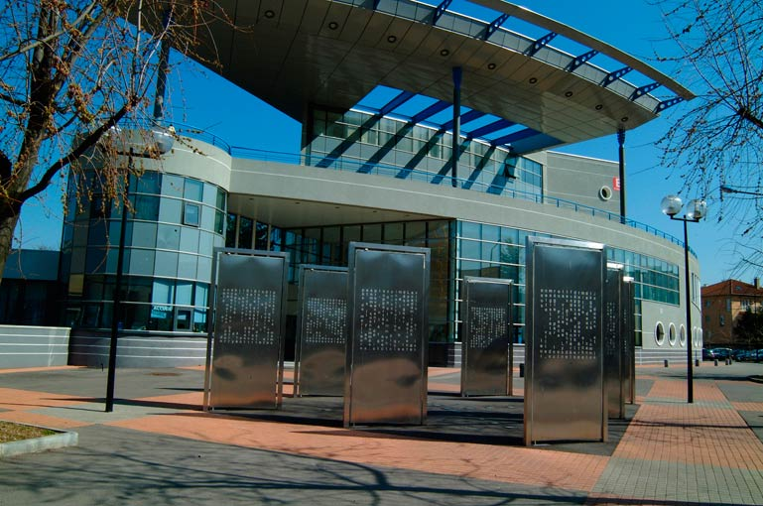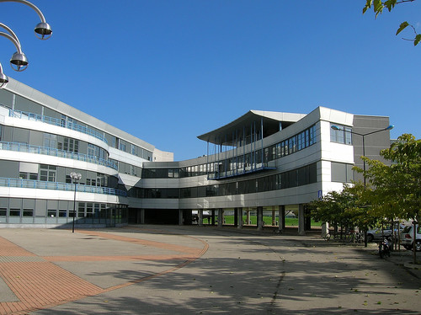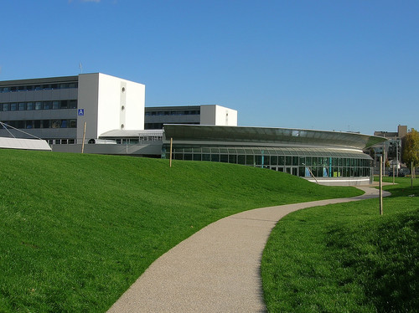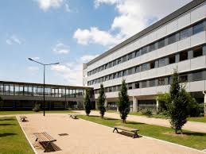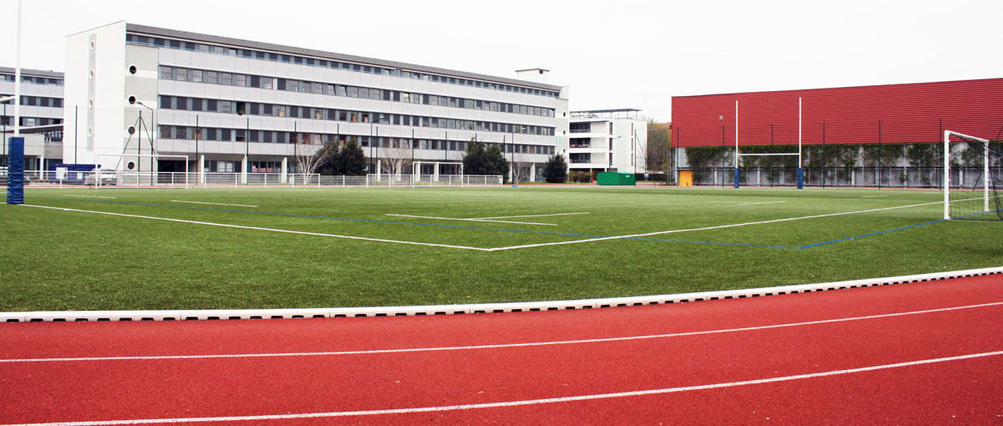

Tuesday May 1st  Wednesday May 2nd | Thursday  May 3rd | Friday  May 4th | Saturday  May 5th | Sunday  May 6th | Monday  May 7th | Tuesday  May 8th
Arrivals  St Exupéry airport    Train stations :  Lyon Perrache  Lyon Part Dieu  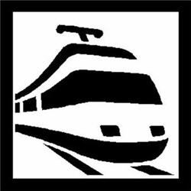  Bus Station  Lyon-Perrache  Students pick up in Stations  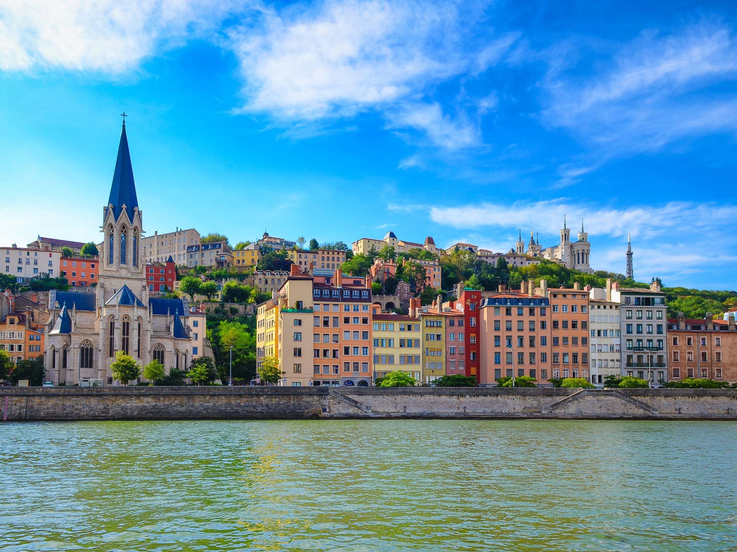  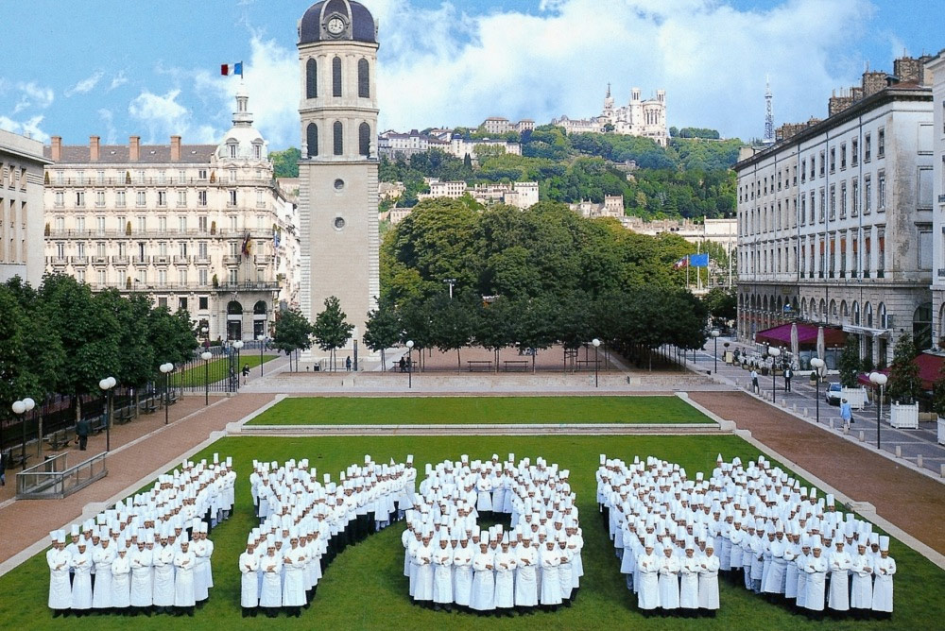 | 8:15  Welcome party    10.00  Young Europeans Association  Games around Europe and European Citizens' Rights | 7.45 am  In class with partners  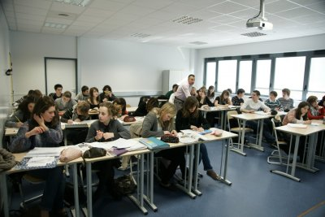 | 9h  Association Human League  Conference / debate    Meeting young migrants  Sports event | Family time | 8.30 Work session  Creating role plays  International teams    4 different rooms    11h 12h30 Role plays +  MUN simulation | Departure    Parents take students to Lyon airport or Train station :
 | 12:30 canteen  | 11:45 / 12:30 canteen | Picnic  |  | 01:00 PM Restaurant in town
 | 01:30 PM Visit of "la Martinière Monplaisir"  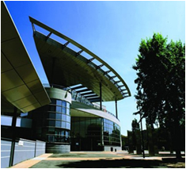  02:00 – 04:30 PM  Presentations on migrants / refugees :  Situation in the different countries  How it is addressed by the media.  Testimonies of migrants (school students)  5.30 Back in families | 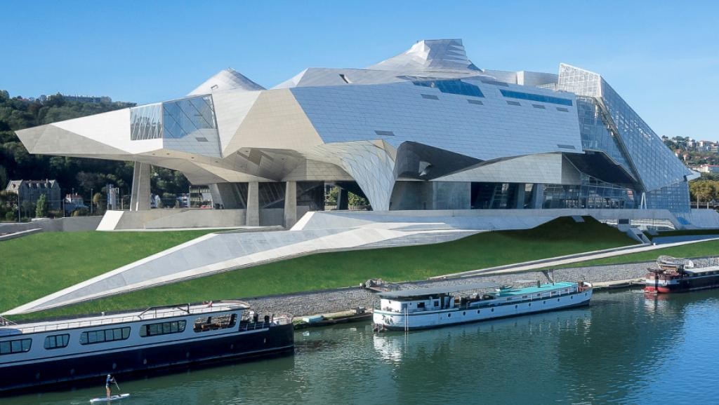  3.00 pm  Lyon Confluence Museum  Guided Tour "Sociétés"  3.00-4.30  Free time in Confluence Modern area of Lyon  5.30 Back in families  Restaurant in town (teachers) | Students in families  Dinner out (teachers)  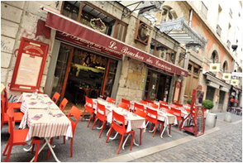 | Family time  Free time for teachers | Fourvière Basilica  Roman Theaters  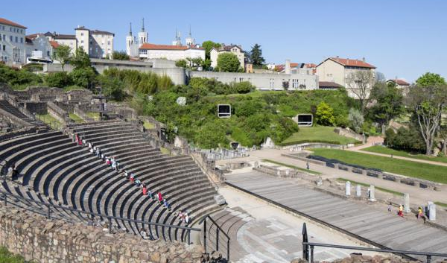  Old Lyon  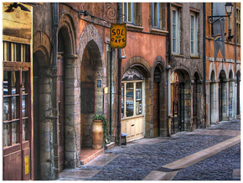  Reading of the poems  Miniature and cinema Museum ?  Free time in old Lyon

