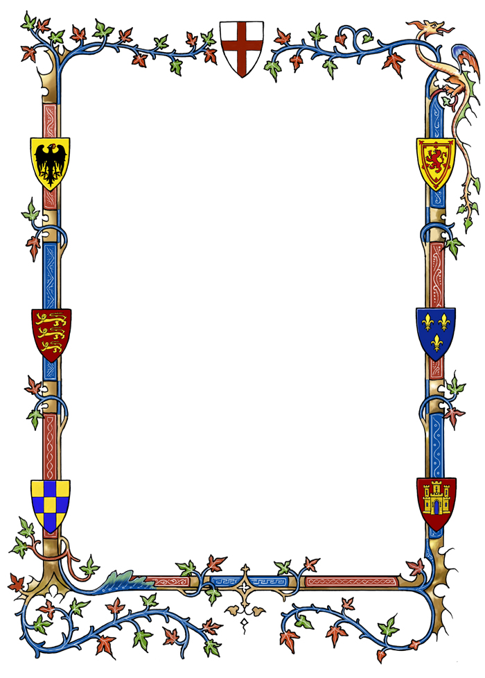

“The pig dragon”

Once upon a time, in a beautiful old castle, deep in the forest, lived a good-hearted king and his queen. They lived happily and ruled their kingdom wisely.
Knights, dames, servants, soldiers, citizens and Balin the Wizard, lived in the castle too. But, except for the soldiers there were also two dragons that were guarding this castle.
One day king James and the beautiful queen Augusta decided to go for a walk with their carriage and their guards, in the nearby river in the woods. As they were resting all of a sudden they were attacked by some bandits, whose leader was a wicked witch, Morgana. After a tremendous battle, the wicked Morgana with her spells and the bandits managed to kidnap the poor queen.
A few days later, a message on an arrow is found on the tall walls of the castle. The message was sent by the witch, asking the trade of the queen with one of the king’s dragons.

The wise king James decided to ask for the wizard’s help. The Great Balin came up with the most brilliant idea! To transform a common pig into a dragon and sent it to the trade. And after the spell was gone the evil witch would be far away.
The big day arrived and the meeting with the witch was given at a clearing deep in the woods. Queen Augusta was locked in carriage with bars and the transformed pig was chained to his foot. When the trade was over the queen returned back to her king and the “dragon”-pig by the witch.
Everyone left satisfied. The wise king James and his queen Augusta went back to their kingdom and the wicked witch Morgana back to her gloomy palace. When she realized the king’s treachery she swore to stay away from his kingdom.
The two dragons stayed vigilant gatekeepers of the castle forever.
And they lived happily ever after.
The end

Students 3rd Class: Antonia, Nikolas, Aggeliki, Tasos, Dionysis V., Emmanuela, Dionysis M., Sophia, Dionysis P., Giorgos, Niki
Teacher: Ioanna Gkiza

