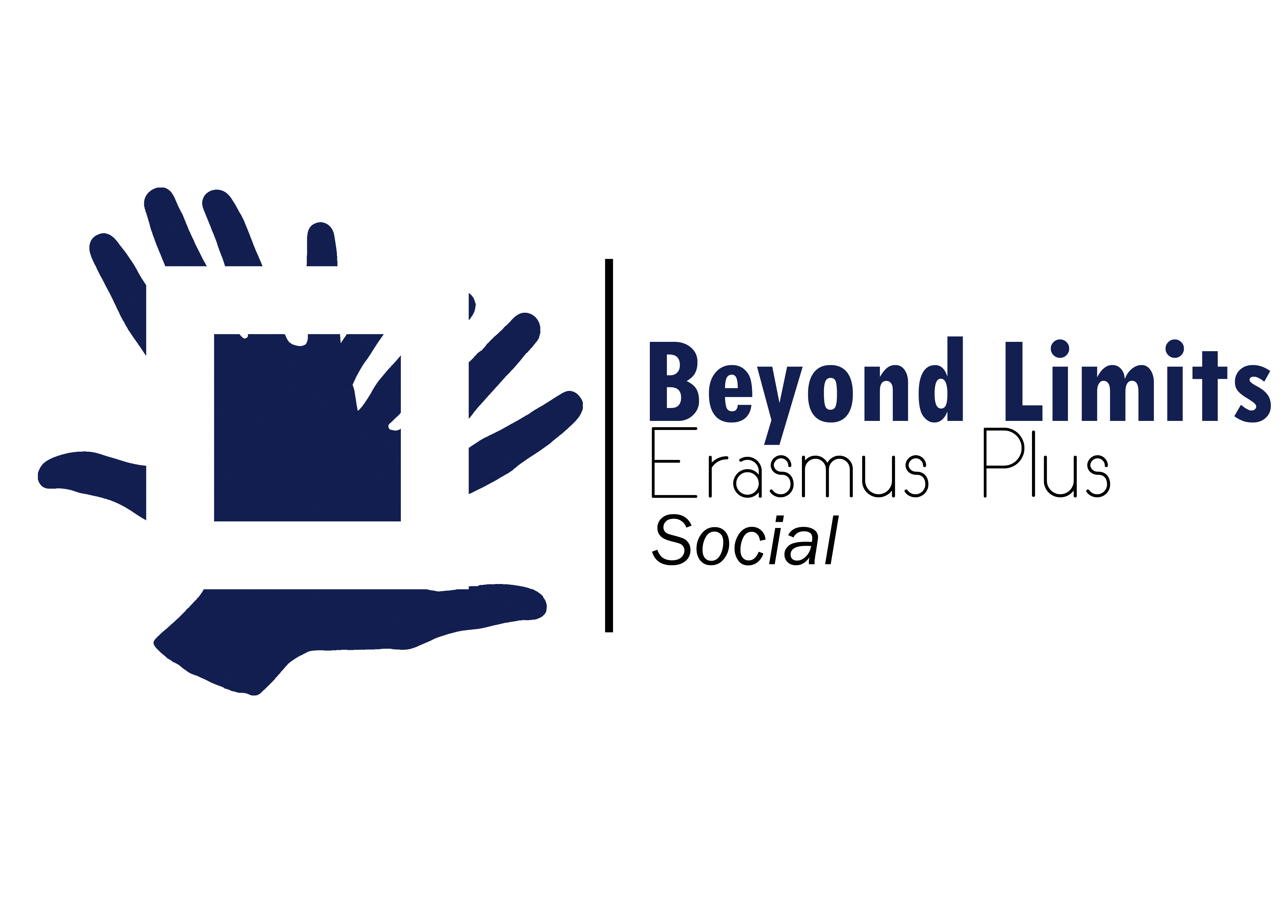
ERASMUS PLUS “Beyond Limits” 2017 -2018 :
Social Limits
Time Machine. How did people live in diferent countries?

TEENAGERS look much the same all around the world . Casual clothes , and a mobile phone next to their hands . But , are they really so alike?..... they are different , because of their different background , that is , the history their society went through . Let’s have a look to our closest past , and try to compare how our societies lived during the twentieth century .

Try to find a person aged about 70 or 80 years at the moment , and ask him or her this questionnaire . Later , we are going to put all the answers together , and we’ll try to elicit how much they have in common , and therefore , we’re going to understand better why we are who we are .

QUESTIONNAIRE
NAME : _______________________ DATE OF BIRTH ________________
1 – Have you ever been through a war time in your country ?...When was that?

2 – How did this war affect your life?...did you have enough food for your body to develope?... Were you forced to leave school , or did you start it very late?... Did you get all the education that was needed for the job you used to dream of?

3 – Was there a hard period after the war?... how did it affect your everyday life?... did your family suffer any political consequences? ...were you banned from any work or social opportunities?

4 – How many people used to live at home with you?... could you have your own bedroom? ... did you have a private space to do your homework or to prepare your exams? ... how often did you have a bath or a shower?

5 – Did you wear a uniform at school?...what was the school timetable?... what kind of relationship did you have with your teachers?

6 – How old were you when you started your first job?... did you get a salary?... what could you afford with your first salary?...And later , with a normal salary , could you go out at the weekends , go to the cinema , buy some clothes , save some money...?

7 – About your free time...how did young people meet ?...was it easy to have some privacy with your girlfriend/boyfriend? ... Did you need any permission from your or his/her parents?

8 – How old were you when you got married? Did you have any children? How many? Did your husband/wife have a job too? Was it easy for you to make ends meet , pay for the rent , the bills ...? Could you afford buying a house?...Was it easy to get a mortgage?

9 – Do you remember how old were you when some of these facilities entered your home for the first time?
Bathroom –
Central heating –
Gaz cooker –
Water heater -
Radio –
Fridge –
Washing machine –
Disc player –
TV –
Telephone –
Hair dryer –
Car –
Computer –
Mobile phone –

10 – Did your family migrate?...from village to town? From their area to another one?From their country to another one?

11 – What was your language at home?... at school? ... interacting in society ?

12 – Could you please tell me which is the most important memory in your life , maybe the happiest , maybe the saddest , maybe the one that changed it forever?

