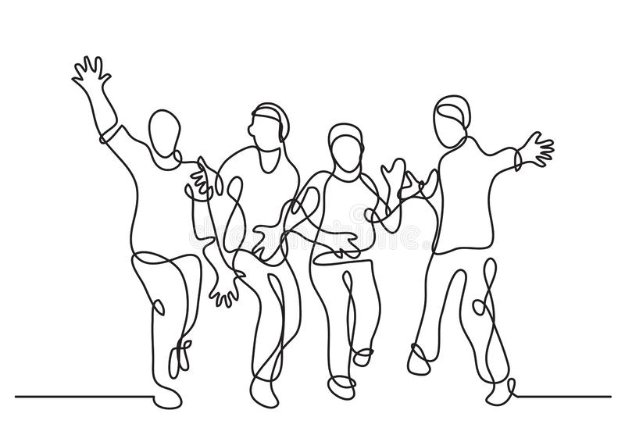
HAPPINESS IS ACTIVITY
-Aristotle

I think that it means if you want to be happy you need to do something for it. For example, you can do some sport, go out with your friends or spend time with your family. But the most important thing is to try to do something about it and believe in yourself. You cannot complain that you are not happy if you are not doing anything for it. If we are going to work for our own happiness, we are going to appreciate it more.

