Moletai
Our hosts took us on a trip to a town named Moletai which is one of the oldest settlements in Lithuania and nowadays a popular resort for the inhabitants of Vilnius.
We were divided into two groups. Each group had its own leader from Lithuania. Both groups received a map and hints for a group picture. After we took our picture on the place described in the hint, we had to send it for approval. After they approved that we took a picture of the right place we were given another hint. While fulfilling the tasks we learnt a lot about the town and discovered that the works of art are placed on each corner to make the tourists feel comfortable there. And it worked, we really had a great time there.
After we ended this activity, we visited a virtual educational tour where we were given VR glasses and watched short videos about Lithuanian history. Next, we visited the unique Museum of Ethnocosmology in Moletai. It is surrounded by lots of statues, rocks, and thematic decorations. As we got inside the building that was looking like a spaceship from 1950´s comics, a guide welcomed us. He took us through the modern exhibition in the underground tunnel. In the exhibition we could see many interesting items such as:
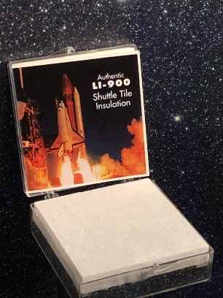Authentic space shuttle tile insulation
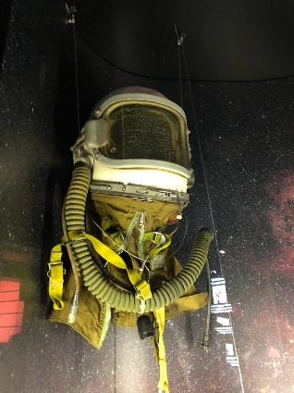Soviet high-altitude helmet GSH-6A
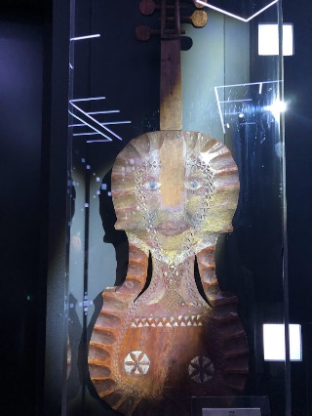Weird looking violin

As we made it to the end of the tunnel, we came into an underground cinema in which we had seen a short movie about how big or how small we are compared to things around us. As the video ended, we headed to the staircase to walk all the way up to the wonderful view from a glass bubble on top of the building.
It was a wonderful day full of unforgettable experiences.
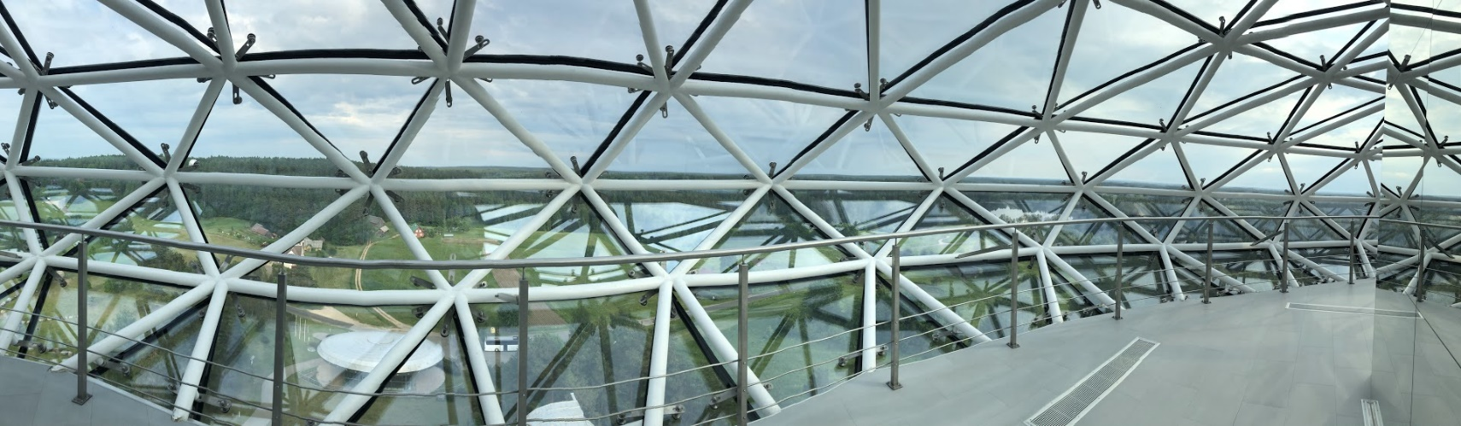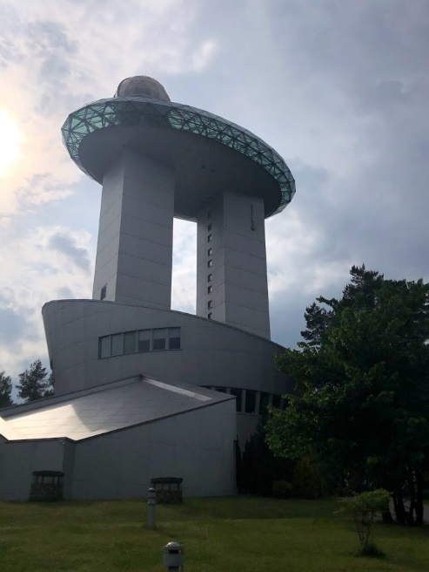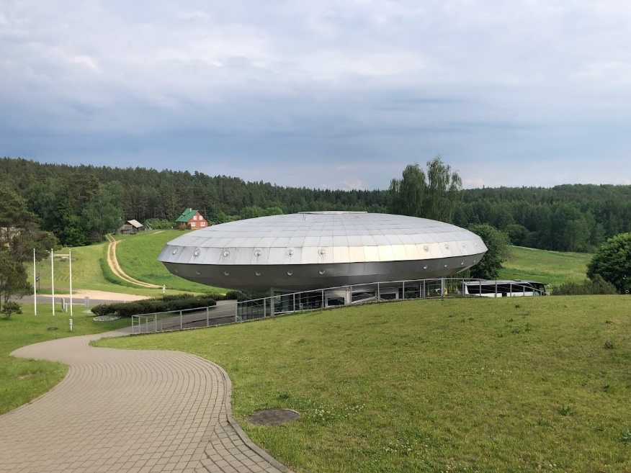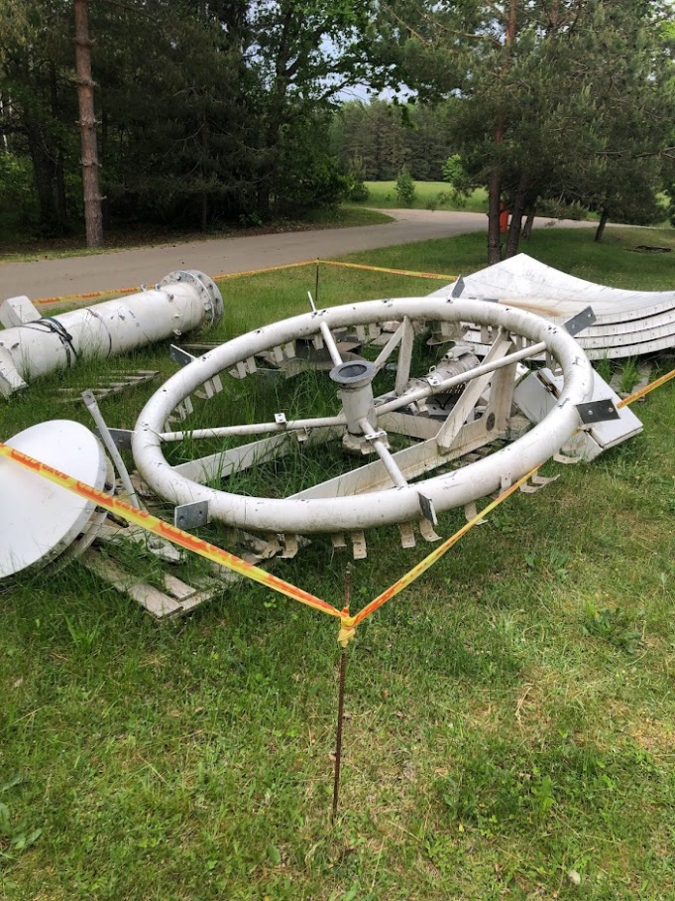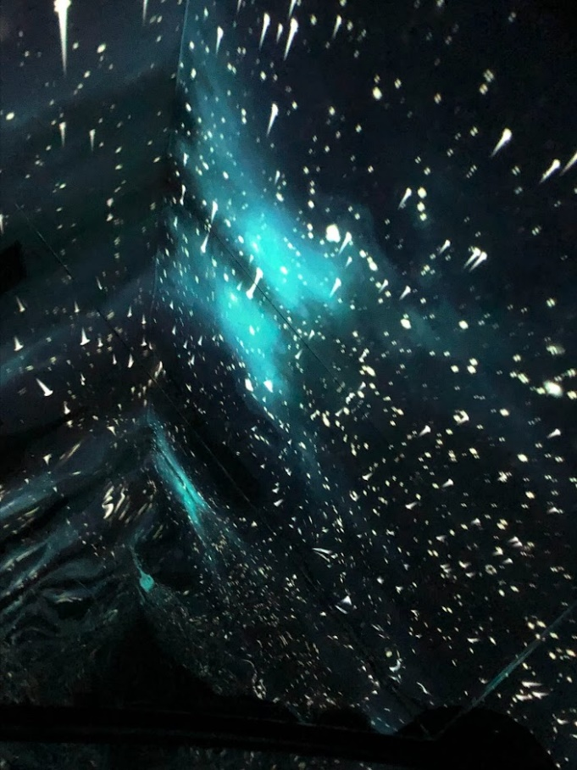
At the end I would rate that excursion 7,5 zeppelini out of 10.

