Ecological Footprint
What is the ecological footprint?
- Ecological footprint refers to the ecosystem balance that is disrupted as a result of people's actions and used to measure the human impact on ecosystems it is an indicator of sustainability. This is when we meet the needs of man from nature ecological footprint calculations are carried out to determine how far it has crossed the border. The effects of living things on the planet, considering the form of printing and use in the field of production considering its quantity, this concept is symbolized in the form of a footprint.
- Its ecological footprint is intertwined with the largest constituent carbon, which makes up it. It is therefore also known as the carbon footprint. It is the carbon that nature has its own to maintain the balance, it is necessary to combat carbon dioxide emissions to reveal t lack of ecological capacity and to reduce the release of we can define it as maintaining its importance.
What are the reasons for the ecological footprint?
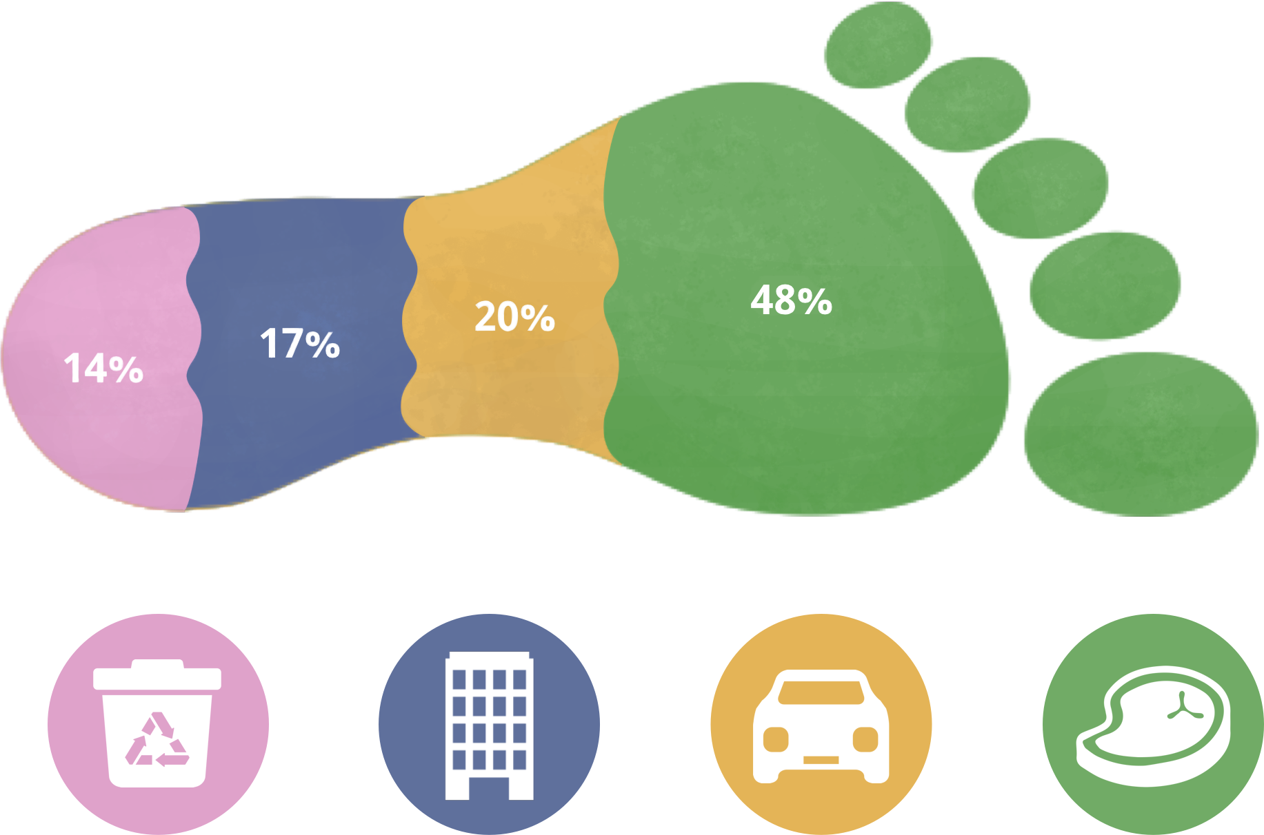

- As a result of the harm that people do to nature and their actions on nature it examines the balance between the dec demand and the supply of natural resources, demand and supply the analysis of the relationship between the decontamination of natural resources and the limit of self-renewal it reveals whether it is used in it. This imbalance is negative by creating it, it creates an invitation to today's global problems. Therefore, it is effective and it provides the opportunity to create a scientific basis for feasible solutions.
How is the ecological footprint calculated?
Ecological footprint = consumption x production area x population
- The consumption variable is considered as a measure of the use of goods. Such as the kilogram weight of the meat used, the joule value of the electricity used it can be handled. In the calculations, the ecological footprint is at low values it is desirable because the biological capacity is equal to or higher than the ecological footprint it ensures that living things live sustainably.
https://www.footprintcalculator.org/home/en your ecological footprint at you can calculate it
What are the effects of ecological footprint?
- According to the calculated data, the necessary measures can be taken and the ecological footprint values if we reduce the world in terms of renewable energy sources and living on it it can have positive effects on all living things. The carbon balance is maintained and the environment becomes beautiful. These include among the positive effects. Decongestants But as a result of ecological footprint calculations if the values turn out to be high, this also creates negative effects. Global warming is the most it becomes a big problem and it becomes difficult to live on earth. This too ecological footprint values should be kept low because it is undesirable.
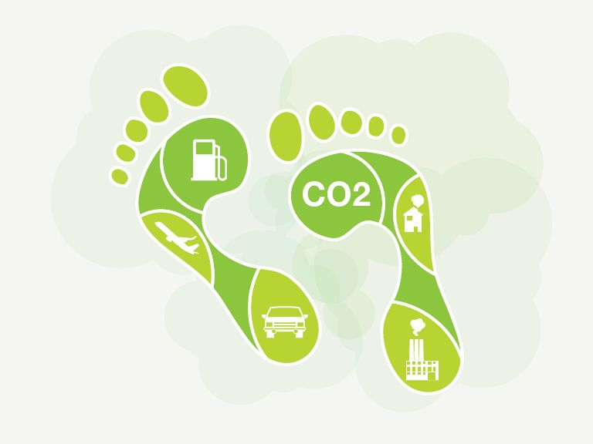
How can we reduce the ecological footprint values?
- The first thing we need to do about this issue is to raise awareness of people about it.
- We can contribute to the reproduction of green areas by planting trees.
- We can throw the garbage in the trash cans.
- We should save energy and avoid waste and prefer renewable energy sources.
- Reclaim recyclable waste to nature by sending it to recycling.
- We can learn to cook and cook at home.

