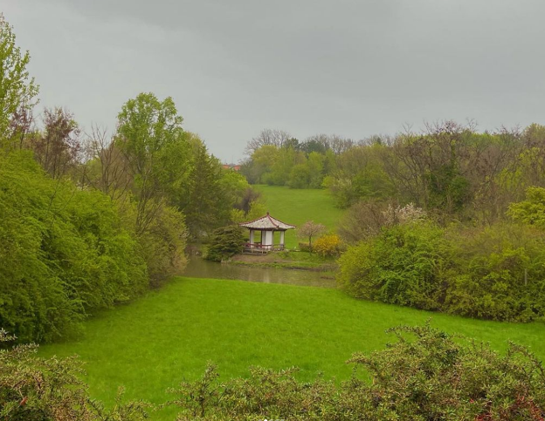
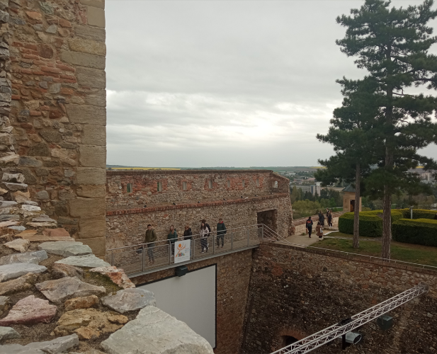
April 27 was also exciting and full of excitement. In the morning, we worked actively in mixed groups (two from Slovakia and two of our students). We all “became” teachers and prepared for lessons, rehearsed, and assigned roles. We are delighted that we have not only had a great time but have also learned what biodiversity is, what it means for our lives and what everyone should do to keep biodiversity to a minimum. We spent this afternoon in Nitra, one of the oldest cities in Slovakia. The Slovak students were our guides. They told in detail not only about the historical objects but also about the current situation in Slovakia, the things they are proud of and what they would decide to change with the enthusiasm of their youth. Together we walked around the botanical garden, again working in mixed groups and doing biodiversity-related tasks. Later we went to Nitra Castle. Student guides presented the history of the city and the castle, from which the development of the surrounding towns began. We have learned that Nitra is the centre of Slovak Christianity. We gathered lots of information and improved our communication skills.

