Cosmic Calendar
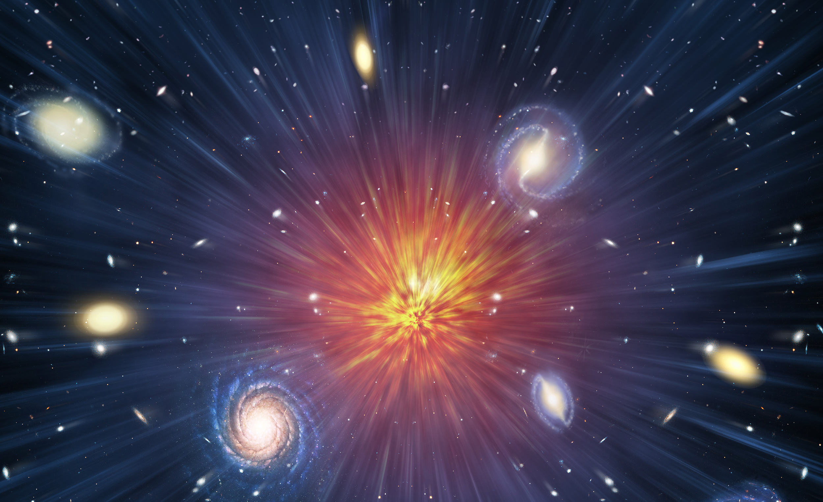
Explore the timeline of the universe and how it all began.

Experience billions of years from the Big Bang through the birth of our Solar System, the split of Pangea and extinction of the dinosaurs to the modern days of science in one calendar.

