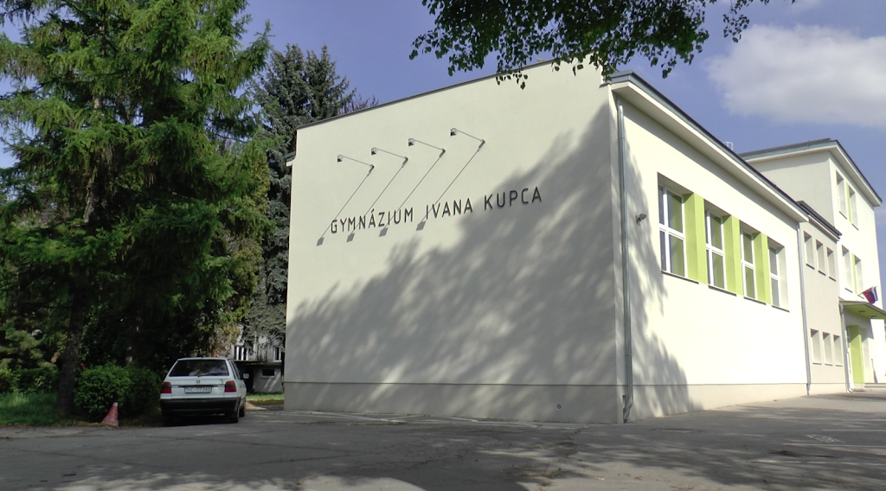

Hello, dear partners,
After wonderful experience from our first eTwinning project last year, our students are keen on setting off this journey again:)
We already know one another a little bit and we hope we will get to know each other even better.
Our "Gymnázium of Ivan Kupec in Hlohovec" welcome several newcomers, altogether we have around 330 pupils at the age from 12 to 19. This year we have four bilingual classes, four classes at four-year-school programme and eight classes at eight-year-school programme and all our students learn English as compulsory foreign language.
Along with general education we also focus on teaching languages, sciences, IT and recently in several classes on interdisciplinarity as we are aware of the changeability of the future job market.
Our students are involved in art, sports, natural and social sciences, language, civic and volunteering projects on school, local, regional, national or international levels.
We are certain that this project will become the source of many beneficial educational materials which all of us will be able to use immediately as well as later in the future.
While learning about the world around us, about different natural and social phenomena, we will learn a lot about each other, our schools, towns, countries, cultures and strengthen our relationships and cooperation.
We are looking forward to interacting with you
Our new eTwinning team from Slovakia

