Question 1:
How much does transportation contribute to carbon emissions globally?
Which of the means of transport are „greener“

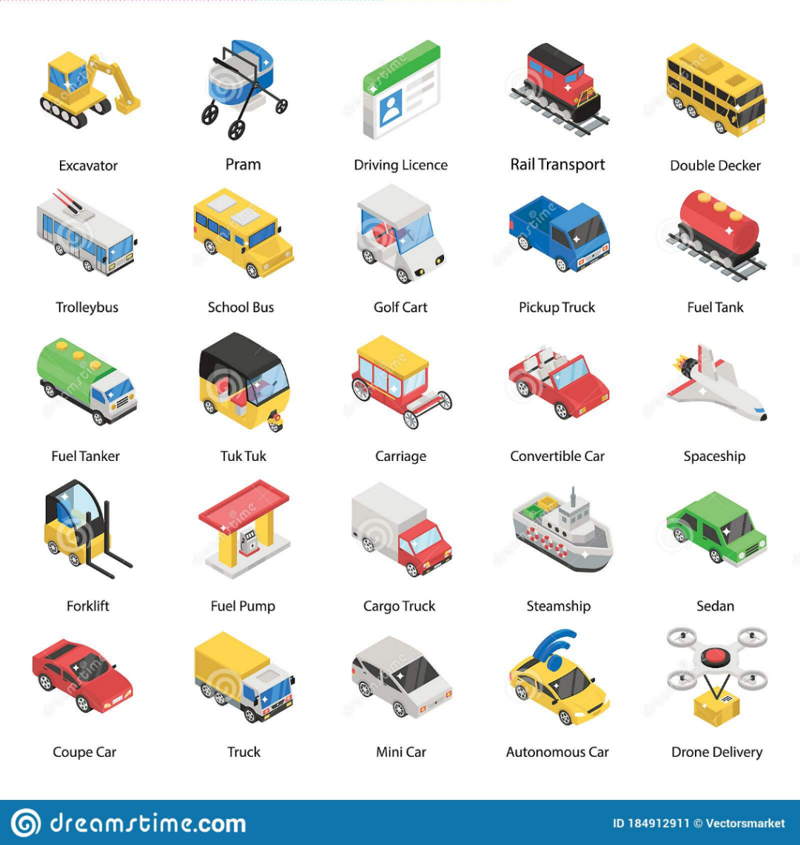
Question 2:
Which means of transport produces the largest amount of CO₂ emissions?
- aviation - planes
- road vehicles – cars, buses, trucks
- ships

What is classified as a „vehicle“?
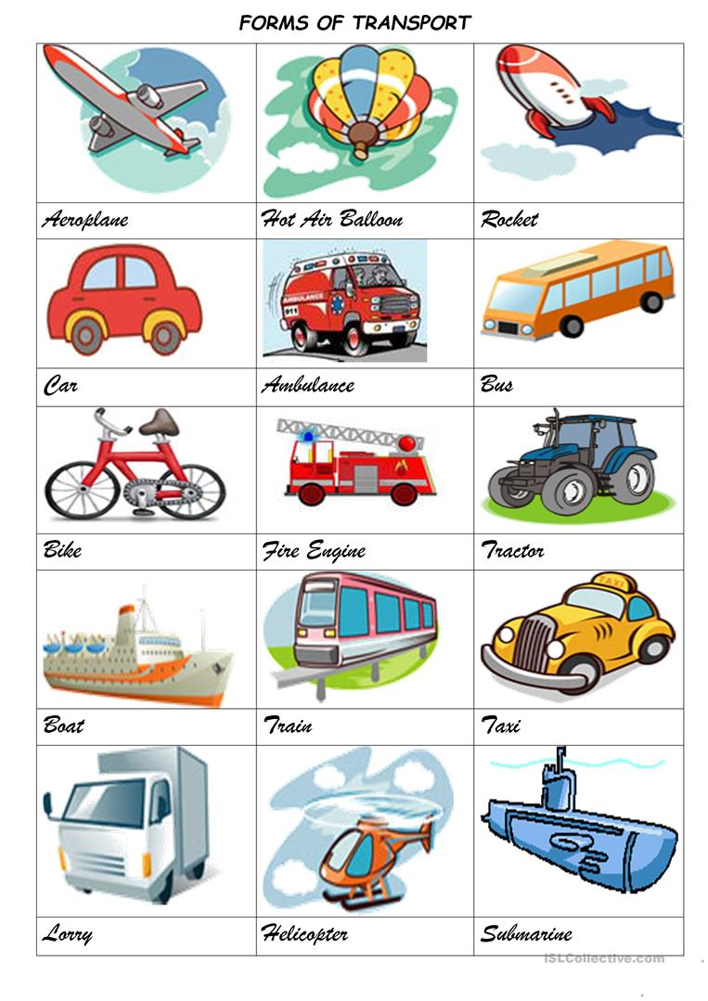

Question 3:

How many cars equal the CO₂ emissions of one plane?

How many people fly in Europe?
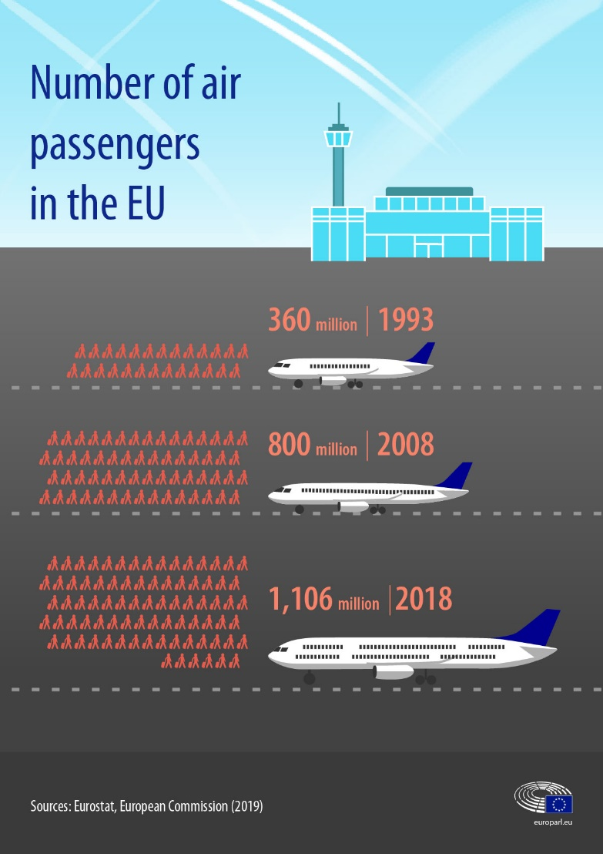

Question 4:
How can I reduce my transportation emissions?
What is the best green transportation?

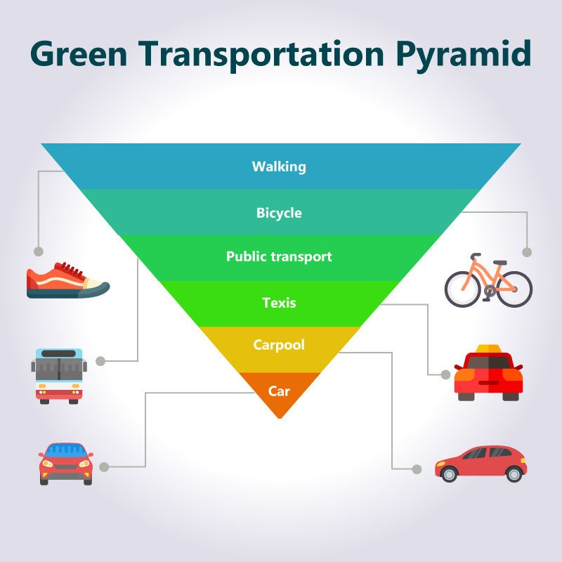
Question 5:

Which four European cities are leaders in eco-friendly transport?
What are the most eco-friendly countries in the world 2020?

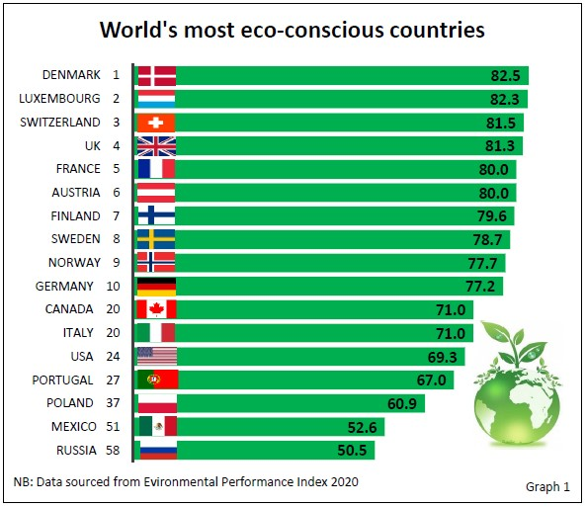
Answers:

Question 1:
24% (almost one fifth of global CO₂ emissions)

Question 2:
a) road vehicles
b) Any machine that transports people, animals (live cargo), or cargo is a vehicle. Cars, trucks, buses, wagons, motorbikes, bicycles, boats, airplanes, and spacecraft, for example, are vehicles. Some dictionaries, however, stress that the term only includes devices that transports people, live cargo, or goods on land.

Question 3:
You could drive 336 cars to Edinburgh for the same CO₂ as one plane.

Question 4:

a) 1. Advocate for more investment in public transportation.

2. Pedestrians, take back your cities!

3. Take buses, trains, and trolleys.

4. Limit your flights and offset the rest.

5. Get a bike!

6. Buy that electric car.
b) Except for walking and riding a bike, it is public transport.

Question 5:
Rzeszów, Poland
London, UK
Ruesselsheim, Germany
Copenhagen, Denmark

