ROUTES IN LONDON
ERASMUS GROUP (ITALY-SPAIN)
- Bus Leigham Court Hotel-Southwark College (SC): 48 minutes aprox.
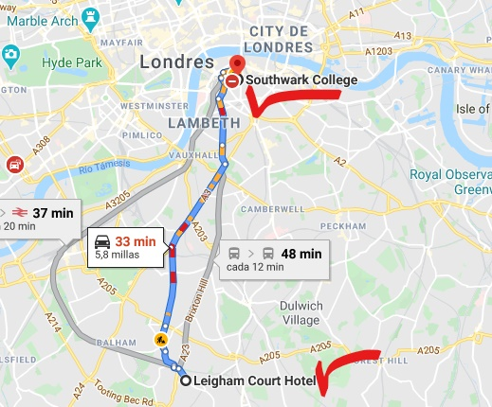
Routes (after lunch in Southwark College-13:00 aprox.)
Monday 24th Route 1 (Walking from SC-Bus to the hotel)
- Big Ben
- Downing Street
- Westminster Abbey
- Buckingham Palace
- Piccadilly Circus
- Trafalgar Square: The National Gallery (Free entry-From 10:00 to 18:00)

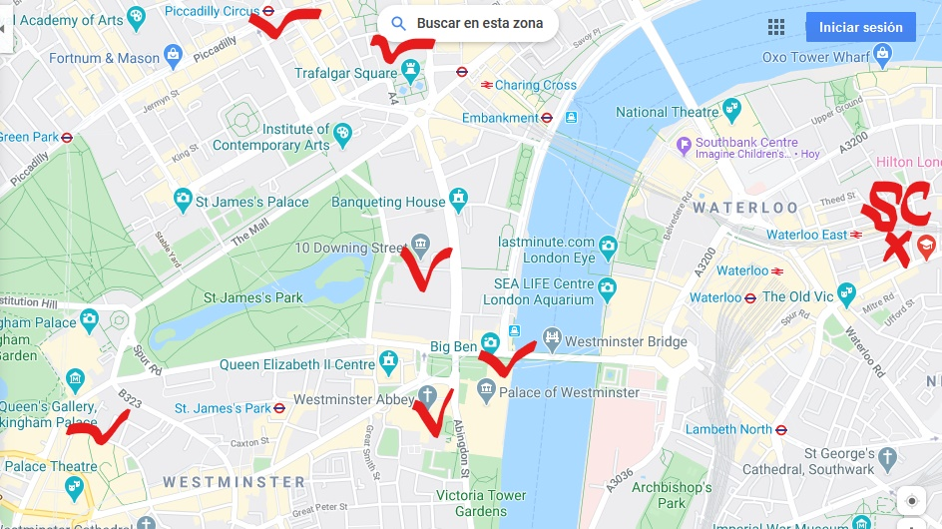

- Other interesting visit-Optional:
The Natural History Museum. Cromwell Road. Free entry-From 10:00 to 17:30

Tuesday 25th Route 2 (Tube from SC-Walking to Covent Garden-Bus to the hotel)
- British Museum (Free entry-From 10:00 to 17:30. Reservation at 13:30)
- Covent Garden
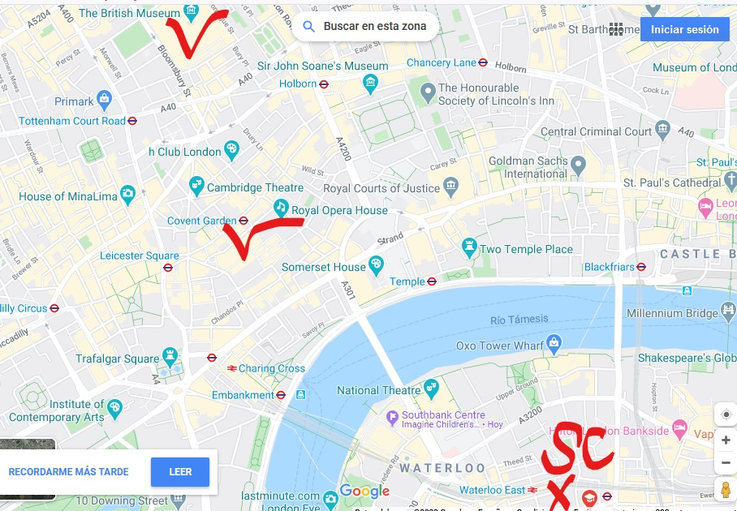

Wednesday 26th Route 3 (Walking from SC-Bus to the hotel)
- London Eye (Online tickets-Time: 13:45)
- Tate Modern (Free entry-Timetable: from 10:00 to 18:00)
- Shakespeare´s Globe
- London Bridge
- Tower of London (From 9:00 to 16:30)
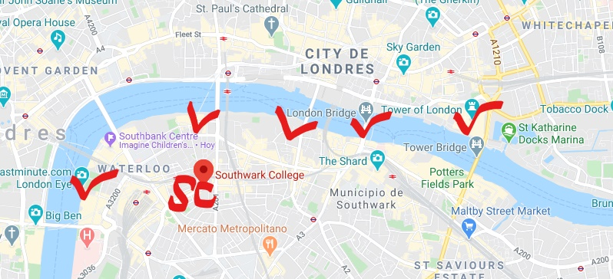
Thursday 27th Route 4 (Tube from Southwark Tube Station to Camden Town Tube Station-Tube to Hyde Park-Bus to the hotel)
- Camden Town
- Hyde Park
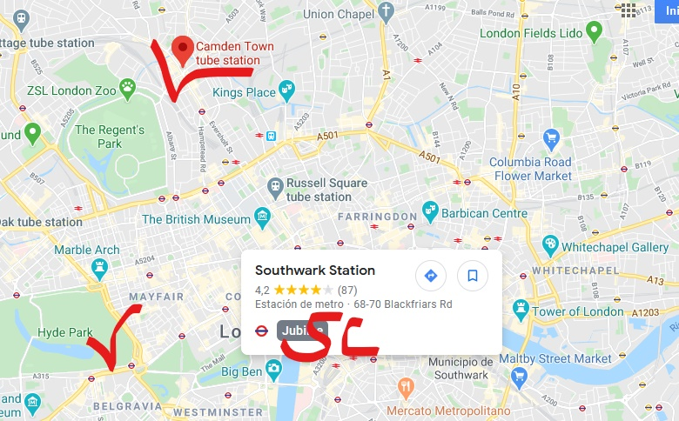
Friday 28th Route 5 (Bus to the hotel-Bus to SC-Bus to the hotel)
- Lunch somewhere of our own choice (Quick lunch-Take away).
- Back to the hotel. Rest and dress up for dinner.
- Meeting at 17:00 at Southwark College for dinner.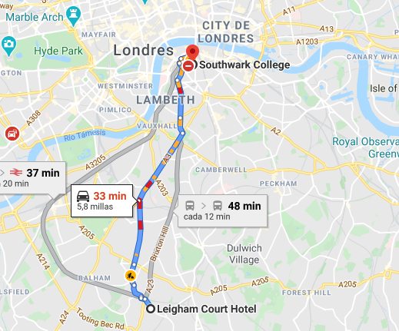
Aránzazu Iturrioz-Beatriz Caballero-Mª José Gutiérrez. IES Cantabria.
Santander, 16th February 2020

