GHOST STORIES:
The Vampire of Glasgow Necropolis

A man patrolling in the Southern Necropolis of Scotland, found a hundred of young local kids searching two friends that disappear there. They thought that a creature of the night called “Gorbal Vampire” killed them. The police didn't believe that story, and they blame the horror comics and films of the époque, for instill those values in the kids.
This was a story that parents told to their children, for not going out alone when the night has come, but, whatever happens that night, it was very real for the boys.
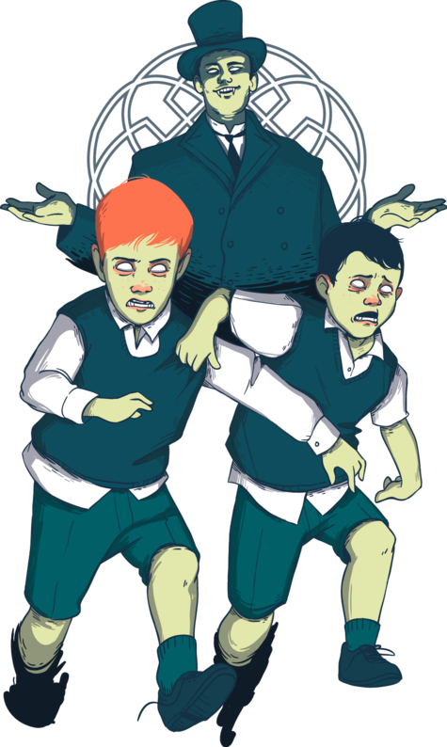

THE LINK:
https://ebooks.visitscotland.com/ghosts-myths-legends/vampire-glasgow-necropolis/

