The Headless Drummer of Edinburgh Castle

No one knows who it is, no one knows what it is, the only thing that we know is his sound tra-ta-ta, the sound of his drum, the sound of the...dead.

He first appeared in 1650, the same year than Oliver Cromwell launched his invasion of Scotland.
People said he belongs to one of Edinburgh castle´s in- famous phantoms.
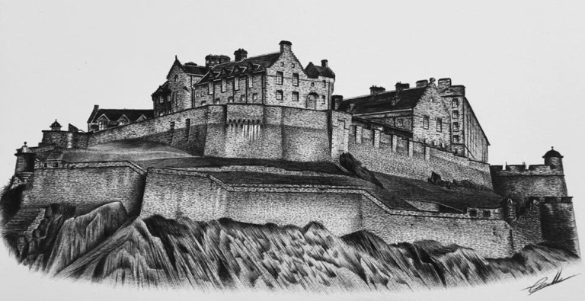
During lots of years this phantom didn't appear, but nowadays you have to be careful when you walk around Edinburgh streets.

