*Welcome autumn !*

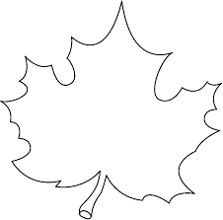

*maple leaf*

*Welcome autumn !*

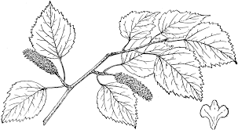

*birch leaves*

*Welcome autumn !*

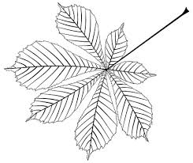

*chestnut leaf*

*Welcome autumn !*

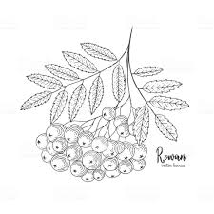

*rowan leaves*

*Welcome autumn!*

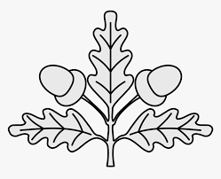

*oak leaves*