
IES LA ROSALEDA

LUIS BUÑUEL nº 8 • 29011-MÁLAGA • TF: 34 952 64 00 35

European Erasmus + project UNIDIVERSITY.
International meeting in SATU MARE (ROMANIA)
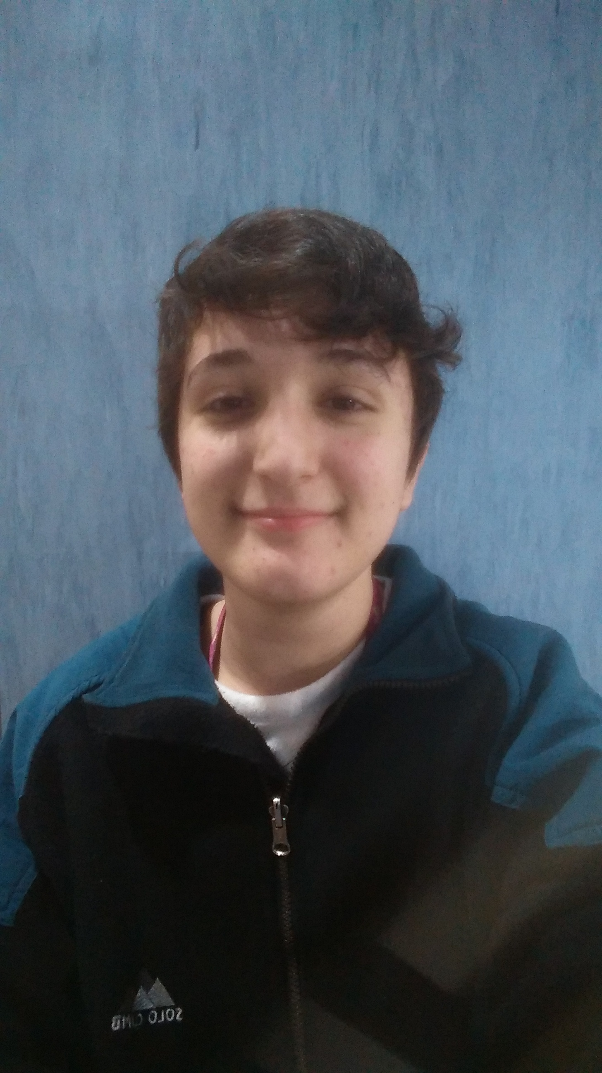

Photo

(From 4th to 11th March 2018)

Full name and family name | María Belén Herrera Morente
Date of birth | 23/08/01
Nationality | Spanish
Home address | Urbanización Altos de Capuchinos nº 16
Identity card number or passport | 25610461F
Home Telephone Number  Father´s mobile number  Mother´s mobile number | 951 25 72 82  685 54 71 37  605 80 21 76
My mobile phone | 633 92 58 65
My E-Mail Address | belenherreramorente@gmail.com
Details of my family  (brothers, sisters etc.) | My family is formed by my mother, my father and my sister (19 years old).
Pets | A dog and a cat.
Do you take any medication? | No.
Allergies (pets, dust etc.) | I don’t have anyone.
Eating habits (vegetarian etc) | I’m vegetarian.
Do you play any sports? Which sports do you like? | I don’t like sports.
Do you play any musical instruments? What sort of music do you like? | I play the piano. I like rock, pop and classical music.
What do you do in your free time? | I like reading, listening to music, watching TV series or playing the piano.
Anything else you would like to say?

