**PIGAFETTA**

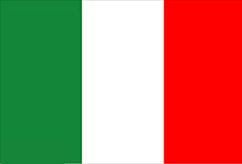

Who was the first Italian to travel around the world?

Antonio Pigafetta

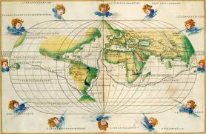

* Strait of Magellan
* Traveler
* Journey



**MARCO POLO**

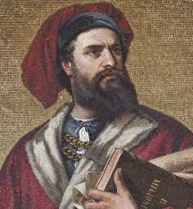



Who was the first italian person to draw up a detailed account of his journey to China?

Marco Polo

* Merchant
* Explorer
* Travels



**LEONARDO**

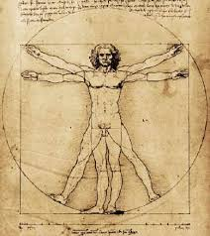

* Mona Lisa
* Genius
* Verrocchio



**DA VINCI**

What is the most famous painting by Leonardo Da Vinci?

Mona Lisa

**GALILEO**

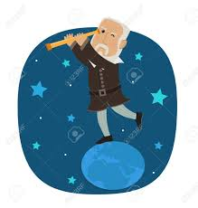



**GALILEI**

What did Galileo Galilei invent in 1609?

The telescope

* Telescope
* Inventor
* Il Saggiatore



**GARIBALDI**

* Caprera
* Risorgimento
* Histrorical

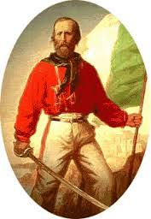

Who is also known as “The Hero of the Two Worlds”?

Giuseppe Garibaldi



**LUCIO**



**BATTISTI**

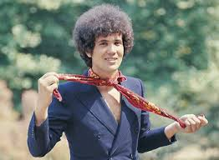

What is the most popular song by Lucio Battisti?

La canzone del sole

* La canzone del sole
* Singer
* Musician

**TAZENDA**



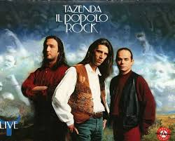

What languages do the Tazenda sing?

Italian and Sardinian

* Sardinian culture
* Spunta la luna dal monte
* 1988

**MARIA LAI**





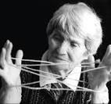

Who was born in the village of Ulassai in 1919?

Maria Lai





* Ulassai
* Mountain
* Inhabitants



**RAFFAELLO**

 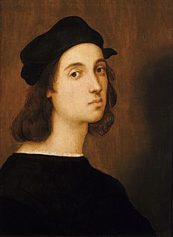



Who painted the transfiguration?

Raffaello Sanzio

* Painter
* Florence
* Brush





**DANTE**

 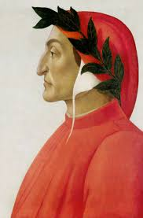 

What did Dante Alighieri write?

The Divine Comedy



* Divine Comedy
* Poet
* Beatrice

**THE 7 KINGS**

**OF ROME**

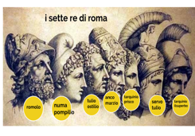



Who was the first King of Rome?

Romulus



* Seven
* Romulus
* Rome



**LEOPARDI**

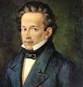





Where was Giacomo Leopardi born?

Recanati

* Recanati
* Poet
* The Infinity

