CHARACTERS | MONUMENTS | TRADITIONS | FOOD
MARIA LAI  Sardinian Artist | 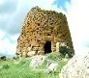  (Sardinia)  NURAGHE | 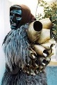  (Ancient Sardianian Carnival masks)  MAMUTHONES and ... | 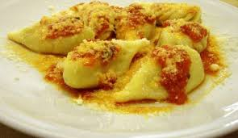  (Stuffed Pasta)  CULURGIONES
LEONARDO DA VINCI  Inventor, Artist, Scientist | 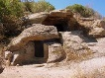  (Sardinia)  DOMUS DE JANAS | 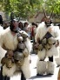  BOES, MERDULES,  FILONZANA (Carnival) | 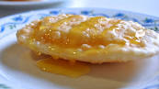  (Typical Dessert)  SEADAS
GALILEO GALILEI  Scientist | 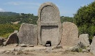  (Sardinia)  GIANTS’ TOMB | (Sardinian Amulet, decorative motif)  PAVONCELLA | 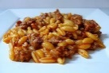  (Handmade Pasta)  MALLOREDDUS
DANTE ALIGHIERI  Literary Man, Poet | 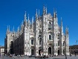  (Milan)  CATHEDRAL | 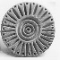  (Clay disk)  PINTADERA | 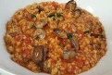  (Handmade Pasta)  FREGOLA
GIACOMO LEOPARDI  Literary man, Poet | 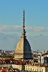  (Turin)  MOLE ANTONELLIANA | 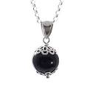  (Sardinian Amulet)  SU COCCU | 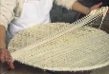  (Handmade Pasta)  FILINDEU
7 KINGS OF ROME  Roman age Kings | 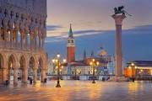  (Venice)  SAINT MARK’S SQUARE | 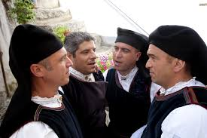  (Choral Singing)  TENORES | 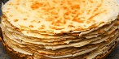  (Handmade Bread)  PANE CARASAU
PIGAFETTA  Navigator, Geographer | 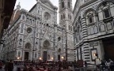  (Florence, Tuscany)  FLORENCE CATHEDRAL | 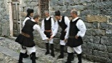  (Traditional Game) MORRA | 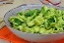  ORECCHIETTE CIME DI RAPA
RAFFAELLO SANZIO  Painter | 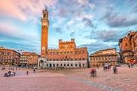  (Siena, Tuscany)  THE CAMPO IN SIENA | 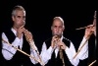  (Traditional Instruments)  LAUNEDDAS | 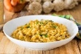  (Rice) RISOTTO
GIUSEPPE GARIBALDI  Army General, Patriot | 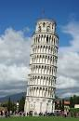  (Pisa, Tuscany)  THE LEANING  TOWER | 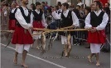  (Traditional Celebration)  BARE FOOT RUN | 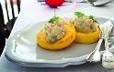  COD WITH POLENTA
MARCO POLO  Traveler, Writer | 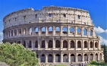  (Rome)  COLOSSEUM | 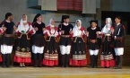  (Traditional Dance)  BALLO SARDO | 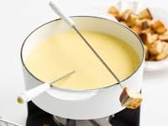  (Mixed Cheese)  FONDUE
LUCIO BATTISTI  Songwriter | 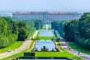  THE ROYAL PALACE CASERTA | 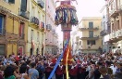  (Wood Columns) CANDELIERI | 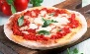  (Pasta,Tomato,cheese)  PIZZA
TAZENDA  Band, Music group | 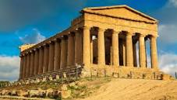  (Agrigento, Sicily)  VALLEY OF THE TEMPLES | 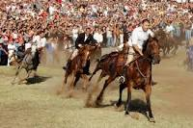  (Equestrian Event)  ARDIA | 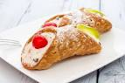  (Sicilian Dessert)  CANNOLI

PROGRAMME
AESTIMAMUS NOSTRAM HEREDITATEM board game

Sassari, 16th December 2019

