NURAGHE
- Archeological treasure
- Bronze Age
- Stones
How many Nuraghi are there in Sardinia?
About 7.000

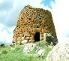

DOMUS DE IANAS

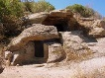
What were the Domus de Janas used for?
Prehistoric burial sites

- Houses of Fairies
- Caves
- Burial sites

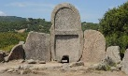
GIANTS’ TOMB
- Tomb
- Bronze Age
- Megalithic
What is the name of a Sardinian megalithic grave ?
Giant’s Tomb

MILAN

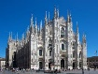
CATHEDRAL
- Gothic style
- Milan
- Lombardy

What style is the Cathedral of Milan built in?
Gothic

MOLE ANTONELLIANA
- Turin
- Alessandro Antonelli
- Panoramic lift and terrace

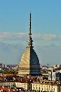
Which was the tallest brick building in Europe in 1889?
The Mole Antonelliana

SAINT MARK’S
- Canal
- Tower
- Water

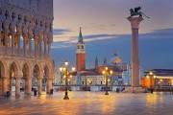
SQUARE
What square is known as “the living room of Europe”?
St Mark’s square

FLORENCE
Who designed the Cathedral of Florence?
Filippo Brunelleschi

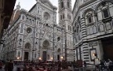
CATHEDRAL
- Filippo Brumelleschi
- Tuscany
- Unesco World Heritage
THE CAMPO IN SIENA
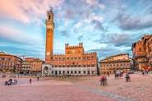
What Italian city has a square with an original shape?
Siena

- Palio
- Shell
- Square

THE LEANING TOWER

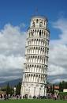

What tower is 56 metre high?
Leaning Tower

- Pisa
- Tower
- Leaning

COLOSSEUM
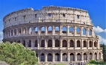

What amphitheatre can you see in the centre of Rome?
The Colosseum

- Rome
- Amphitheatre
- Ancient

THE ROYAL PALACE
IN CASERTA
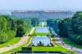

What royal residence was built in Naples in the 18th century?
The Royal Palace in Caserta

- Kings
- Caserta
- Residence

VALLEY OF
THE TEMPLES

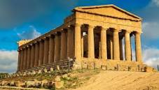
What’s the name of the archeological area in the province of Agrigento (Sicily)?
The Valley of the Temples

- Doric temples
- Agrigento
- Archeological area

