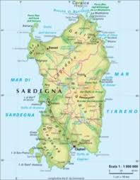
Erasmus+ project «AESTIMAMUS NOSTRAM HEREDITATEM – board game»
Short-term exchange of groups of pupils
Host school: Istituto Comprensivo «BRIGATA SASSARI"
15th – 21st December 2019
Schedule of the week
Saturday 14th (Spain) and Sunday 15th (Greece)

- Arrival of the groups

Monday 16th (8.00-14.00)

- 8.00 Welcome guests and sightseeing of our school
- 8.30 Opening concert played by students of our musical course
- 8.45 Our cultural heritage (part I)
- 11.00 Coffee break and buffet
- 12.00 Our cultural heritage (part II)
- 14.00 End of activities

Tuesday 17th (8.00-18.00) Whole day trip in Alghero 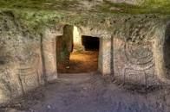 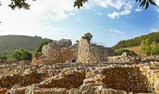

- 8.00 Meeting point at «Piazzale Segni» and departure by bus
- 9.00 Anghelu Ruju Necropolis (archaelogical site)
- 10.30 Tour around the protected marine area of Capo Caccia-Isola Piana, inside the Park of Porto Conte
- 11.30 Palmavera Nuraghe
- 13.30 Lunch at Pizzeria «Lido»
- 15.30 Walking tour in town and free time
- 17.15 Departure
- 18.00 Arrival in Sassari

Wednesday 18th (8.00-18.00)

- 8.00 Project activities at school
- 12.00 Let's play! (Morra and Sardinian Dance)
- 13.00 Tasting of Traditional Dishes prepared by students and families
- 14.00 Students return home to host families
- 15.00/15.30 Meeting point at Porta S. Antonio
Waking tour of Sassari and visit to its most important monuments
- 18.00/18.30 Families will meet students in Piazza d'Italia

Thursday 19th (8.00-15.00) Half day trip in Castelsardo 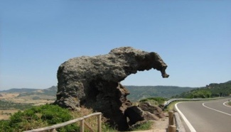 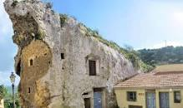

- 8.00 Meeting point at «Piazzale Segni» and departure by bus
- 8.45 Short stop at «Elephant's Rock», a natural rock eroded by time and wind;
a single rock of volcanic origi, it resembles a seated elephant
- 9.30 «Sa Rocca», Domus de Janas: an enormous rock home to an underground burial site dating to the IV-III millennium BC
- 11.30 Visit to «The Castle»
- 12.30 Walking Tour and free time (Packed Lunch)
- 14.15 Departure
- 15.00 Arrival in Sassari

Friday 20th (8.00-18.00) Whole day trip in Nuoro and Mamoiada

- 8.00 Meeting point at «Piazzale Segni» and departure by bus
- 10.00 The Sardinian Ethnographic Museum (Nuoro)
- 12.00 Sardinian Masks Museum (Mamoiada)
- 13.30 Lunch at «Istentales» (traditional Sardinian Farmhouse)
- 16.00 Departure
- 18.00 Arrival in Sassari

Saturday 21st

- Departure of the groups

