SAY.WRITE.SHOW – DEVELOPING STUDENTS’ AND TEACHERS’ COMMUNICATION SKILLS
QUESTIONNAIRE FOR STUDENTS – REPORT ON RESULTS

BORNOVA KARACAOĞLAN MAHALLESİ SECONDARY SCHOOL, İZMİR,TURKEY
ARGUMENT
This project is complementary to the traditional education and to other projects the partner schools have carried out so far. It focuses mainly on developing participants’ communication skills and it brings a further insight into the important characteristics of partner countries’ cultures and civilizations.
After students in target group having been selected, it had to be evaluated their communication skills and habits and their knowledge related to the partner countries in the beginning of students’ participation in the project activities.
A questionnaire was created at the level of partnership to be applied to 50 students. The questionnaire has 14 questions which focus on:
-communication habits: 5; 6; 7
-communication abilities: 1; 2; 3; 4;
-cultural knowledge: 9; 10; 11; 12; 13; 14
-motivation for taking part in the project: 8
RESPONDENTS
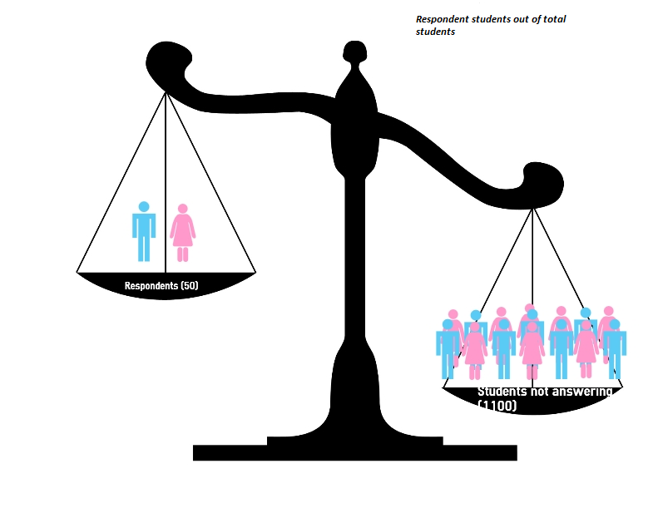
There are 50 students aged 10-15 (grades 5-8) in the target group. The students selected to answer the questionnaire represent all levels and the number was selected so that it reflects the proportionality of the target group: 20 students grade 8 (there are 10 students grade 8 in the target group), 15 students grade 7 (there are 10 students grade 7), 15 students grade 6 (there are 5 students grade 6).

RESULTS
- Do you enjoy talking to your colleagues?

- What types of communication do you find easy to use?

3- When you are in a group of children, how much do you involve yourself in the conversation?

4- When do you feel you cannot communicate with the others?

5- There is a debate in your classroom on an interesting subject. What do you do?

6- Which are the main sources that help you learn a foreign language?

7- How do you feel when you see people around you can't understand your message?

8- Why do you want to take part in this project?

9- What do you know about Romania?

10- What do you know about Italy?

11- What do you know about Latvia?

12- What do you know about Spain?

13- What do you know about Turkey?

14- What do you know about Poland?

