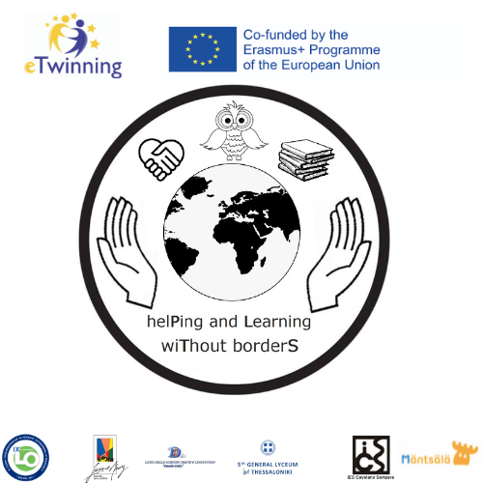
helPing and Learning wiThout borderS
2020-1-PL01-KA229-082145

The ANALYSIS of the PROJECT’S PARTICIPANTS’
answers to the surveys

Project Teachers
the end of November 2021

Please evaluate the influence of the project
on the development of your skills
 | Strongly agree | Agree | Neither agree nor disagree | Disagree
social skills | 7 | 7 | 2 | 0
digital skills | 5 | 6 | 5 | 0
communication skills | 7 | 9 | 0 | 0
linguistic skills | 7 | 9 | 0 | 0
emotional empathy | 8 | 6 | 2 | 0
time management | 5 | 7 | 4 | 0
teamwork | 9 | 5 | 2 | 0
leadership traits | 7 | 5 | 4 | 0
critical thinking | 7 | 7 | 2 | 0
problem-solving | 6 | 7 | 3 | 0
Please evaluate the influence of the project on your school practice
 | Strongly agree | Agree | Neither agree nor disagree | Disagree
I learned more about metacognition | 7 | 6 | 3 | 0
I help my students to become Reflective Learners by using Learnish | 7 | 7 | 2 | 0
I learned a lot from the seminar on neurodidactics | 6 | 4 | 6 | 0
I shared good practices and new knowledge with my colleagues from school | 8 | 7 | 1 | 0
My cooperation in the workplace has improved | 4 | 10 | 2 | 0
I use Project Based Learning | 6 | 7 | 3 | 0
I use Cooperative Learning | 5 | 10 | 1 | 0
Please evaluate the influence of the project on your school
 | Strongly agree | Agree | Neither agree nor disagree | Disagree
Students participating in this project are more motivated to learn foreign languages | 10 | 5 | 1 | 0
Students participating in this project are becoming better learners | 7 | 7 | 2 | 0
The number of students engaged in volunteering and charity events has increased | 5 | 8 | 3 | 0
Thanks to Project Based Learning and Cooperative Learning methodologies, the students in my school have developed their 21st century skills | 6 | 7 | 3 | 0
My school has got engaged in more volunteering and charity events | 7 | 4 | 5 | 0
My school community has a bigger awareness of global and environmental issues | 7 | 7 | 2 | 0
My school has implemented more "eco" strategies or got involved in more "green" initiatives | 6 | 8 | 2 | 0
In my school a Learning Community has been created for voluntary teachers who want to support each other | 6 | 4 | 4 | 2
During the first year of the project's realization,
I learned to use the following digital tools effectively:

Google docs, Google forms, Zoom, Meet |  | Language applications
Canva, Kahoot, Google forms, Zoom, Google Meet, Doodle |  | Canva was new to me, (DuoLingua for learning Italian)
website,social media,canva, monkey survey |  | Slide presentation software (Google Slides) Graphic design apps (Canva) Video conference (Zoom, google meet)
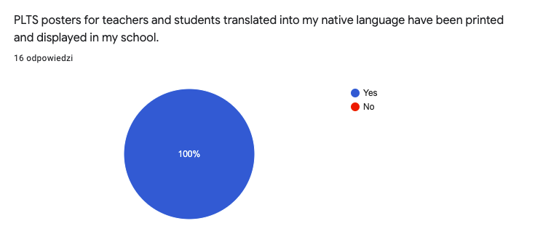

CONCLUSIONS
Strong points:
Thanks to the project implementation, the majority of participating teachers have developed key competencies and XXI century skills. The majority has the following observations: their students have become better learners, who are better motivated to learn foreign languages, their students have developed XXI century skills, their school has engaged in more volunteering and charity events, and eco-actions, their school community has become more aware of global issues and environmental problems. 11 teachers learned to use effectively new ICT apps. PLTS posters have been translated, printed and displayed in all partner schools.
Weak points: In some schools Professional Learning Communities haven’t been developed yet and the teachers do not support each other in their everyday educational challenges. Some schools did not engage in more volunteering and charity events. It is possible that not all participating teachers saw the seminar on neuroscience. Some teachers (3 out of 16) do not use Project Based Learning and Cooperative Learning.

STUDENTS AFTER C-3 LTT ACTIVITIES - SKILLS AND SATISFACTION
the beginning of November 2021

Rate the extent to which LTT Activities in Palermo have helped you develop the following competencies and attitudes
 | Strongly agree | Agree | Undecided | Disagree | Strongly disagree
The study on noise and its influence on my well-being has made me more aware of the impact I have on my health. | 9 | 26 | 3 | 1 | 0
The workshop on Fast Fashion has made me want to popularize and use the eco friendly shopping options. | 19 | 14 | 6 | 0 | 0
The students exchange has motivated me to learn more and better. | 23 | 15 | 1 | 0 | 0
I made new international friends. | 31 | 7 | 1 | 0 | 0
I am more aware of the Sicilian cultural and historical heritage. | 24 | 13 | 1 | 1 | 0
I understood what it means to be a Reflective Learner. | 12 | 25 | 2 | 0 | 0
I understood that failure is a part of success. I am less afraid to make mistakes. | 13 | 20 | 6 | 0 | 0
Thanks to the task on the Reflective Learning poster, I have developed my digital competences. | 7 | 18 | 14 | 0 | 0
My linguistic skills (vocabulary, grammar) have improved. | 19 | 16 | 4 | 0 | 0
Is there any other competence or skill you have developed during your students' exchange in Palermo? Have you learned anything important or valuable to you ? If yes, please share :)
Yes, now I’m able to talk with people from other countries without being shy.
I have learned to be more self-confident
During the exchange with the students I met wonderful people, but above all I learned a lot. I learned that despite the great differences between us there are many affinities that, thanks to this experience, we had the opportunity to get to know
I learned about the sicilian culture and history
Yes absolutely, I have surely improved my English speaking skills and I have learnt how to express my opinions. Furthermore I got to discover new cultures and customs, which I found very interesting and exciting.
I learnt how to be less shy with people that I don't know.. it was an amazing experience!
What do you think about the atmosphere during the realization of the project?
Was it friendly?
37 positive answers like the ones below:
During the project I found a very friendly environment, it was fantastic to communicate with other people with whom we had known each other very recently and it seemed to have known each other for a lifetime
It was friendly and everybody was working
absolutely yes
It was very friendly and I had a lot of fun
Absolutely yes,I felt comfortable all the time
It was one of the best experiences i had in my life
The environment was friendly and I was very comfortable with all the people involved in the project.
It was super friendly, and I was very comfortable.
it was friendly and quiet
2 negative answers:

It wasn’t friendly and it felt really bad to be honest
There was a lot of noise
Which was your favourite activity (from: making a poster on Reflective Learning, learning about the impact noise has on your well-being, making the public news on noise, fast fashion workshop, recycling creative workshop, last day performances, trip to Erice and Trapani, trip do the Valley of Temples, a visit to the botanical garden in Palermo)? Tell us why.
- We had so many wonderful activities that it's hard to pick only one but the most memorable activities were definitely the last day performances where I truly felt part of the group. I also loved all our trips to different locations and the relaxing atmosphere in the Botanical garden.
- my favourite activity was the trip to Erice and Trapani, because it was interesting and there I made my new friends
- my favorite activities were: the performances, and the trips of tuesday and thursday especially on the bus ,where i got to compare myself with other guys and put into practise my knowledge
- I think that my favourite activity and generally the best part of the trip for me was the workshop for fast fashion. During this project I learnt a lot about the impact that fashion has on us and helped me realise how much I and everyone affect our planet by only buying clothes.
- Visiting the city
- Recycling creative workshop : it was my favorite activity because I think we had the possibility to use our imagination and we could exchange ideas and advice...
- I think that the most interesting was the fast fashion workshop but my favourite was the last day cause I had a great time with the people I met.
- my favorite activities were the trip to the botanical garden and the last day performances
- The last day performances were awesome because I felt closer to other people and their culture
- I think last day performances because we had a lot of time to be ourselves and had fun with the others
- My favorite one is the trip to Valley of Temples because it was an informative and very engaging outdoor experience
- Trip to Erice
- My favorite activity were the trips, there i had the opportunity to make new fantastic friends.
- my favorite experience was going to Agrigento, i don’t know why but that day i had a lot of fun, and then it was amazing because i saw the beautiful temples!
- the impact noise has on your well-being, because i learned how much noise can affect everyone's life today
- I liked the activity of fast Fashion.
- Trip do the Valley of Temples
- I really liked the visit to the Valley of Temples and the trip to Erice, because I spent a lot of time talking with people and getting to know the students from other countries.
- My favourite activities were the visit to the Valley of Temples (because I loved its aesthetic and history) and the recycling creative workshop (because I love sewing and it was very enjoyable).
- I don't have any favourite activities, because I think all of them were constructive
- the trip to Valley of Temples
- As someone who is very interested in fashion and sustainability, my favorite workshop was surely the one about fast fashion.
- i don’t know
- My favorite activities were trips, because we visited a beautiful part of Sicily where we don't go every day.
- I also loved the last day of activity when we danced all the typical dances of our countries.
- my favourite Activity was the visit to the botanical garden
- The visit to Valle del Templi because the experience was amazing and the views was very beautiful and i learned a lot about Italy history and greek stories

After C-3 LTT Activities in Liceo Danilo Dolci in Palermo, you are going to be the ambassador of Reflective Learning in your school community. Please tell us how you are going to promote Reflective Learning in your school.
I will try to set a good example of being a Reflective Learner in my class. | 26
I will make sure the Italian version of the poster on Reflective Learning is printed and hung on one of the school's walls. | 6
I will explain what it means to be a Reflective Learner to my classmates. | 17
Is there anything else you would like to tell us?

- i’m really thankful for this experience <3
- Thanks for this opportunity to travel, learn and meet amazing people. <3
- Yes, I would like to tell you that this Exchange was my best experience. I met a lot of wonderful people and I'm sure that I'm going to meet them one more time.
- I wanna go back
- This experience that you gave us was one of the best experiences of my life, I'm glad I was part of it and contributed to this project. Thank you so much for giving me this opportunity.
- yes.. it was the best experience of my life! I’ve known the best people ever! I'm happy to have participated in this project because at first i was a little scared to host the girl, but then, after the first day together, I made friends with her and the others. Thank you so much for this opportunity, I appreciate it a lot!

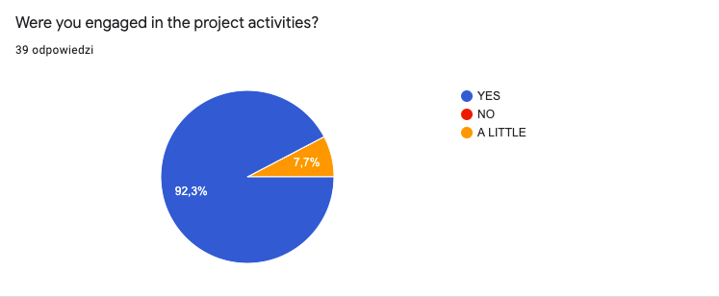
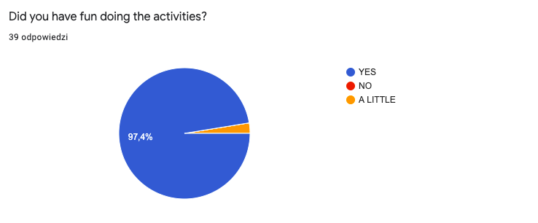
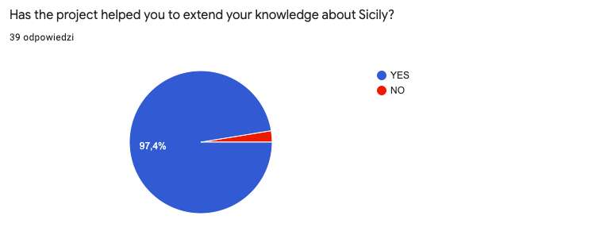
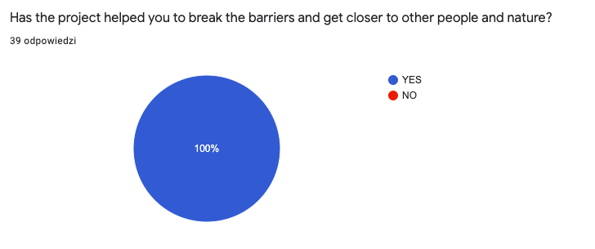

REFLECTIVE LEARNERS CHECKLIST
STUDENTS PARTICIPATING IN C-3 LTTA
the beginning of November 2021

Please answer the questions honestly.
 | YES | NO | I STILL NEED TO WORK ON IT.
I can say what I am good at. | 27 | 0 | 18
I can give reasons for my ideas. | 38 | 0 | 7
I can say whether I worked well. | 33 | 1 | 11
I know that it is important to try hard. | 42 | 0 | 3
I can say which bits of work I find easy or difficult. | 40 | 1 | 4
I know about the different learning styles and can choose a suitable learning style for the activity I am doing. | 32 | 0 | 13
I understand I need to be positive to perform well. | 30 | 2 | 13
I know it is important to make the right choices in my work and in school. | 43 | 0 | 2
I plan when to stop and reflect on my progress in a task and revise my plans when necessary. | 23 | 3 | 19
I recognize the need to break down problems into steps. | 33 | 1 | 11
I use my previous learning to help me complete tasks. | 41 | 3 | 1
When considering issues with an ethical dimension I try to make a difference. | 33 | 1 | 11
Independently, I decide on what resources I need and then I access them from the classroom or elsewhere in school or home. | 38 | 1 | 6
I can say what I need to get better at (including my personal targets). | 35 | 0 | 10
Reflections on Reflective Learning ;)
 | YES | NO | I DON'T KNOW.
Did you hear about Reflective Learning before you joined the PLTS Project? | 13 | 32 | 0
Did you find the concept of Reflective Learning useful? What are the advantages of being a Reflective Learner? | 43 | 0 | 2
e.g.
Yes, absolutely. Now I’m much more aware of my learning techniques and I focus more on how I can improve myself based on the information I’ve collected during this project.

You know your strengths and weaknesses and you understand how you learn, you also learn from your mistakes.
I found it hugely useful. Being a Reflective Learner has many advantages such as progressively improving, making better use of our study time or learning to be honest with ourselves and recognize our failures and our successes.
I think that knowing how to be a good reflective learner can help you to be more productive and can make you realise which things you can improve in your studying methods.
Do you feel motivated to work on being a better Reflective Learner? | 43 | 0 | 2

CONCLUSIONS
Strong points:
- The LTT activities before, during and after the mobility helped to develop teachers and students’ key competences: Communication in mother tongue, Communication in foreign language, Digital competence, Learning to learn, Social and civic competence, Sense of initiative and entrepreneurship, Cultural awareness and expression, Mathematical competence and basic competences in science and technology and XXI century skills (critical thinking, creativity, collaboration, information literacy, communication skills, media literacy, global awareness, social responsibility, thinking skills, perseverance)
- 100% of participants claim the project has helped them break the barriers and got closer to people and nature. 100% were engaged in the project activities. 97,4% learned more about Sicily and its culture.
- 71% of students realized the importance of Reflective Learning and learned how to be a Reflective Learner. 93% found it useful for learning and life.
- Reflective Learning has been promoted in all the partner schools and local communities thanks to the distribution of PLTS posters with simple and practical tips and the use of Learnish - language supporting learning by participating students and teachers.
- The LTTA motivated most of our students to learn better, stay positive despite the challenges and learn from mistakes.
Weak points:
- In the area of Reflective Learning we can see that our students need more support in setting their goals, making the right ethical choices and stopping and reflecting on their progress, revising.
- Most students felt welcomed and found the atmosphere friendly. Still, one student didn’t, so next time we need to make sure that all the students receive as much care and attention as they need.

ANALYSIS OF ALL PARTICIPATING STUDENTS ANSWERS -
DEVELOPMENT OF XXI CENTURY SKILLS

All the project students were engaged in online collaborative activities throughout the whole year (1.12.20 - 30.11.2021). Some of them in single projects which have already been finished (Air Pollution Comparative Analysis, Water Management Comparative Analysis, Fight Overpackaging poster, Survey on Noise, Biodiversity in My Camera Exhibition), the others in ongoing projects - social media and project’s promotion.
Unfortunately, although almost all our participating students completed the survey, it was possible to see only the 40 responses in the basic free of charge plan. We treated the answers as representing the whole project students team.
https://www.surveymonkey.com/results/SM-52M9K3DC9/

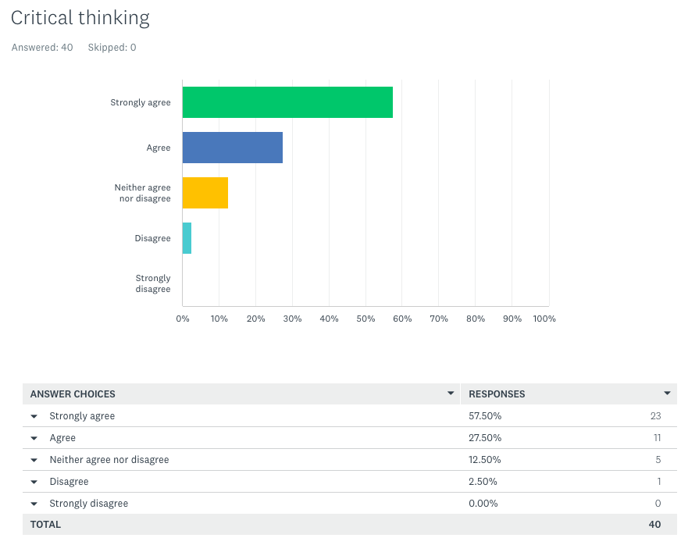
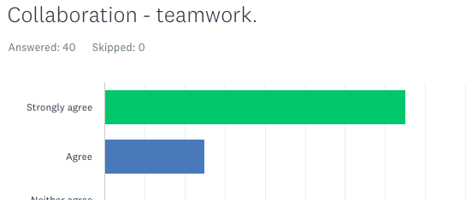
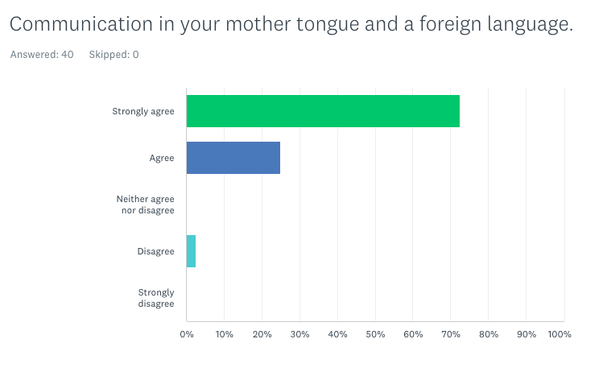
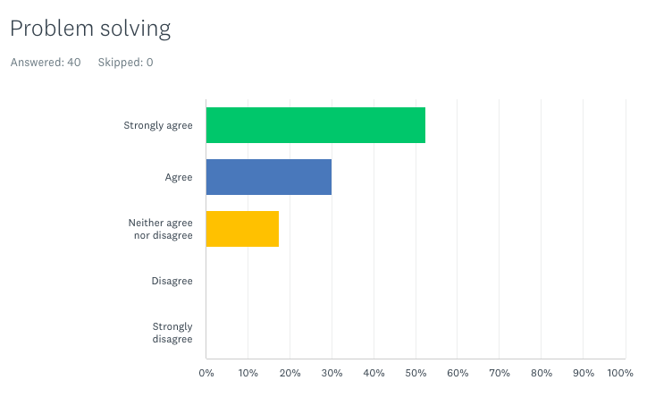

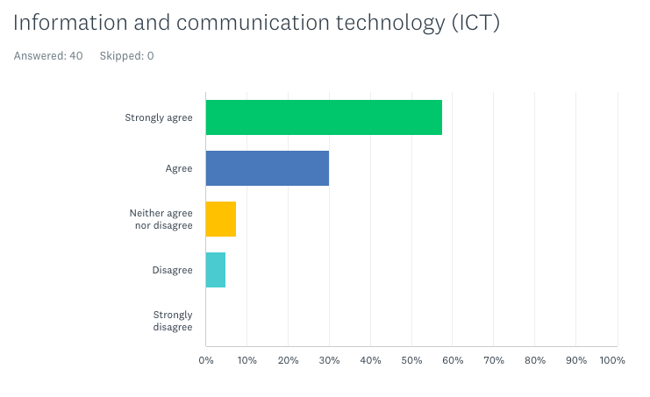
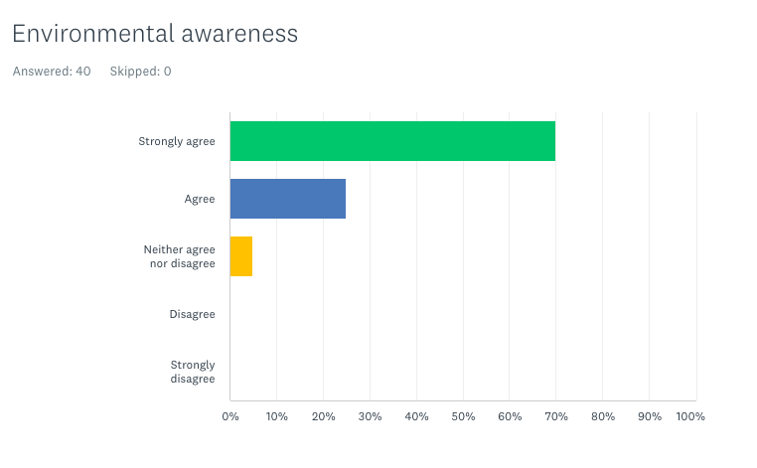

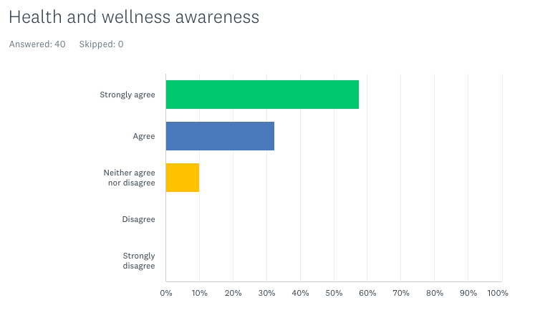
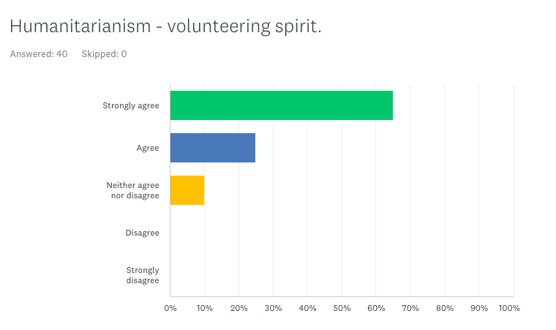
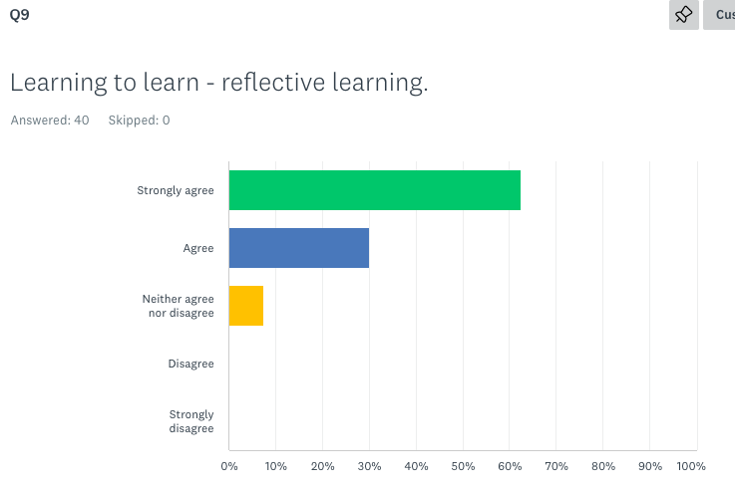
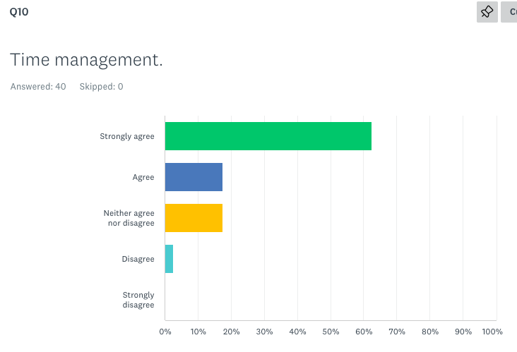
CONCLUSIONS
- Between 80-90% of students claim the project has helped them develop the following competencies: critical thinking, collaboration, time management, learning to learn, humanitarianism - volunteering spirit, health and wellness awareness, environmental awareness, information and communication technology, problem solving, communication in mother tongue and a foreign language.
- Time management, problem solving,ICT, and communication are the skills that 2-5 % of the students didn’t develop. We hope the next planned activities will help all the students involved develop these particular competences. Teachers can be the biggest supporters on everyday basis for the students in this area.

SCHOOLS REPORT ANALYSIS
Students achievements and interest in maths and science

- 16% of participating students (6 schools included) have improved their grades in either maths or science.
- 11 % of participating students became more interested in maths and science - they have decided to take extended national exams in these subjects.
- Early School Leaving: Portugal 0%, Poland 1 students 19/20 and 1 student 20/21 school year

Peer learning and volunteering
- 68% of the project students (6 partners included) started to volunteer to help their colleagues with the school subjects they find more difficult, which is a win-win situation, as all the students involved learn from and with each other, improving not only the knowledge related to the school subjects, but also their own personal skills, such as responsibility, empathy, solidarity and self-organization.
- 92% of the project students engaged in volunteering activities, eco actions and charity events - they developed Social and civic competence and Sense of initiative and entrepreneurship competencies.

PROJECT’S CERTIFICATION AND VALIDATION

The Italian partner confirmed the Europass mobility documents to all the students and teachers participating in C-3 LTTA.
Each C-3 LTTA participant - both teachers and students - has received a certificate of attendance issued by the hosting school.

