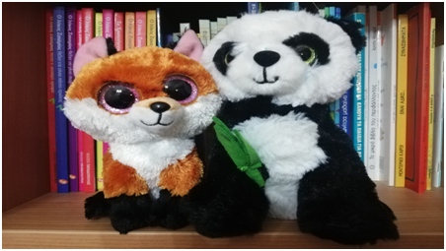
I am Earth!
I am Quake!
Hi Guys!
We are your two new friends who came to find out all we need to know about earthquakes, what they are, how they are caused, what to do and how to protect ourselves.
We want your help to find out all this.
Every Friday we will come to your house and discover information, myths, stories, tales, pictures and anything else you can imagine about our European Project about Earthquakes.

The material that you will gather, along with your parents, will brought it to our classroom in whatever form you can, eg: printed material, in a usb stick or in school’s email.
This weekend we will be hanging out at your house we want to have a great time together !!! So inside the box, you will find a notebook where you can write or draw: how we spent time together, describing what we did when we were together, or how you felt you were welcomed. It would be great to have a photo together and in order to see your schoolmates how we spent time together!
Let’s start!!!
Our first mission for this weekend, is to find any information about Enceladus, mythology, stories, etc. in Greece. You can bring the information you have with your family to our class in whatever form you can, eg: printed matter, in a stick, in our school email
We will have a great time!

Best Regards
Your friends
Earth and Quake.

