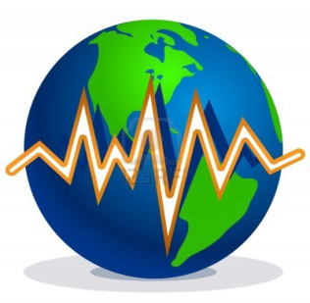
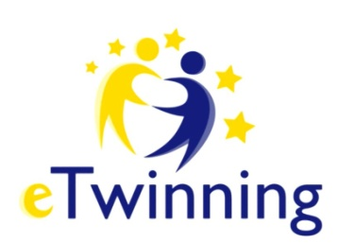
eTwinning Project 2019-2020

Shake shake like Earth and Quake
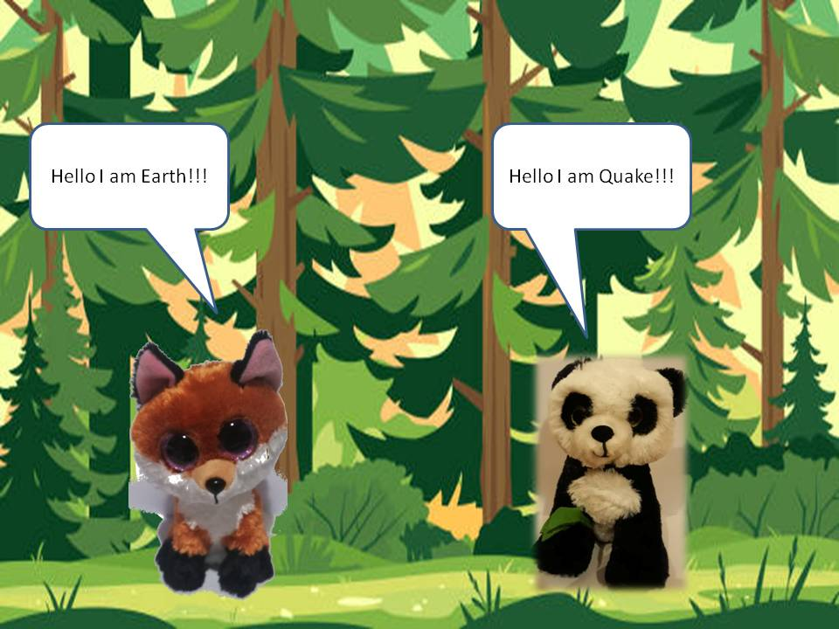
Dear Parents, We would like to inform you about the implementation of a European eTwinning program designed by our school in collaboration with the other 3 schools / 4 kindergarten departments in Greece and Turkey.
The schools and teachers participating are:

2nd Kindergarten of Perama - Archonti Vaia - Georganti Penelope - Kasiktsi Georgia - Rentzepi Katerina - Tsapara Maria
2nd Kindergarten of Peristeri - Arkouli Anthi
22nd Kindergarten of Keratsini - Papadogkona Konstantina
Akdeniz İlkokulu - Mindavalli Neslin

About our project - Educational Goals
- To know and understand infants the natural phenomenon of earthquake scientifically and experimentally, and by observation.
- To Reflect, observe and make assumptions about how the phenomenon, its manifestations and effects are generated.
- To Experiment with a variety of materials and draw reasonable conclusions from their findings.
- To cultivate the skills of comparison and classification as well as their mathematical thinking more broadly
- To get acquainted with peers from other kindergartens, develop social and communication skills.
- To understand the importance of collaboration, engage in exploratory and collaborative learning, learn to respect the opinions and works of others.
- Develop thoughtful observation skills, learn to pay close attention to the world around them, focus on real problems, propose and seek solutions.
- Get in touch with ground floor robots by integrating them into the training process.
- To be properly informed about the earthquake phenomenon and to inform their narrow and wider environment.
- Express themselves freely and creatively in a variety of ways and means.
- Create surveillance material on earthquake protection

By the end of the school year, children will carry out a variety of activities using different tools (analog and digital, robotics kit, stem education). They will develop communication, collaboration, creativity and critical thinking skills that make them an active citizen of the 21st century.
At the same time we will also need your help and cooperation as you will assist us with actions, creation of materials and searching for material and information during the implementation of our program.
In our project we are not alone. Two heroes Earth ( a fox) and Quake (a panda), want to learn more about earthquakes and how can be protected. Is there a solution?
They ask for help from students!! Students from partner schools are going to work together and try to accomplish different missions. They will learn about earthquakes and also find ways about seismic protection. They will create educational material for their schools and families!

Τhank you in advance for your cooperation
Yours sincerely
Teachers' team

