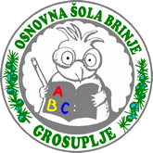
CAKE STEALING
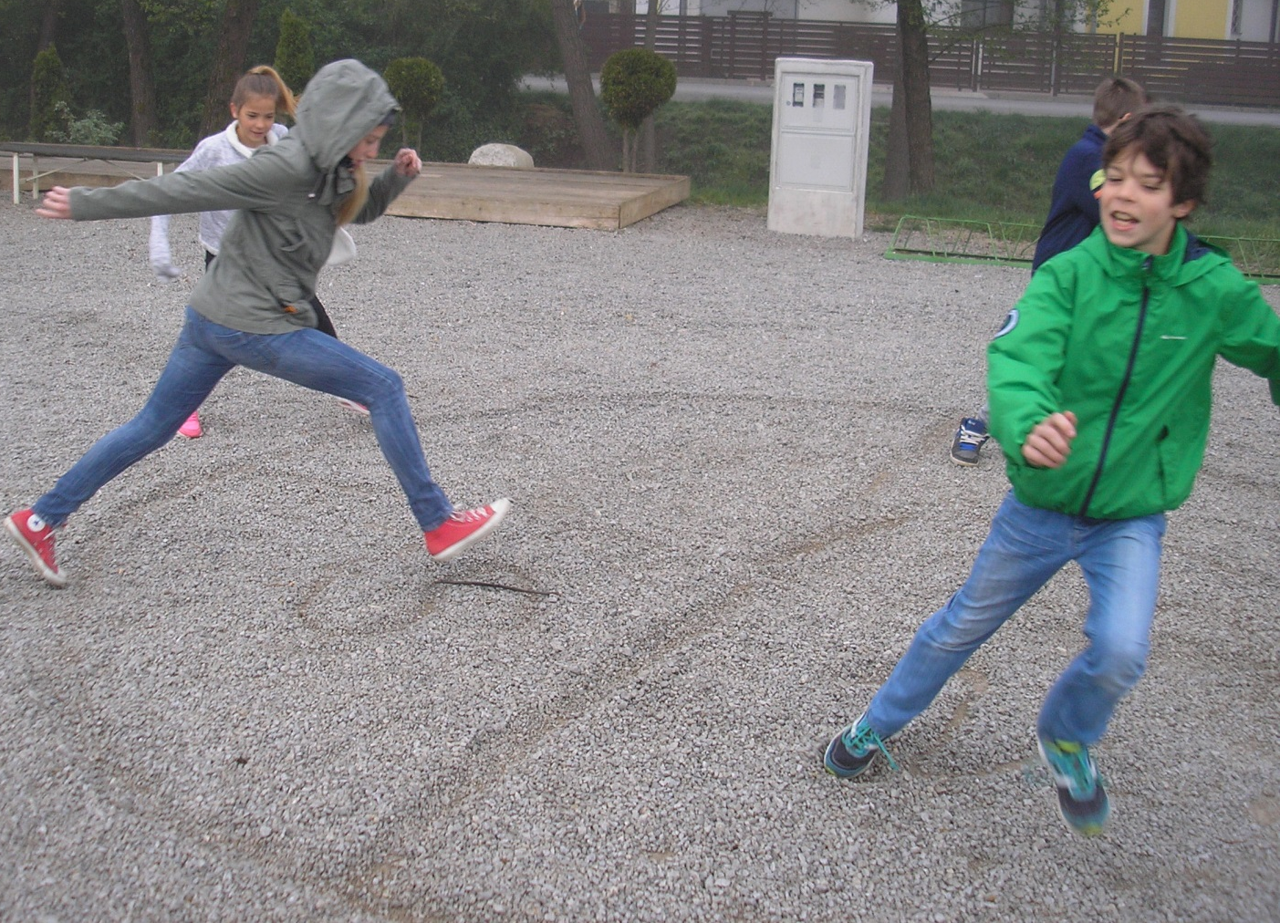
EQUIPMENT:
- a small ball/stick
- a surface that can be drawn on
- a chalk for drawing a circle
.

THE GAME:
The game is about taking the cake
away from your co-players. If you
hit your co-player with a ball, you
can take a piece of his cake, otherwise
he/she can take a piece of yours.
RULES:
When the ball is thrown on your part of the cake, you must step on it and yell »Stop!«. All other players have to stop running and you try to hit one of them with a ball. If you succeed, you can take a part of his/her cake, otherwise he/she takes a part of yours.

TORTO KRAST
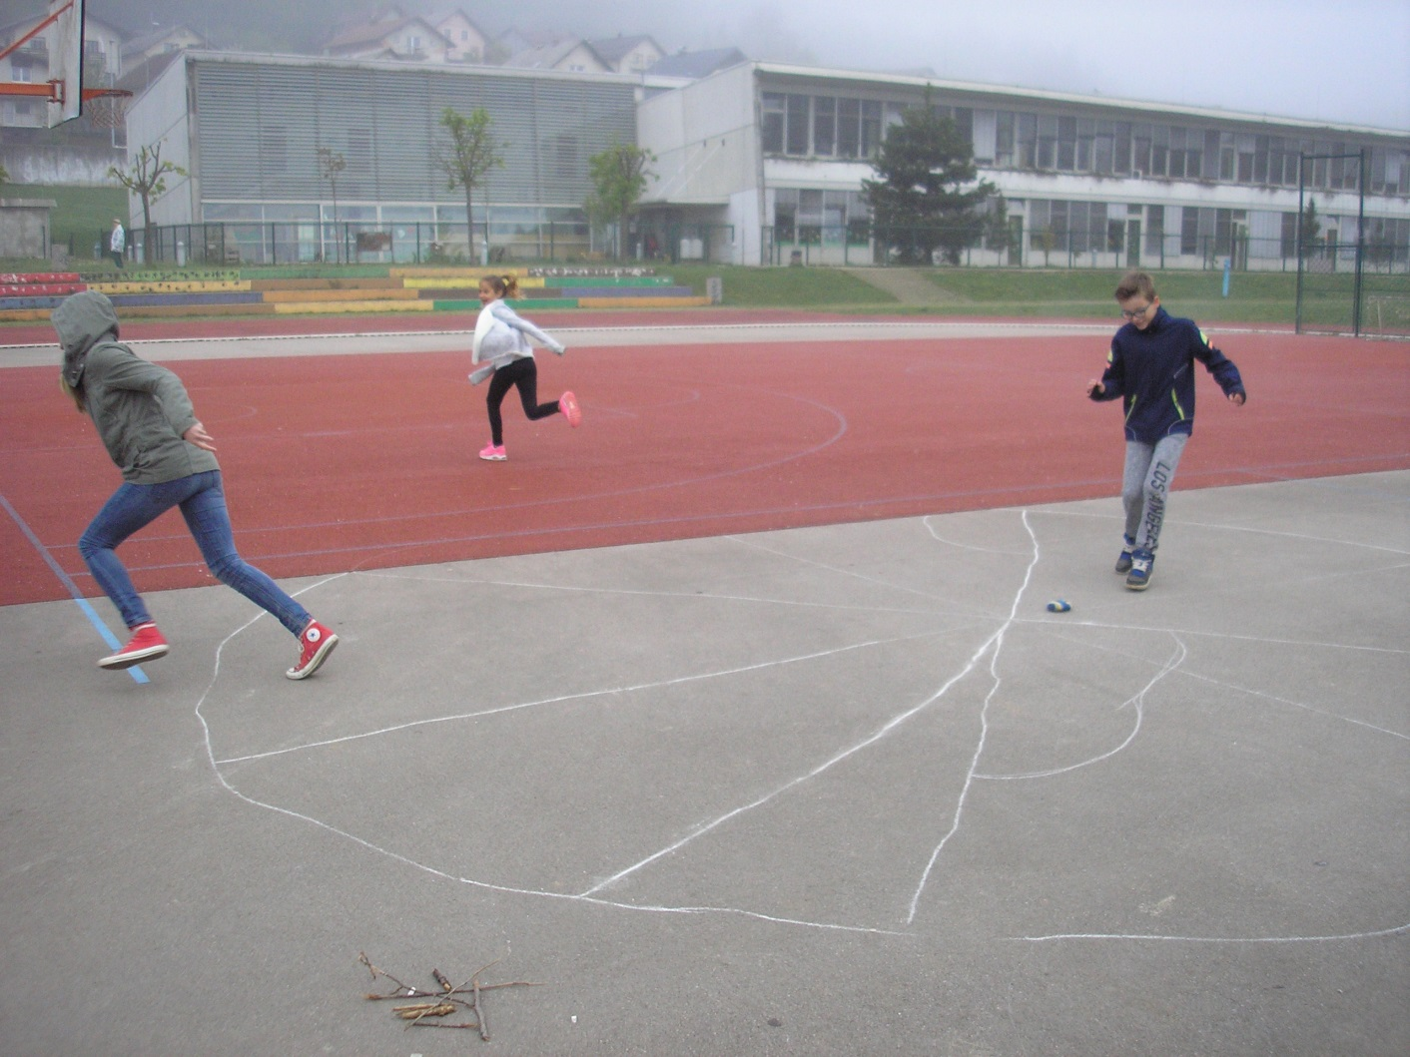
PRIPOMOČKI:
- majhna palčka/žoga
- podlaga, na katero lahko rišemo
- kreda, s katero narišemo krog
.

IGRA:
Cilj igre je prisvojiti si kose torte
svojih soigralcev. Če soigralca
zadeneš z žogo, mu lahko
vzameš košček njegove torte, sicer pa on vzame košček tvoje torte.

PRAVILA:
Igralec vrže žogico. Če je žogica na tvojem delu torte, moraš stopiti nanjo in zavpiti »Stop!«. Vsi ostali igralci se morajo ustaviti in z žogo lahko ciljaš enega med njimi. Če ga zadeneš, mu lahko vzameš del njegove torte, sicer pa on lahko vzame del tvoje torte.

