AGRUPAMENTO DE ESCOLAS
PROFESSOR PAULA NOGUEIRA

C4 - VOLUNTEERING ON ENVIRONMENT
23rd to 27th September 2019

EVALUATION REPORT

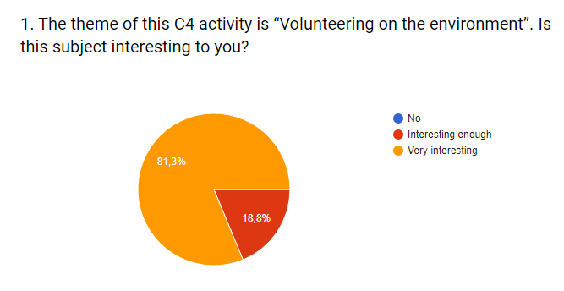
* 32 Students answered the evaluation questionnaire

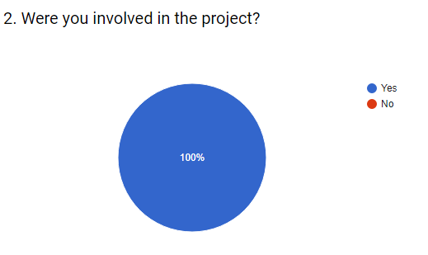

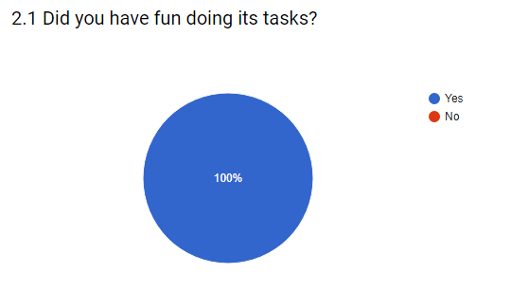

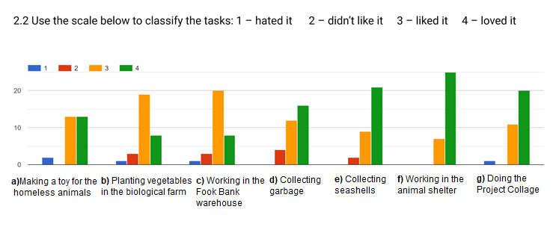

3. Which, from the above, was your favourite task? Tell us why.
Most of the students stated that their favourite task was working at the animal shelter.
When asked why, they say that they love animals and like to help them.
One of the students said „I was able to give a little love to those tender dogs”!

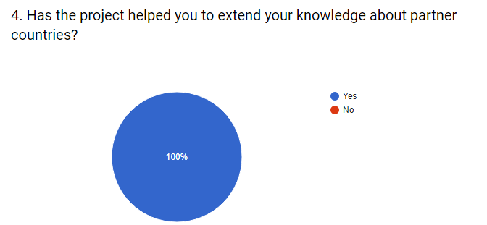

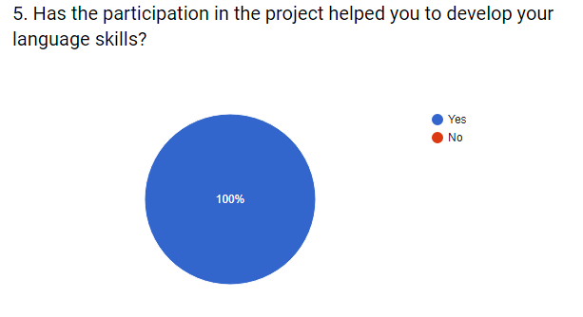

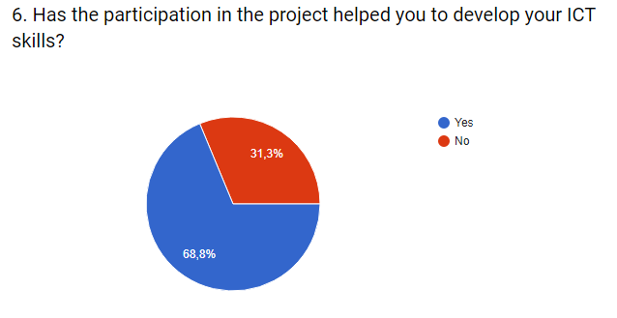

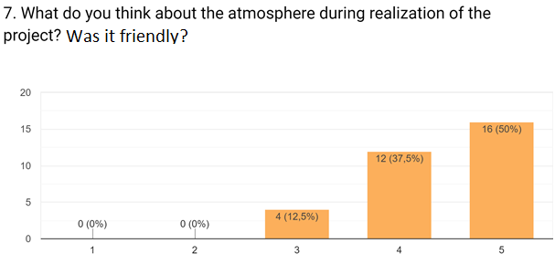

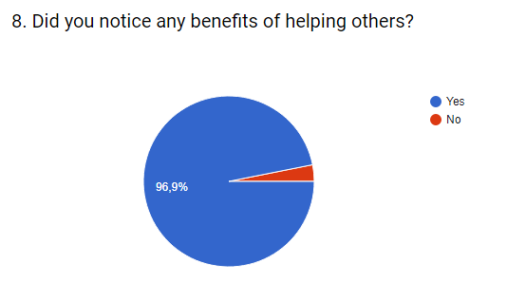

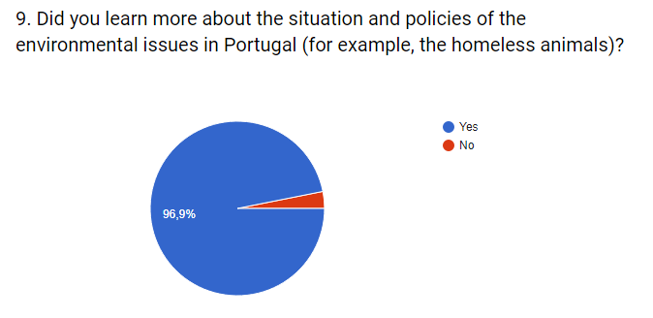

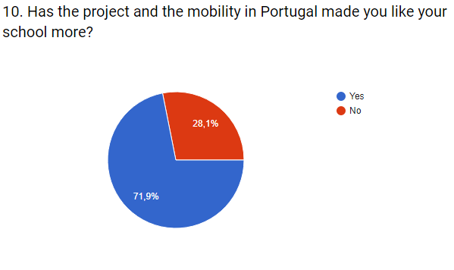

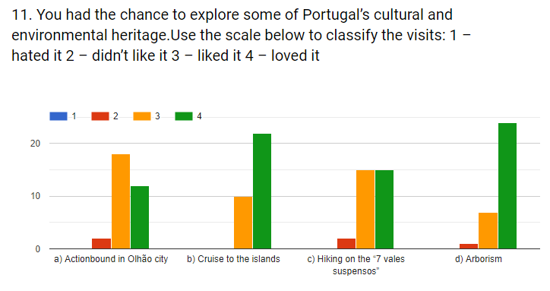

Most of the students chose the cruise to the islands, giving several reasons, such as: they made „things“ at the beach; the views; picking trash on the beach.
The second favourite activity was the arborism, because: they had a lot of fun; they love walking on the trees; they had never done it before.

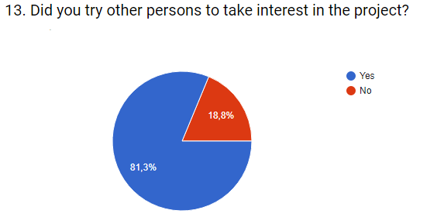

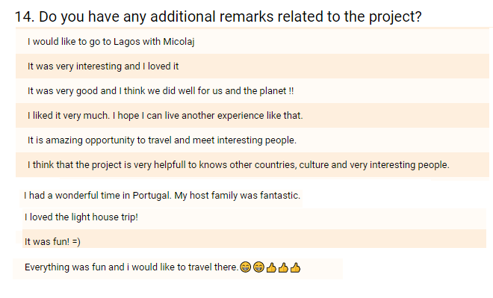

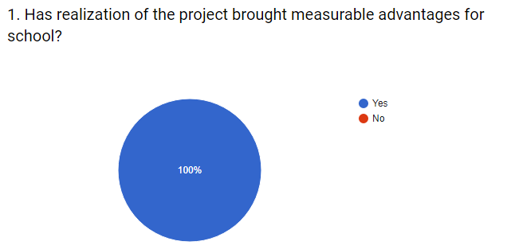
* 18 teachers answered the evaluation questionnaire

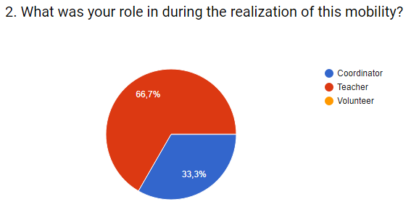

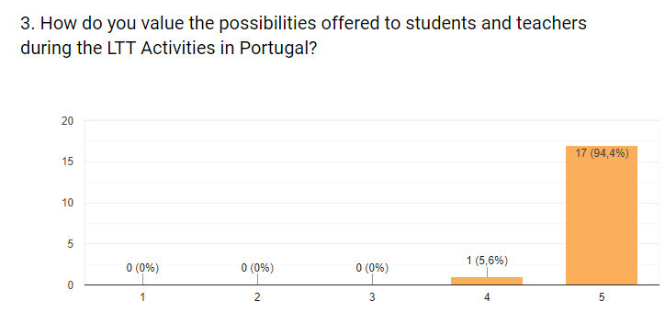

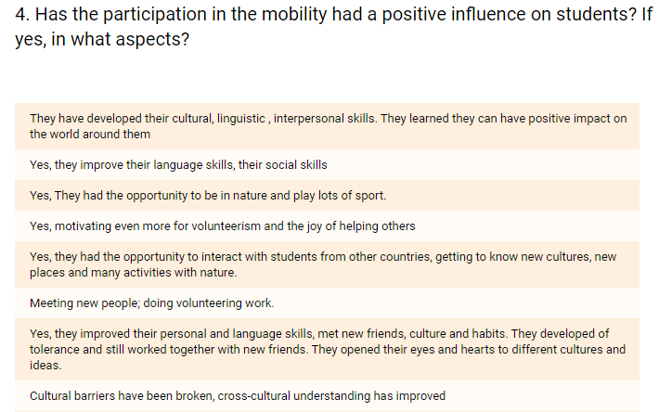

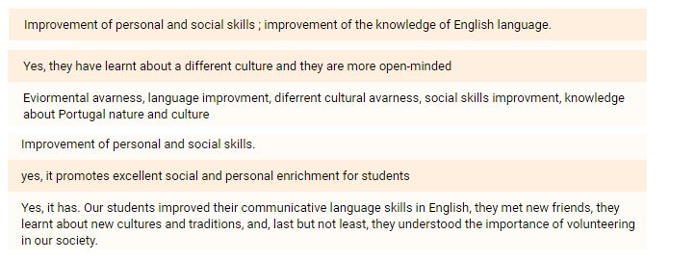

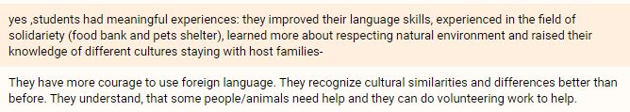

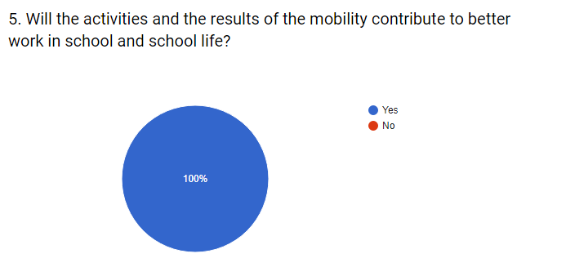

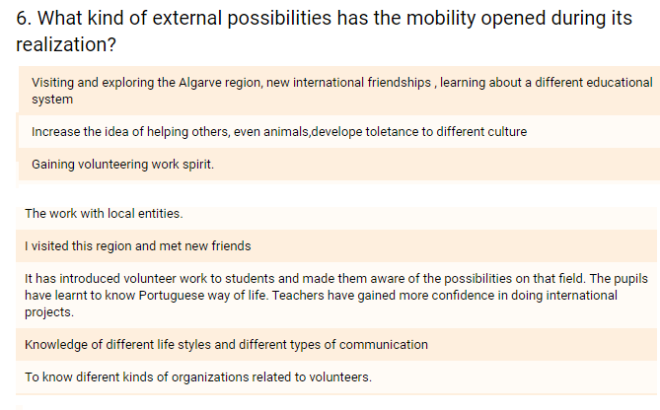

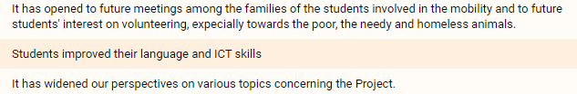

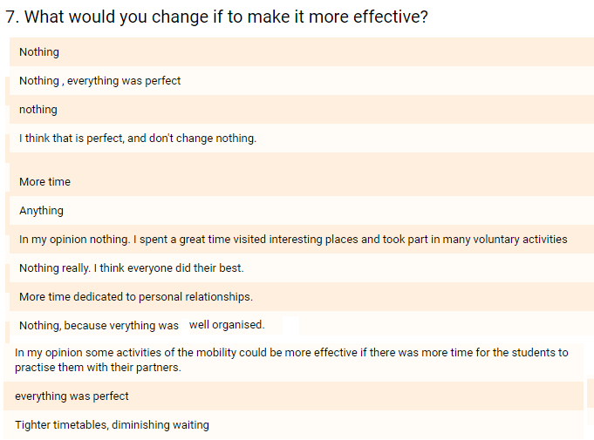

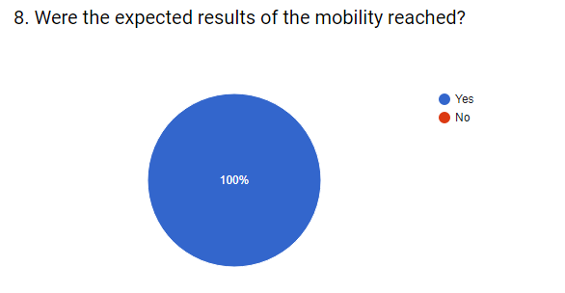

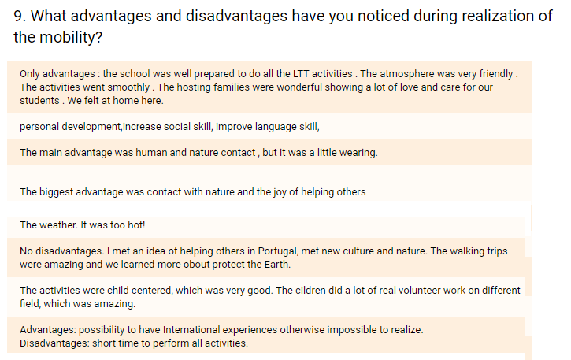

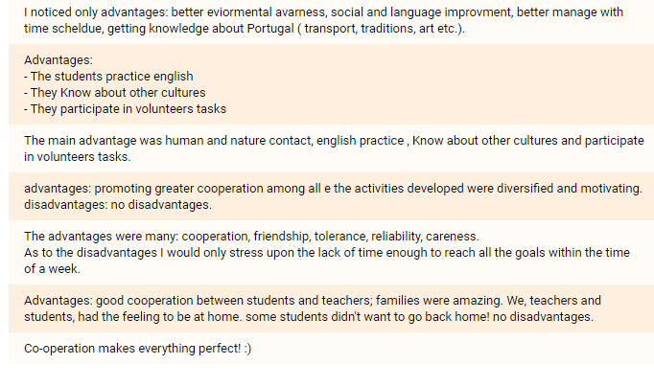

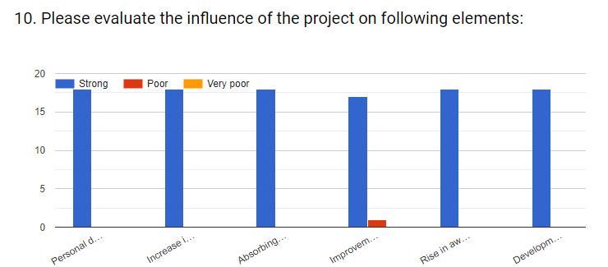

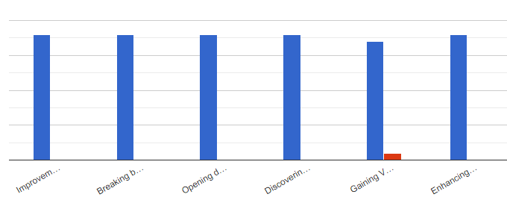

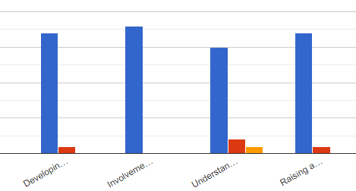

- Analysed topics:
Personal development of participants.
Increase in Key competences, social skills, learning to learn, sense of initiative and
entrepreneurship, digital competence.
Absorbing the idea of helping others, learning about help without benefits.
Improvement in Language and ICT skills.
Rise in awareness of cultural diversity and knowledge about cultural and historical heritage.
Development of tolerance to different cultures.
Improvements on the sense of solidarity, cooperation, team spirit, communication skills.
Breaking barriers, prejudices.
Opening doors to different cultures and ideas, beliefs.
Discovering the value of friendship.
Gaining Volunteering work spirit and taking initiative.
Enhancing the achievements of low-skilled pupils.
Developing positive views on the EU and Erasmus+ project programmes.
Involvement in an international work.
Understanding EU policies on different fields.
Raising awareness on global issues.

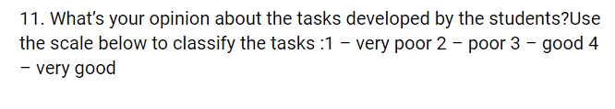
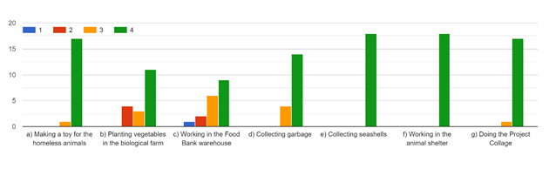

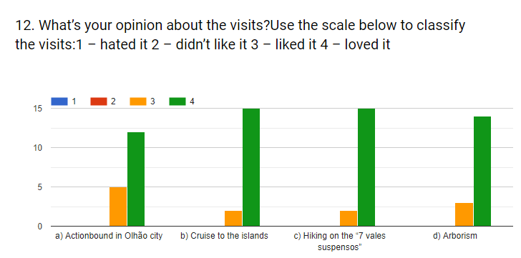

The most loved visit was the cruise to the islands. People gave several reasons, such as:
. love of the ocean
. collecting garbage
. visiting the lighthouse
. everybody had a lot of time on the beach
. the students enjoyed and learned a lot
